Children can be abused physically, sexually, emotionally or through neglect. The concerns that you have may make up part of a bigger picture which could help to prevent serious harm to a child. Giving families help at an early stage can prevent abuse and neglect.

This leaflet is the first of 3 levels of training for people who work in either a paid or voluntary role with children in Cornwall. If you have not already done so, ask your employer to talk through this leaflet with you and tell you who to contact within your organisation if you have concerns. If you think you need further training talk to the person who gave you this leaflet or to your manager.

NEVER KEEP CONCERNS
ABOUT CHILDREN’S SAFETY
TO YOURSELF

Contact information

South West Child Protection Procedures Cornwall & Isles of Scilly Safeguarding Children Partnership Procedure (proceduresonline.com)

Local Safeguarding Children Board Website Cornwall and the Isles of Scilly Safeguarding Children Partnership - Home page (ciossafeguarding.org.uk)

Emergency Services | 999
Devon and Cornwall Police | 101
Children’s Multi-Agency Referral Unit | 0300 1231 116
Children’s Multi-Agency - out of hours | 01208 251300
If you have concerns about a professional or volunteer working with a child contact the Local Authority Designated Officer (LADO) for Cornwall | 01872 326536

Keep this leaflet in a safe place you never know when you might need it!


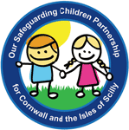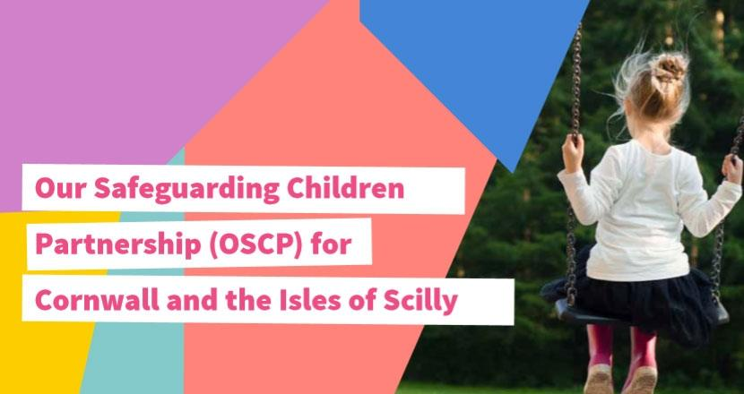
CHILD PROTECTION & SAFEGUARDING CHILDREN

KEEPING CHILDREN SAFE

No one wants to hear about children being abused, neglected or unsafe and that sometimes makes it difficult to respond so ….

Remember these three important messages:
1 | ALL CHILDREN HAVE A RIGHT TO BE SAFE NO MATTER WHO THEY ARE OR WHAT THEIR CIRCUMSTANCES.
2 | KEEPING CHILDREN SAFE IS EVERYONE’S RESPONSIBILITY.
3 | WE ALL NEED TO LISTEN TO CHILDREN EVEN THOUGH WE MAY NOT ALWAYS BE COMFORTABLE WITH WHAT WE HEAR.

Relevant legislation and guidance

Childline
https://www.childline.org.uk/

Working together to Safeguard Children
Working together to safeguard children - GOV.UK (www.gov.uk)

Professional Differences: If you do not agree with the advice you are given and feel a child remains at risk of harm, it is your professional responsibility to take further action. You can use the OSCP Resolving Professional Differences Policy for guidance: https://ciossafeguarding.org.uk/scp/p/our-policies-and-procedures/policy

WHO SHOULD I TALK TO IF I HAVE CONCERNS ABOUT A CHILD?

Name: Jodie Watkins-Young
Role: DSL. Interim Headteacher
Phone: 01872 520385
Email: jwatkins-young@pencalenick.org

Name: Diana Barry
Role: Deputy DSL. Behaviour Lead
Phone: 07494 096671
Email: dbarry@penclenick.org

Name: Lorraine Faulkner
Role: Deputy DSL. Head of Care
Phone: 07494 096658
Email: lfaulkner@pencalenick.org

Name: Guy Chappell
Role: DSL. CEO, Special Partnership Trust
Phone: 07807 495402
Email: ceo@specialpartnership.org

If these contact people are not available do not delay but contact one of the numbers at the end of this leaflet.
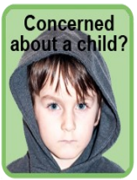
REMEMBER

- It doesn’t matter if you are a paid worker, a volunteer or a member of the community, you have a responsibility to act if you are worried about a child.

- Each agency will have someone who has a responsibility for child protection and safeguarding issues - they have had training to know what to do next.

- It is not your responsibility to investigate child abuse but you should tell the appropriate person within your organisation. It will be this person’s job to decide whether to pass your concerns on. If necessary, they will speak to Children’s Social Care or the police. The police and social workers can then decide whether they need to investigate your concerns.

