Transition Booklet for Young people with LDD
Cornwall
CSW Group are able, to support young people from age 13 up to 25 who have an Education Health and Care Plan (EHCP) with their transition from School to their post 16 provision. Our advisers are qualified to level 6 in Advice and Guidance and are registered with the Careers Development Institution.
They are based in secondary and post 16 educational providers across Cornwall and Devon and will work with the young person, Parents/carers, and educational Providers to provide impartial advice and Transition support.
Your Adviser is Fran Dolan Tel: 07805809362 Email: fran.dolan@cswgroup.co.uk
Website: www.cswgroup.co.uk

There are many different options available to young people when they leave school. Below are some of the main options to students in Cornwall with an EHCP.

Local FE College provision

The majority, of students move into college when they leave School.
Each college has a selection of courses within its Foundation Studies that may suit your son/daughter.
It is recommended that you visit the colleges to gain information about the courses and college environment.
The courses range from 3 – 5days. You can apply for enrichment days to make the course a 5-day provision up to the age of 18. You will also need to consider transport options when considering a college place. (See transport information sheet.)
Below is a summary of some of the Foundation Level courses available locally.

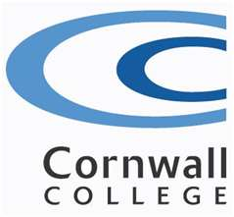
Cornwall College – Camborne
Address: Trevenson Road, Pool, Redruth, Cornwall, TR15 3RD
Foundation Studies Contact: Ruth Dixcee
Tel: 01209 611611
Email: enquiries@cornwall.ac.uk
Website: www.camborne.ac.uk

Foundation Programmes, The Faculty for Continuing and
Community Education
Foundation Programmes runs a range of courses for all ages and abilities, ranging from pre-16 learners to adults with mental health issues, at various locations across the county.
Support is available on all courses for students who require it. Enquiries for all courses can be made through the college student enquiries department – 01209 616310.

Multi-options Entry Level 3 – L1 & L2 – Course Manager is Steve Watkinson
Who is it for: Students aged 16-19 years of age who are undecided about their future choices and would like to try a number of options in college before making a decision.
Course information: Options include art, catering, motor vehicle, built environment, public
Personal progress – towards independence
Who is it for: 16-19 and 19+ year old students who experience severe and/or multiple learning difficulties and are, progressing on from a school of special education.
Course information: Students follow a broad and balanced curriculum within a wide
range of vocational subject options. The course focuses on independent living skills as well as increasing communication skills. Opportunities to experience work placement and enrichment activities are also available.

Personal Progress – towards employability E1-E3
Who is it for: 16-19 and 19+ year old students who experience learning disabilities/
difficulties.
Course information: Students will develop their independent living skills through a variety of practical and theoretical sessions. They will also take part in developing an enterprise project as well as enrichment sessions including sport, IT, and catering. Opportunities to experience work placement are also available.

Cornwall College St Austell. John Keay House, Tregonissey Road, St Austell, PL25 4DJ

Contact Michelle Lobb 01726 226557 michelle.lobb@cornwall.ac.uk

Foundation Learning Vocational intends to prepare learners before progressing onto a level 2 course, still developing soft skills but with more of a focus on vocational learning – with these sessions being delivered in the various college departments. Options include –
Wednesday – hair, construction, childcare
Thursday – media, performing arts, sport
Friday – business, hospitality & catering, travel & tourism
 | Foundation Learning |  | Vocational Academy
 | Independence | Skills | Vocational  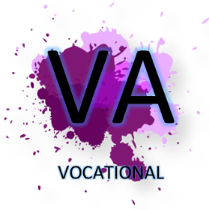 | Works
Overview | Working towards the preparing for adulthood programme to develop a more independent, confident and resilient young person. | Developing study and social skills to prepare for learners next steps. | Explore different vocational areas whilst developing vocational skills, behaviours and attitude to successfully study at level 2 or employment for the next step. | Preparing for work with employability skills and relevant work experience.
Entry requirements | No formal entry requirements | Working at Entry 2 or above in English and maths | Working at Entry 3 or above in English and maths | Entry 2 – Level 1  Learners offered qualifications relevant to current academic ability
Main qualification | RARPA  Covering the four areas of preparing for adulthood – employment, independent living, good health and friends, relationship and community. | BTEC Entry 3 Entry to Vocational studies  Award / Cert / Extended cert  Some of the topics include – gardening, home maintenance, IT, media, enterprise, cooking, community action and independent living. | BTEC Level 1 Introductory Vocational Studies  Award / Cert / Diploma  Some of the current vocational options include – sport, digital media, childcare, health and social care, art and design, construction, horticulture, hair and nails, business and IT, catering, science and motor vehicle. | C&G Employability Skills Award Entry Level 3 & Level 1  Some of the employers we work with include – Pinetum, Cornwall Hospice Care, Into Bodmin, Cornwall Care, St Austell Brewery, Tesco.
English and maths | Functional Skills  C&G units  College certificate when exemption is appropriate | Functional Skills  C&G units  College certificate when exemption is appropriate | GCSE  Functional Skills  C&G units  College certificate when exemption is appropriate | GCSE  Functional Skills  C&G units  College certificate when exemption is appropriate
Work experience | Inclusive work experience offers - up to 30 hours depending on learner | Inclusive work experience offers - up to 30 hours depending on learner | One-week work placement Feb 2022 | Built into study programme:  Stage 1 – 1 day a week  Stage 2 – 2 days a week

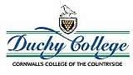
Duchy College – Rosewarne
Address: Rosewarne, Camborne, Cornwall, TR14 0AB
Pathfinder Contact: Ruth Dixcee
Tel: 01209 611611
Email: rosewarne.enquiries@duchy.ac.uk
Website: www.duchy.ac.uk

Please note: Since September 2015, the Duchy pathfinders’ course, is based at Cornwall College Camborne main site. Trevithick Court building. Students will still be able to access facilities at the Rosewarne site but are transported down for those sessions.
Mainstream courses
Support is available for students on all courses. Please talk to admissions or course tutors about your son or daughter to ensure they get the support they need.

Pathfinder (Entry Level)
Who is it for: Students with additional learning needs who have an interest in land based subjects and wish to develop their practical and personal skills.
Course information: There are four land-based areas to choose from – horticulture,
animal care, agriculture, and conservation.
Functional skills are included as well as a wide variety of enrichment

Duchy College Stoke Climsland, Callington PL17 8PB 0300 123 4784
Learning Support Manager is Charlie Hedger charlie.hedger@cornwall.ac.uk
There are 4 main pathways:
Foundation Learning: Independence Pathway
Foundation Learning: Skills towards Vocational Studies
Foundation Learning: Vocational Studies
Foundation Learning Works Pathway: Pathway 2 Employment
It offers a supported environment to increase learners’ independence and confidence and offers plenty of vocational opportunities.
Learner can include agriculture, animals care, equine and horticulture within their programme. They can learn to drive a tractor and learn all aspects of farming.

Penwith College

Address: St Clare Street, Penzance, Cornwall, TR18 2SA
Foundation Studies contact: Pam Rozentals email: pamr@truro-penwith.ac.uk
David Atkinson-Beaumont Curriculum Manager for Foundation Studies:
davidbeaumont@truro-penwith.ac.uk
Tel: 01736 335000
Email: enquiry@truro-penwith.ac.uk
Website: www.truro-penwith.ac.uk

Mainstream courses
Support is available for students on all courses. Talk to admissions or course tutors about your son or daughter to ensure they get the support they need.

Access inclusive learning
Who is it for: Post-16 students with a range of learning needs.
Course information: Independent living skills, basic skills, recreational and vocational skills, and sheltered work placement such as in the Manor Café on site.

Personal Progression through Practical Life Skills, Entry
Levels 1 and 2
Who is it for: Post-16 students with severe and multiple learning needs.
Course information: The course offers units in: developing skills for daily life, using
community facilities, using leisure time, practical project work, taking part in an enterprise activity, developing creative skills, and keeping fit and healthy.

BTEC Entry Levels 2 and 3 certificates in Skills for Working
Life
Who is it for: Post-16 students who have moderate learning difficulties.
Course information: Apart from literacy, numeracy and IT, students will have the
opportunity, based on their interests, to study motor vehicles, hair and beauty, leisure and tourism, health and social care, horticulture, arts and media, hospitality and catering, retail,

Truro College
Address: College Road, Truro, Cornwall, TR1 3XX
Contact: Theresa Edwards (foundation Studies) Gemma Marshall (Learning Support Co-ordinator)
Tel: 01872 267000
Email: enquiry@truro-penwith.ac.uk
Website: www.truro-penwith.ac.uk

Mainstream courses
Support is available for students on all courses. Talk to admissions or course tutors about
Your child to ensure they get the support they need.
Students have the opportunity, to experience a range of vocational sectors. In addition
students will develop their functional skills (maths, English, ICT), Work Skills, PSD, and
undertake work experience.

Access inclusive learning
Who is it for: Post-16 students with a range of learning needs.
Course information: Independent living skills, basic skills, recreational and vocational skills, and sheltered work placement. Subjects include basic skills (literacy, numeracy, and IT), music, art, history, film studies, environmental awareness, exercise and leisure, swimming, horticulture, enterprise, cookery, drama, sport, popular culture, and music awareness.
52
Access to community and education
Who is it for: Post-16 students who have profound and multiple learning needs.
Course information: An individually designed programme whereby tutors work in
partnership with carers, families, and significant others to devise, implement, monitor, and evaluate education programmes. Each programme is tailored to individual needs, and built around a multi-sensory approach.

Access to Skills Development
Who is it for: Learners on the autistic spectrum.
Course information: The environment is highly structured. We use symbol, pictorial, and writer communication boards and sheets to help. We work closely with service providers, schools, and other professionals.
The timetable includes: communication, ICT, horticulture, Swimming, relaxation, and
tutorial.
This Course is based at Truro College’s Tregye Campus near Carnon Downs.

Bodmin Community College – Lostwithiel Rd, Bodmin PL31 1DD 01208 72114

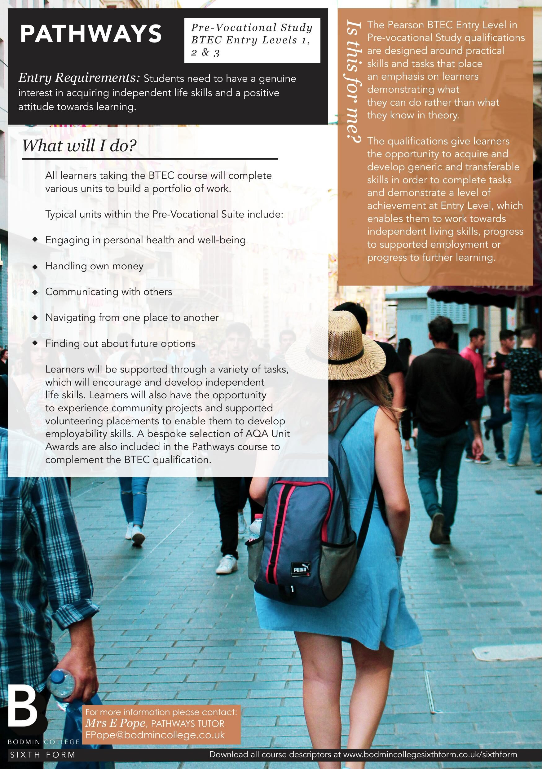

Supported Internships and Programme of study

These placements are an alternative to college or a potential progression route to and from college for students with EHCP’s, aged 16-25. They are overseen by the adult education sector but funded by a young person’s EHCP.
Any request for a placement must go through County’s SEN department and go to a SEN Panel for agreement. Your CSW Adviser will be able to advise and complete an Options Appraisal form to support with this process. The Activities the providers offer is varied, and it is always best to contact the provider for further information to see what can be offered to meet the needs and learning goals for your son or daughter.

However, in general, a programme of study is usually for 3 days per week and consists of 2 days in the classroom and 1 day work experience.

Some local providers include:
They run from two sites centrally located in Penzance and Truro.
Website: https://cornwallrcc.org.uk/projects
Facebook: www.facebook.com/learnyourwaycornwall
Look out for Try it days taster sessions advertised on their facebook page.
For more info Contact: Martin Prodger on 01736 322090 / 07732 604467

Students who complete the programme of study and are looking for employment could progress on their 1 year supported internship programmed called Work your way.
They focus on developing life skills and independence skills and preparation for employability. They work with lots of organisation’s within, the community.

TST
Transferable Skills Training
Callington
Cornwall
PL17 7HW
01579 384 798
katie@transferableskillstraining.com
Transferable Skills Training (TST) is an education and training centre specialising in teaching vocational skills to young people. TST was established in 2004 to work primarily with young people who have fallen outside mainstream education or training, offering a provision to 16-19 year olds, alongside young adults with EHCP’s up to the age of 24. We have a flexible and individual approach to re-engaging these young people, helping them to gain vocational qualifications, and to progress into further training, education, or employment. Where needed, our learners are given full support, with all aspects of personal and social development alongside their educational programme.
It is set in the grounds of Merryhue Farm.
For learners who are 16-18 years old, or over 18 years and have an EHCP, we offer a full-time study programme which comprises of 3 elements:

Core Qualifications
- The awarding body is OCN London
- Qualifications can be an Award, Certificate or Diploma
- See individual course pages for more details

Functional Skills
- The awarding body is NOCN
- Levels of study start at Entry Level through to Level 1 and Level 2
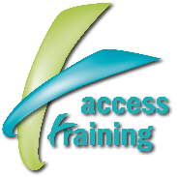
Access Training
Gerald Banks: 07966890180
Julie Banks: julie.banks@accesstraining.co.uk>

Access Training provide various, options for children and young adults with SEND. The tailored programmes have been developed for learners, who have a wide range of educational needs and abilities and provides relevant outcomes through a person-centred approach that prepares the learners for a successful transition into adulthood.

They offer bespoke packages which gives a high specialist support and can sub-contract to other Providers so that the most appropriate provision is found.

They cover the whole of Cornwall.

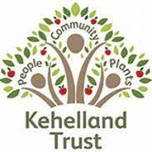Kehellend College
They offer a range of activities not just Horticulture for students on their peaceful site in Kehelland.
Website: https://kehellandtrust.org.uk//
Contact: Liz Myhill
Email: training@kehellandtrust.org.uk
Work mobile: 07570 363073
Education office mobile: 07909 497954
Kehelland College is set in a 16-acre site just outside of Camborne. Our full time education programs include accredited qualifications for learners focused on independent living, progression opportunities around employment and volunteering supported through Kehelland Trust operational site and external work experience placements, mental health wellbeing skills, English and Maths and a range of progression projects. We have a wide range of on-site work experience opportunities including sales/customer service, onsite shop, catering kitchen, horticulture, site maintenance (using machinery), outdoor education.
We are accredited through OCN London and deliver 3 full time learning programs; Achieve, Advance and Succeed. Achieve includes accredited learning around health and fitness (relevant to the learner's starting point), household skills, independence skills, horticulture, local history, work experience, using public transport. Alongside the accredited units are non-accredited units to support progress with team activities, relationships, emotional wellbeing, English, math’s, reading and writing. The site is open 5 days a week. Learners attend the education program for 3 days a week. 2 days are in the classroom and 1 day a week in the chosen area of work experience on-site. We have activities during the week that learners can join in with which can include yoga, kickboxing, football, singing and fit to wiggle.
Reach Out Creative Futures
I East Hill (Severn Stars Inn) St Austell PL25 4TW
www.reachoutcf.com
Trish Hoskin 07977522498 trish@reachoutcf.com
Reach Out Creative Futures identifies the importance of early intervention to enable children of all ages to help them meet their full potential. We specialise in supporting children and young people identified as having low self-esteem and confidence and work with these students to build resilience, self-esteem, and better aspirations for their future.
Our delivery model is through creativity. Students are encouraged to think about creating a collaborative piece of work to encourage teamwork, communication skills, planning and evaluation. Our experience has demonstrated that this delivery model has successfully helped students to move forward and become happier, more confident young people.
Reach Out operate from the former Severn Stars Inn and having meeting rooms and a coffee shop which mean that the students gain, a whole range of skills, within hospitality.

Based in Tolvaddon nr Camborne
Facebook: https://www.facebook.com/CornwallSupportedEmployment/
Contact: Tracey Chater
T: 01872 250105
M: 07772 585012
E: tracey.chater@unitedresponse.org.uk

United Response is a national charity with over 40 years’ experience in supporting adults and young people with learning disabilities, mental health needs and physical disabilities to take control of their lives. Cornwall Supported Employment (CSE) is a part of United Response. We offer group & one to one mentoring/job coaching, specialist accessible training, work placements/tasters and provided in-work support. We encourage people to start thinking about what getting paid work means to them, offering pre-employment support and then support after they get a job. We work alongside, employers, to ensure the people we support can access meaningful volunteering, fantastic work placement opportunities which lead into paid jobs.
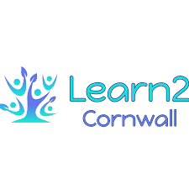Learn2 Cornwall based Nr Madron Penzance
Facebook: https://www.facebook.com/learn2cornwall/
Contact: Kyrstie Mann
T: 07375847764
E: learn2cornwall@gmail.com

If you are a school leaver and are feeling overwhelmed about attending a large college environment why not come to Learn2 Cornwall first as a stepping stone.
If you are nearing the end of education why not let us create a transition2 adulthood programme for you which aims to increase independence whilst working with adult social care to create a seamless transition with new support and daily routines.
We offer an alternative to college where you can gain qualifications, work experience and independence in readiness for the next steps in your life whether it be education, day placements or moving out from home. We work in a person-centred way to try and support young people to access as much as possible.
We offer qualifications from Entry Level 2 meaning we may be able to accommodate learners from Entry level 1 upwards.
Our education offer runs for 3 days per week, however, we can offer 5 day provision by using the additional 2 days per week for enrichment activities.

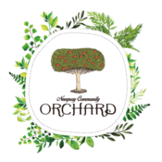Newquay Orchard based in Newquay.
Growing futures 2 yr Programme of study
Facebook: https://www.facebook.com/newquayorchard/
Website: https://newquayorchard.co.uk/
Contact: Gemma@newquayorchard.co.uk

Orchard is all about learning together on a unique journey, developing confidence, knowledge, skills and abilities. It is about learning how to work with others and share enthusiasm for life and the outdoors
Our education programmes aim to help you achieve whatever you want to achieve. Outdoor Education is not always accessible to those with SEND, but education at the Orchard makes learning about our environment accessible to all. As we are based at the beautiful Newquay Orchard, we do not confine ourselves to learning in a classroom (although we do have a lovely one with a wood burner, built by Orchard Volunteers). Our lessons also take place in our Community Grow Space, our Polytunnel and our Wood Workshop and make use of the fascinating biodiversity of the site.

run a programme of study called TOAST (Taking our achievements and successes together.)
For young people 16-24 with an EHCP
Based at two Sites in Redruth and St Austell
Email: https://www.cn4c.org.uk/learning-for-young-people-toast
Contact: Stuart Hood Email: shood@cn4c.org.uk

We offer a range of free courses from Entry Level English, Maths, and IT, to Level 2 and 3 Awards in employability skills and Further and Higher Education Awareness sessions. Our Community Learning courses will enable you to explore a range of topics from mindfulness to creative writing and environmental sustainability, with no prior qualification necessary.

ENRICHMENT ACTIVITIES
For students under 18-year-old with an EHCP, that have been, identified as, needing 5 days provision, County can authorise top up days with certain providers to ensure 5 days provision is available. This is organised by your SEN Caseworker, and you can request this by email.

Arrangements for placements at Independent Specialist Providers. (ISP’s)
Where it is, expected that a learner’s needs, will not be, met at the local college, the CSW Adviser, parents and carer or other agency may wish to research possible Independent Specialist Providers. Some of these, offer day placements or if outside of Cornwall residential placements.
Currently, local authorities have a duty to consider applications for funding places at ISP’s for students with LLD whose needs cannot be met in the local FE colleges.
The main source of information for ISP Colleges is the Natspec directory and website: www.natspec.org.uk.
When a suitable specialist college has, been identified, an assessment is undertaken, at the college and a decision is made by the college about suitability and a place is or is not offered. If a place is, offered the CSW Adviser can support with an application for funding to the Local Authority. Evidence will be needed, to show, that the local sector college has been fully considered, and consulted and the possibility of joint funding with other agencies involved will need to be sought.

ISP Providers in Cornwall: (day placements only)
ROC – Life skills College - based at Boscawen Farm near Blackwater
http://www.roc-uk.org/our-services/education
Contact: Rebecca Vann
E:Rebecca.Vann@unitedresponse.org.uk
T: 01872 560530 M: 07894 751224

Oakwood Court College – Torpoint Campus
http://www.oakwoodcourt.ac.uk
Contact: 01626 864066 Mail: admin@oakwoodcourt.ac.uk

Adult Social Care Services
There will come a time when staying in further education is no longer appropriate for your son/daughter and you may wish to explore services that can support them to develop their independence skills and access meaningful day time activity.
You can request an assessment of need from adult social care due to change in their circumstance.
You can do this online via their website: https://www.cornwall.gov.uk/health-and-social-care/adult-care-services/
Or call 0300 1234 131 and request an adult social care assessment. You will need to explain the reason why. This process can take time and there is usually a waiting list for this. (if you already have a social worker you can approach them direct).
Your Social worker will be able to advise on the types of services that you may be able to purchase below are just some of the centre-based provisions that you may wish to start exploring.
Moorvue Rural Centre
Centre providing land-based support and training.
Contact: Stephen & Nicola Cock Tel: 01736 365491 www.moorvue.co.uk
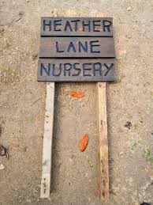Heather Lane Nursery is based at Canonstown near Penzance.
Facebook: https://www.facebook.com/hlnursery
Website: https://www.heatherlanenursery.co.uk/

JOHN DANIELS CENTRE: A council run day services based in Penzance. They offer a range of activities to their service users and will be based on young persons interests and aspirations.
Tel: 01736 368 531

based in Gweek nr Helston
Facebook: https://www.facebook.com/holifieldfarmproject.daycentre.learningdisabilites/
Email: holifieldfarmproject@yahoo.co.uk
website www.holifieldfarmproject.co.uk

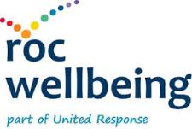 Boscawen Farm Based at Blackwater
Farm based day service offering work experience and training for people with a learning disability.
Website: https://www.unitedresponse.org.uk/roc-wellbeing/
T: 01872 560530 M: 07841205790
based nr. Hayle
Contact: Lynn Roberts
Email: drymvalleycen@aol.com
Telephone: 01736 850707
Website: www.drymvalleycentre.uk

There are many other placements across Cornwall offering a range of vocational experiences in Horticulture, animal care and Catering. See www.Cornwall.gov.uk for further info
Benefits advice:
Disability Cornwall
Disability Cornwall's DIAL helpline will help people with disabilities of any age in Cornwall.

Units 1G & 1H
Guildford Road Industrial Estate
Guildford Road
Hayle TR27 4QZ
e-mail: info@disabilitycornwall.org.uk
W: Disability Cornwall
DIAL helpline 01736 756655
e-mail: dial@disabilitycornwall.org.uk

Special Needs Transport for students in further education
For students that are unable to travel independently on mainstream college transport, the Local Authorities may be able to provide a supported minibus or taxi.
Eligibility
Students must be under 25 years of age on 1 September of the forthcoming academic year. Students must be registered, as full-time students, at a school/special school or college of further education on a course of study for the full academic year of three terms (450 guided learning hours per year).
Transport will expect students to attend their most local college – any exceptions to this, will need to have clear reasons, for choice stated and agreed by Transport.

Length of provision
Students with special educational needs will, be provided with Special Needs Transport for the length of their course, as long, as they are, under 25 years of age.

To Apply
You must complete the post 16 Transport Application Form online and pay the appropriate contribution.
https://www.cornwall.gov.uk/education-and-learning/schools-and-colleges/post-16-transport/

For students 16-19, A contribution, towards Post 16 transport is required. Payment can be by one payment or collected before the start of each term.
Your CSW Adviser can advise on any Learner support funds that may be available to help towards Transport costs.

For students aged 20-25 No Contribution is necessary.

Supporting documents required:
The post 16 Transport department will require supporting documents as evidence that the student requires Specialist transport arrangements and is unable to travel to college by the mainstream bus routes.
Evidence may take the form of letters of support from a doctor, social worker, educational psychiatrist/psychologist, or other professional bodies. Transport will also request proof if you are receiving DLA Mobility.
Once this, has been approved by the Commissioning Team, the Council’s Passenger Transport Unit will usually decide the mode of transport to be provided and whether a passenger assistant needs to be deployed.

The Council will seek to provide suitable transport using the most cost-effective method, utilising public transport (trains and buses), contract buses, taxis and volunteer drivers. If any of these are unavailable or prove unsuitable, a travel allowance maybe offered to students, to make their own way to school/college. The allowance is paid at 25 pence per mile. Transport is, provided to and from the school/college at scheduled times Monday to Friday. Transport will not be scheduled to accommodate each individual student’s course timetable.

