Behaviour and Relationship Policy

To be read in conjunction with the SPT Anti-Bullying Policy

At Pencalenick School and the ARBs our Behaviour and Relationship Policy reflects our understanding of the complex needs of all our learners and how this affects their ability to self – regulate and manage their behaviour positively in order to engage with their learning. We aim to take a holistic, whole person approach to behaviour that encompasses; sensory processing, trauma informed approaches, positive behaviour strategies and appropriate environments. At Pencalenick School and the ARBs we endeavour to build relationships founded upon mutual trust, care and respect with all members of the school community. We want all learners to be proud of belonging to our special school family, for young people to feel safe at school, to develop meaningful relationships, make positive behaviour choices and learn how to self –regulate their emotions and feelings. This policy reflects our understanding of the complex needs of all of our learners and how this affects their ability to self-regulate. This policy will commit to educational practices which Protect, Relate, Regulate and Reflect for all.
Aims
At Pencalenick and the ARBs we have high expectations for all our learners in terms of their ability to learn and every day is viewed as an opportunity to extend knowledge and skills. However, one of the biggest barriers to achieving this may be the learners’ difficulty to self- regulate. Access to the curriculum can be severely hindered for a learner who is emotionally dysregulated. It follows, therefore, that a happy and emotionally regulated learner is more inclined to make progress due to their readiness to learn and engage. We aim to:
- To provide a supportive setting in which learners feel secure and where good behaviour and effort are celebrated.
- To celebrate all positive behaviours and achievements in line with our PSHE Policy.
- To embed strong working relationships with parents and carers to ensure the best outcomes for learners.
- To provide strategies which encourage learners to communicate their feelings in more appropriate ways.
- To ensure that our school environment is calm and informed which improves the quality learning.
- For the learners to develop an awareness and consideration of others.
- To underpin the SPT offer within Spiritual, Moral, Social and Cultural education and through the informed delivery of Promoting British Values.
- To provide consistency of approach to dealing with positive behaviour support through staff training. A large number of our staff have undertaken Team Teach training. We also have school based staff who are trained to deliver Team Teach Training within the SPT.
- To use reflective practice to support behaviour challenges.
- To plan for the use of primary prevention strategies to manage challenging behaviour, in line with the Restraint Reduction Standards (2019).
- To provide a means of systematically recording data associated with positive behaviour management adopted across the SPT.
- To provide a means of securing data associated with positive behaviour management strategies adopted across the SPT, using this to accurately report to Governors/Trustees each term for their scrutiny and challenge.
- To provide a means for multi-agency support for our schools, parents and learners with respect to complex behaviour particularly in relation to be-spoke provision which may include for example sensory profiling or specific diets which informs practice.
- To determine the most suitable learning environment for any learner within a school following close consultation with parents and carers and multi-agency professionals.
- To ensure the safety of all learners/staff within the school.
- To ensure the school remains compliant within its statutory duty under Section 175 or 157 of the Education Act 2002 for safeguarding in promoting the welfare of children.

Trauma Informed Approach
Pencalenick’s aim is to fully understand the learners past life experiences, triggers that affect their lives, emotional situations that they find challenging to self-regulate in and support them through this. We will implement strategies guided by our specialist Trauma and Mental Health Informed Practitioners to support learners who are identified as requiring this additional support. Research suggests that children and young people with Severe Learning Disabilities are more likely to experience a Mental Health need. Our aim is to identify these needs quickly, support the learners in making sense of their experiences, manage emotions and feelings and ensure they maintain the capacity to build relationships despite these difficult events that may have happened to them.
Due to the provision Pencalenick offers, the varying age of learners and their differing needs, we look to use a Trauma Informed style language to support learners through the school day. This will underpin all communication and interactions that staff have with learners across the school will naturally understand the impact of trauma, past and present, on our learners lives.
A Trauma Informed Approach acknowledges evidence-based research within health and the neurosciences that demonstrate a clear correlation between the adversities a learner experiences in childhood and its potentially damaging effects on their later physical health, emotional health and social outcomes.
Trauma-informed practice is not designed to treat trauma related difficulties. Instead, it seeks to address the barriers that those affected by trauma can experience when accessing education.
Our Trauma Informed approach will be delivered through staff interactions that are based on the Protect/Relate/Regulate/Reflect model and will be supported by using the PACE approach - Play Acceptance Curiosity Empathy.
Our Trauma Informed approach identifies a way of relating to pupils that support them to feel safe, this can reduce the need for pupils to enter the fight or flight mode therefore supporting a reduction in anxiety within school.

PACE
- Play – Playfulness, light, open, hopeful and spontaneous.
- Acceptance – Unconditionally accepting of all of the experiences of the learners, so they trust staff not to be judgmental.
- Curiosity – Non-judgmental active interest in how learners experience what happens to them in their lives.
- Empathy – Felt sense of the pupil’s feelings and needs which is actively communicated to the pupils.
Protect
Ensure that all students are greeted warmly in all areas of the school.
Staff trained in ‘PACE’ modes of interaction: warm, empathetic, playful and curious (proven to shift children out of flight/fright/freeze positions).
Staff ensure that interactions with children are socially engaging, warm and inviting.
Focused interventions that help staff to get to know learners better on an individual basis. These relationships are key to enabling children to feel safe whilst in school ensuring all learners have access to an emotionally available adult.
School staff adjust expectations around all learners to correspond with their developmental capabilities and experience of traumatic stress. This includes removing traumatised learners away from situations they are not managing well, providing a calmer, smaller area with emotionally available regulated adult.
Staff to provide a voice for our learners and advocate on their behalf.
Relate
A whole-school commitment to enabling children to see themselves, their relationships and the world positively.
Provide learners with repeated relational opportunities (with emotionally available adults) to make the shift from ‘blocked trust’ (not feeling psychologically safe with anyone) to trust, and from self-help to ‘help seeking’.
Staff trained in empathic and playful modes of interaction. Each class to have a nominated TIS Warrior to ensure good practice is consistent in all classrooms.
Relating with the learner we can show we are listening and seeing their feelings, supporting and recognising the emotions they are experiencing.
Regulate
Relational interventions specifically designed to bring down stress hormone levels (e.g. from toxic to tolerable) following the Motional Snapshot activities and in class experiences enabling them to feel calm, soothed and safe. This is to support learning, quality of life and protect against stress-induced physical and mental illness, now and in later life.
Evidence-based interventions that aim to repair psychological damage caused by traumatic life experiences, through emotionally regulating, playful, enriched adult-learner interactions.
The emotional well-being and regulating of staff is treated as a priority to prevent burnt out and stress related absence, debrief sessions are in place to support post incident.
Reflect
Staff are trained in the art of good listening, dialogue, empathy and understanding.
Time to reflect post incident, to talk about alternatives to their behaviours while still acknowledging the emotion behind them. You can reassure them that you care about them but the behaviour they are exhibiting is not acceptable.
Provide learners with other options, give choices. If you feel like this again you can……...
Provide time to discuss events and situations, this can be done through a social story, books or story sack.
Discuss feelings within the classroom as a daily experience. Talk about experiences others have had.
Identify how it feels to be calm/relaxed, provide learners with opportunities and reflect on the differences they may feel in these moments.
Avoid putting the learner back in the same situation and reliving a trauma. What can I do differently?
Staff to reflect on what was the learner trying to tell me in that moment, what is the behaviour telling me?

Responses from staff
- Affect Attunement – Meet the learner’s emotional intensity (positive or negative) on an energetic level, to connect with the pupil in their pain or joy. Mirroring the same level of energy to build a connection around the trauma and help the pupil understand the feelings and emotion. The pupil will hopefully see this as positive connection with staff helping to build the trusting and emotional available relationship.
- Empathy – Recognition of how the learner is experiencing the event, even if this is very different to how you are experiencing it. Staff won’t dismiss the feeling, they will help affirm, understand and recognise what the learner is feeling.
- Containment – Staff will be able to be in the moment with a learner’s intense feelings without absorbing the emotion and acting upon it. At times this will mean being able to bear the learners pain. Containment is also supported through clear structures to the day, boundaries and actions that are followed through on.
- Emotional Regulation – Bringing down toxic stress to tolerable stress and the moving to states of calm. Soothing and calming the learner’s emotional dysregulated state, will over time, develop effective stress regulating systems in the brain and a more positive feeling through the learner’s body. This can be done through calming conversations, timeout and sensory support/items but in each case will be bespoke to the learner in question.
- Use of Voice and Body Language – In most cases, staff will use a calm and lowered tone of voice when managing behaviour to communicate calmness, safety and empathy to a learner. All staff ensure that their body language is always open and non-confrontational.
- De-escalation strategies – Staff are trained in a range of de-escalation strategies through Team Teach. These include – distraction, re-direction, change of face, use of humour, offering reflection or calming space and time 95%. Only 5% requires physical Interventions (Prompts, Guides, Escorts and Restraints).
- Motional Profiling – To support learners, who are identified, a Motional Comprehensive Snapshot can be created. This provides key staff to have an understanding of areas where support and development are needed, optional activities are also provided. These profiles will be created by staff teams, including parents, working with that particular learner and will also be supported by the Pastoral and Behaviour Lead.

Terminology that’s accepted at Pencalenick:
- Dysregulated
- Unsettled
- Emotional
- Distressed
- Displaying behaviours that are challenging
- Unhappy
- Anxious

Motivators and Consequences
The reinforcing of appropriate behaviours is an essential component in the learning process and enables the development of skills in all areas of a young person’s life. Rewards or motivators are those that are given to a learner after he/she has behaved in a way that gains an adult’s approval. At Pencalenick, rewards are likely to take the form of either an object (e.g. iPad) or an experience (e.g. getting a certificate) and are based on the individual preferences of each individual young person. The practice of removing stars or rewards that have already been earned bears a strong resemblance to punishment, and is therefore incompatible with Pencalenick’s stance on Positive Behaviour Support. It is not acceptable practise for rewards to be revoked.
At Pencalenick School we believe that it is important for our children and young people to clearly link a specific behaviour with its consequences. Therefore, the consequences we use are linked to the presented behaviour’s function and make sense to the young person. For example, if a young person presents with a behaviour of concern because he/she is trying to avoid a demand the adults would wait until the young person is calm and will reinstate the demand. (An example of this could be the reluctance to transition or complete a set work task.) At the same time, consideration will be given on the reason the young person is reluctant to follow this demand and appropriate proactive strategies will be implemented in order to reduce the likelihood of this happening again. In addition, the class team will focus on teaching the young person appropriate functional skills that will enable the young person to achieve the same outcome without having to use a behaviour of concern. The consequences may vary for different pupils in line with their individual needs and the function of their behaviour.
Consequences for behaviours of concern will only be used with students who are at a stage emotionally where they can exercise some control or choice over their behaviour. It is not appropriate to hold a student to account for their behaviour, by implementing a consequence, when they are at an emotional development stage where they operate from the reptilian brain or brainstem when they experience heightened emotions and revert to fight/flight or freeze at these times.
Behaviour Support
At Pencalenick School we define behaviours of concern as any behaviour which:
- reduces the quality of an individual’s life.
- reduces access to learning.
- puts a child or young person at risk (physically or emotionally).
- puts the people around a child or young person at risk (physically or emotionally).

Behaviours of concern may show that:
- the child or young person has needs or wants which they are not able to communicate through other means.
- the child or young person’s medical needs are not being met – they may feel ill or in pain.
- the child or young person is experiencing demands which are too much for them.
- the child or young person is experiencing feelings such as frustration, anxiety, depression or anger.
- the child or young person is overwhelmed by their environment or others around them.
- the child or young person needs more help to understand what is expected of them.
Low-level disruption is addressed quickly to ensure learners’ behaviours do not disrupt lessons or the day-to-day life of the school. If bullying, aggression, discrimination, and derogatory language occur, they are dealt with quickly and effectively.

In judging whether a particular behaviour is a cause for concern adults consider the child or young person’s age and level of development.

Behaviours of concern are categorised into three levels. If a learner presents with a Level Three behaviour or is persistently presenting with Level One or Level Two behaviours a Well-being Plan and a Behaviour Risk Assessment is written. External agency and parent/ carers recommendations are included, where appropriate.
Well-being Plans are individually tailored behaviour plans which outline proactive and reactive strategies, in addition to teaching contextually appropriate skills, developing communication systems and suggestions on modifying the environment to support the young person to learn the necessary skills that will enable them to self-regulate and manage their own behaviour. By colour coding the Well-Being Plans we show the different stages of the behaviour as an individual’s behaviour moves between. All staff are expected to follow the strategies mentioned in the learners’ Well-being Plan consistently in order to support the learners when moving between the different stages of behaviour safely and effectively.
Red Well-being plans and Behaviour Risk Assessments have been shared with and agreed and signed by parents/carers. All wellbeing plans and behaviour risk assessments are shared with parents. Individual Risk Assessment are reviewed yearly across the school but given that they are ‘live’ document, the class teachers in consultation with the Pastoral and Behavioural lead must regularly update them if the behaviours presented change/evolve to ensure a consistent, pro-active approach.

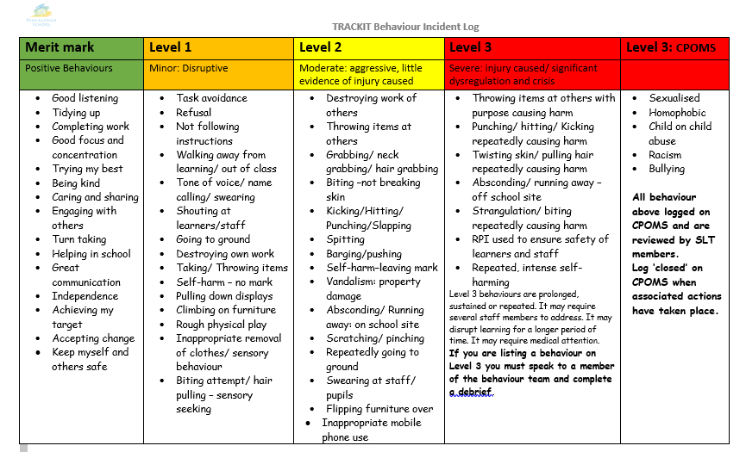
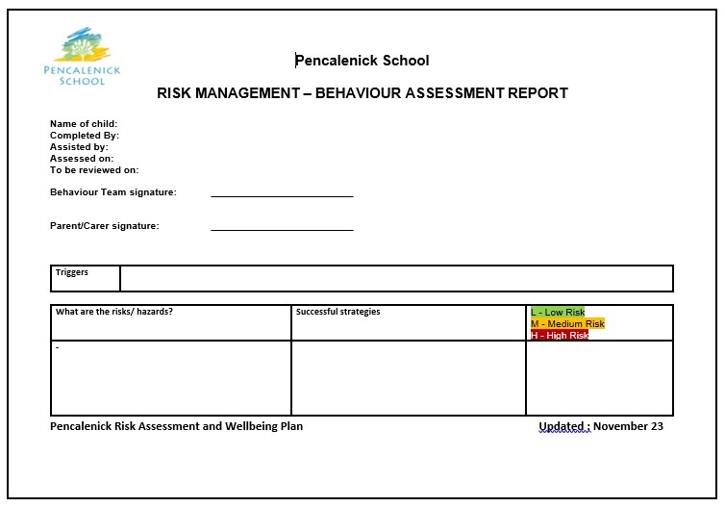
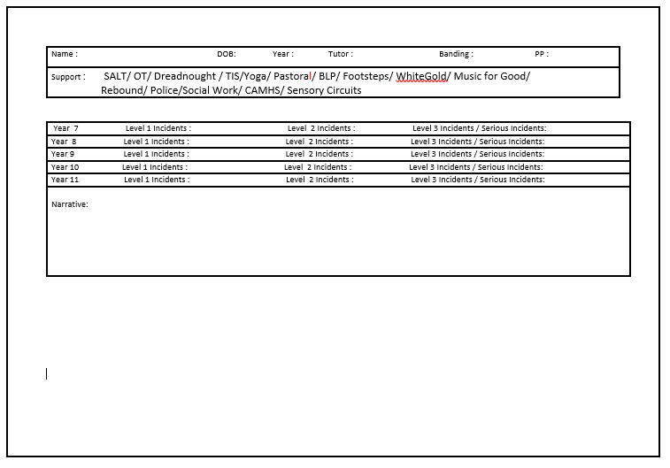
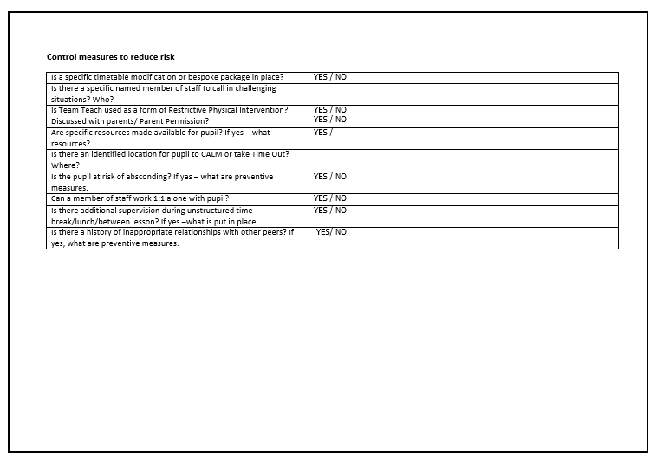
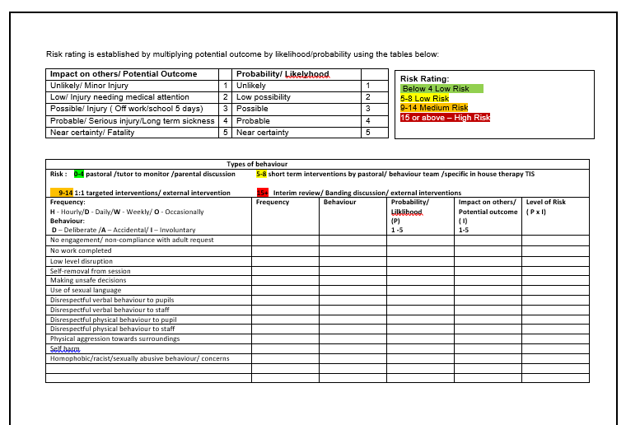
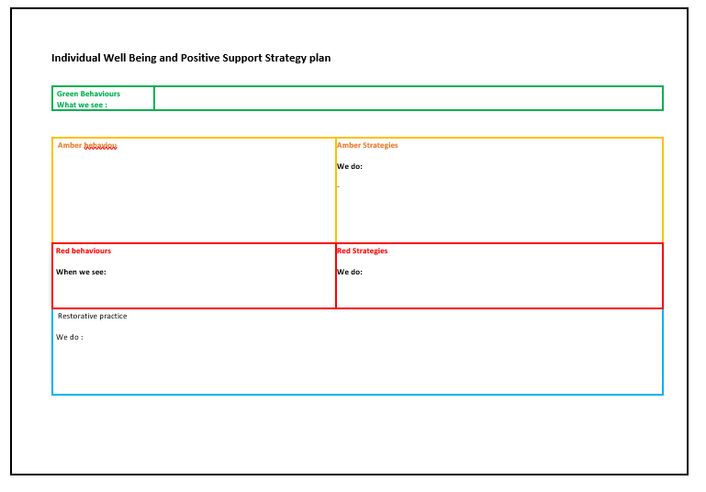

Sensory Processing Difficulties
Sensory Processing is the ability to register, discriminate, adapt and respond appropriately both physically and emotionally to sensory input from the environment. Children and adults living with a disability can often take in and use and process sensory information differently to other people. The way we take in and register, or make sense of sensory information, strongly influences our ability to learn new information, self – regulate, perform activities and to participate in activities with other people.
Staff at Pencalenick and ARBs use differentiated and appropriate strategies to support learners who present with sensory processing difficulties. Multi-agency advice is sought to support learners.
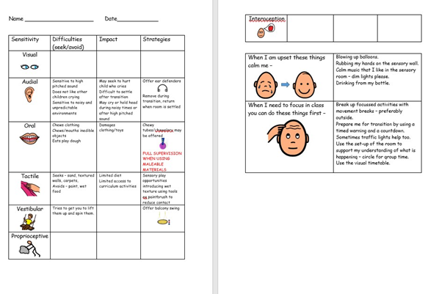
Positive Handling/ Restrictive Physical Intervention (RPI)
At Pencalenick School excellent relationships between staff and learners are vital. It must be recognised that due to the nature of the learning difficulties presented by some of the learners who attend Pencalenick School that the use of physical interventions are on occasion, necessary. However, no intervention is used unless it demonstrably considers the welfare of the pupil, it is in their best interest, is proportionate and balances the rights of both staff and learners. We believe there is a clear distinction between physical contact, restrictive and non-restrictive physical intervention. None of these methods are used as sanctions or punishment or as a response to staff shortages.
Physical Interventions may include:
- Prompts – This is the lowest form of using force to control a person behaviour.
- Guide – Moving someone forward but they have the ability to leave.
- Escort – The person is unable to leave you because you are holding them. The person is complying. It may be moving a person from point A to point B to keep them safe.
- Restraint – Physical control with the application of reasonable force with the intent of overpowering the person.
As the safety and wellbeing of all staff and learners is paramount, staff should always first give consideration to both their own safety and that of others as well as remember that we only ever use the minimum level of force needed to restore safety and care. The guiding principles relating to the use of reasonable force are as follows:
- It is an act of care and control, not punishment. It is never used to force compliance with staff instructions.
- Staff must take steps in advance (proactive and reactive strategies) to avoid the need for the use of reasonable force through dialogue and diversion and at the level of understanding of the child or young person in a person centred approach.
- To prevent severe distress, injury, or damage, only the minimum force for the shortest amount of time will be used.
- After an incident, staff will be able to show that the intervention used was in keeping with the learner’s individual Wellbeing Plan and Individual Risk Assessment or the Trust’s Behaviour Policy.
- Every effort would have been made to secure the presence of other staff, and these staff may act as assistants and/or witnesses.
- As soon as it is safe, the restrictive physical intervention will be relaxed to allow the pupil to regain self-control.
- Procedures are in place for supporting and debriefing pupils and staff after every incident as it is essential to safeguard the emotional well-being of all parties involved.
- A distinction will be maintained between the use of an emergency intervention, which is appropriate to a particular circumstance, and the use of planned intervention. (See below)
- Senior leaders and staff are aware of Restraint Reduction Network Standards (2019) and understand that any restrictive intervention must be based on an assessment that intervention is likely to cause less harm than not intervening.

Emergency Restrictive Physical Interventions (RPI) – An emergency RPI may be employed in response to an incident requiring a rapid physical response (for example a child running on to a road). In such circumstances the ideas of a duty of care and reasonable, proportionate and necessary actions must remain paramount. Staff should use the minimum force for the shortest amount of time to maintain safety, consistent with the Team Teach training they have received.
Planned Restrictive Physical Interventions (RPI) – Involves a planned RPI being employed by staff in response to an identified behaviour when all other strategies have been unsuccessful and the learner is posing a significant risk to him/herself and/ or others. They should be described in writing (in the Well-being Plan), in advance, by the class teacher and shared with the behaviour lead and class team and, as far as possible, agreed and signed by parents/ carers. The identified strategies are based upon the individual behaviour risk assessment and are recorded on the Well-being Plan. All incidents of restrain must be recorded on the behaviour monitoring system as soon as possible. A debrief must be completed by a member of the senior team or behaviour support team within 24 hours.
Sometimes, when faced with extreme behaviour, the judgement may be that by becoming physically involved the member of staff will increase the risk of somebody getting hurt. In this case the correct decision may be to support the young person into a safe space and give the learner time and space to regain self-control. At this point, the staff must decide on the most appropriate course of action which is to make the environment safe, remove the audience, take vulnerable children to a safer place, remove all potential hazards and weapons, ensure that colleagues know what is happening or get help. The chosen actions should always be designed to reduce the risk to others and to yourself.
The Education and Inspections Act (2006) states that:
All members of school staff have a legal power to use reasonable force. This power applies to any member of staff at the school. It can also apply to people whom the headteacher has temporarily put in charge of pupils such as unpaid volunteers or parents accompanying students on a school organised visit. Reasonable force can be used to prevent pupils from hurting themselves or others, from damaging property, or from causing disorder.
In a school, force is used for two main purposes – to control pupils or to restrain them.
The decision on whether or not to physically intervene is down to the professional judgement of the staff member concerned and should always depend on the individual circumstances.

The following list is not exhaustive but provides some examples of situations where reasonable force can and cannot be used.
Schools can use reasonable force to:
• remove disruptive children from the classroom where they have refused to follow an instruction to do so;
• prevent a pupil behaving in a way that disrupts a school event or a school trip or visit;
• prevent a pupil leaving the classroom where allowing the pupil to leave would risk their safety or lead to behaviour that disrupts the behaviour of others;
• prevent a pupil from attacking a member of staff or another pupil, or to stop a fight in the playground; and
• restrain a pupil at risk of harming themselves through physical outbursts
Education and Inspections Act (2006)

Members of staff will not be expected to undertake the use of reasonable force without knowledge of the school’s policy. Our current, chosen Accredited Training organisation in Positive Behaviour Management & Physical Interventions is ‘Team Teach Ltd’.
Pencalenick School acknowledges that physical techniques are only a part of a whole school approach to behaviour management and Team Teach emphasises the importance of diversion, de-fusion and de-escalation. It provides a gradual, graded system of response.
Training will be regular (according to evidenced risk assessment, both formal [re-accreditation] & informal, according to need) and in line with the Team Teach code of practice. Untrained staff are not expected to engage in restrictive physical interventions with learners except in an extreme emergency when the health and safety of others would seriously be put at risk by a failure to do so.
Pencalenick School acknowledges that restrictive physical techniques are only a small part of a whole school approach to behaviour management.
Team Teach describes a broad range of risk reduction strategies. It is a holistic approach involving policy, guidance, management of the environment, and deployment of staff. It also involves personal behaviour, diversion, de-fusion and de-escalation techniques.
The physical techniques are intended to reduce risk and Team Teach techniques always seek to avoid injury. Any injury will be reported using the appropriate accident form. In some circumstances, following the use of more restrictive holds, it is acknowledged that learners may encounter some minimal discomfort when appropriate release techniques are used. However, this is very brief and transient and poses less of a risk than the behaviour they are employed in response to.
Complaints and Allegations
The availability of a clear policy about the use of reasonable force, should reduce the likelihood of complaints but may not eliminate them. If any staff have experienced another member of staff using ‘unacceptable use of force’ and banned techniques they must report this to the Head Teacher as soon as possible.
Where a complaint or allegation is made, the school will follow the Local Authority protocol. For further information, please refer to the SPT Complaints Policy and the SPT Whistle Blowing Policy.

Safe Spaces
As part of our continuum of provision to help learners develop their skills within managing their own behaviour Pencalenick School have ‘safe spaces’. These are spaces designed as a place of retreat for those pupils who require a period of quiet time where they can regulate if they are feeling overwhelmed by the classroom environment. When using the safe spaces the learner is observed and/or accompanied by a member of staff. If rooms are used they are resourced with games and equipment to promote a relational approach to regulation and behaviour support. Learners are regularly joined by one or two other learners in these spaces to complete short group activities. The rooms are not used as seclusion rooms.
If, in the event a learners’ behaviour is becoming particularly complex and they are starting to pose a risk to themselves or others within the school, they may be re-directed to one of the safe space rooms. Pencalenick School acknowledges that any use of a safe space could be viewed as seclusion if a pupil is taken or directed there for this reason. Any learner who requires a safe space due to challenging or disruptive behaviour has a Wellbeing Plan in place which states the reason for use. These plans are checked by the SLT for compliance according to the protocol and DfE guidance in using safe spaces. Safe spaces are not used within any school as a way of planned confinement of pupils. The pupils are always alongside an emotionally available adult who will remain with them to support them to regulate and calm. Further information can be found in the SPT Behaviour Policy.
Debrief – see procedure APPENDIX A
Following a Level 3 incident staff and learners will meet with a member of the behaviour support team, within 24 hours, for a debrief. A record of the debrief will be kept in the behaviour monitoring folder. It may not be appropriate for the learner to be involved in the debrief process, post incident. If this is the case a member of staff who knows the learner well, or the parent/carer can complete the form with a member of the behaviour support team. If a member of staff has been hurt they will be supported, away from the classroom, for as long as necessary. All injuries, staff or learner, requiring hospital/GP attention are logged on Assess Net. Learner Behaviour Risk Assessment and Well-being plans are reviewed, and updated if necessary, following an incident. All Level 3 behaviours are reviewed and discussed at bi-weekly safeguarding meetings. Level 3 behaviours are reported to governors, via the Headteacher’s report, on a termly basis.

Exclusions
We do not believe that exclusion is the most effective way to support our learners and we will always try to adapt and personalise the provision for all of our learners in order to ensure that they are able to access education. However, in extreme and exceptional circumstances, the Head teacher may need to exclude a pupil temporarily or permanently - this will be considered very carefully. It is also possible for the Head teacher to convert a fixed-term exclusion into a permanent exclusion, if the circumstances warrant this. Safe conduct by learners is essential to ensure that all pupils can benefit from the opportunities provided by education. This is essential when safeguarding the most vulnerable students. All behaviours incidents that potentially warrant an exclusion are discussed by the Headteacher with the CEO of the Special Partnership Trust before finalising this decision and informing parents, as per the Special Partnership Trust Behaviour Policy and Exclusion Policy.
A decision to exclude a learner permanently from Pencalenick School is only be used as a last resort and will be taken only if
- there is a significant risk to themselves or others or
- allowing the learner to remain in school would seriously harm the education or welfare of the learner or others in the school.
- allowing the learner to remain in school would put employees at risk.
- in response to a serious breach or persistent breaches of the school's behaviour policy;
The reasons below are examples of the types of circumstances that may warrant a suspension or permanent exclusion. This list is non-exhaustive and is intended to offer examples rather than be complete or definitive.
- Verbal abuse or threatening behaviour against a pupil
- Verbal abuse or threatening behaviour against an adult
- Use, or threat of use, of an offensive weapon or prohibited item that has been prohibited by a school’s behaviour policy
- Bullying
- Racist abuse
- Abuse against sexual orientation or gender reassignment
- Abuse relating to disability
- Persistent breach of Law
- Physical assault against a pupil or an adult
Where learners are at serious risk of exclusion, the Local Authority and all relevant external agencies will be involved and an urgent meeting will be called. Exclusion will be the last resort after all other steps have been exhausted.
For further information, please see the Special Partnership Trust Behaviour Policy; Cornwall Council Exclusion from school policy; DfE Exclusion from maintained schools, Academies and pupil referral units in England - A guide for those with legal responsibilities in relation to exclusion.

Rewards
Developed with the pupil parliament/ wellbeing champions:
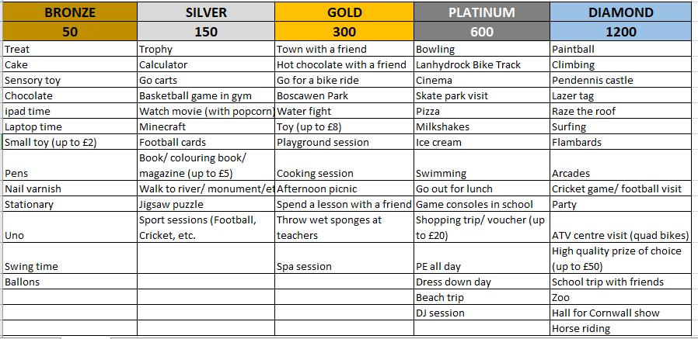

Legislation
This policy takes into account relevant legislation, regulations and guidance including the most recent publications from the Department for Education, Department of Health and the Health and
Safety Executive. This policy is also based on the special educational needs and disability (SEND) Code of Practice and the Safeguarding and Child Protection Policy/Keeping Children Safe in Education).
The principal legislation to which this guidance relates is:
- the Education Act 2002, as amended by the Education Act 2011;
- the School Discipline (Pupil Exclusions and Reviews) (England) Regulations 2012;
- the Education and Inspections Act 2006; • the Education Act 1996; and 7
- the Education (Provision of Full-Time Education for Excluded Pupils) (England) Regulations 2007, as amended by the Education (Provision of Full-Time Education for Excluded Pupils) (England) (Amendment) Regulation
- Suspension and Exclusion Guidance: changes September 2023
- Sexual Offences Act 2003

Self-stimulating behaviour – see support plan and terminology Appendix B
Masturbation is defined as the touching and stimulation of your own genitals for sexual arousal and pleasure. Masturbation is a common human behaviour and having a learning disability doesn’t switch that behaviour off. Masturbation can often, but not always, lead to someone experiencing an orgasm. It is normal for children to touch and explore their genitals from a very young age. However, most people report that they start to masturbate for pleasure when they are going through puberty. A poor understanding of and compliance with social and legal rules about public masturbation and inappropriate touch can significantly limit a person’s freedom and social interactions. If someone masturbates in public places it is reasonable to conclude that they won’t be allowed independent unsupervised access to public place where other people may see them masturbating. Therefore, allowing inappropriate masturbation can seriously curtail a person’s freedom and growth towards independence. Behaviours learned or allowed to develop when a person is young can last a lifetime. Dealing with masturbation in a timely manner can mean that a person with learning disabilities can experience sexual pleasure in private, and not put other people in harm’s way. They can then experience freedom and social interactions without being labelled as someone who engages in inappropriate sexual behaviour.
PSHE (including Relationships and Sex Education) at Pencalenick School forms an integral part of our whole school curriculum offer that aims to provide our learners with the necessary knowledge, skills and attitudes to lead healthy, happy and safe lives. It is important that young people are taught and understand the ‘rules’ around appropriate behaviour. We recognise that our students have unique needs and challenges and we aim to address these through a tailored, inclusive and well-organised Relationship and Sex Education (RSE) Curriculum. We have specified Safeguarding units mapped out for our R2L learners through the NSPCC Speak Out/Stay Safe programme. There are also opportunities built in to the curriculum for responsive RSE. Within classes or phases that are concerning or sexualized in nature, teachers have the opportunity to plan RSE sessions to support learners with these issues
Being able to masturbate is a human right. The right to be sexual is enshrined within the Human Rights Act (1988). Everyone has the right to masturbate in private. Our right to masturbate can only be intervened with if we negatively impact other people. The Sexual Offences Act 2003 sets clear guidelines around masturbation and public spaces. This also applies to people with learning disabilities. There is no minimum legal age at which you can masturbate on your own and in private, as UK law only looks at sexual behaviour that involves or affects other people. A private place could be a bedroom at home (if not shared by anyone else), or a bathroom at home. The following are not private places: Toilets at school/college/work; Shared bedrooms; rooms labelled ‘Private’ (for example private office spaces); Public toilets; Family rooms at home; Anywhere a person could be seen or heard.
Self-touch can be undertaken for a variety of reasons that have nothing to do with sexual gratification. Sometimes physical conditions or sensory needs that are not about sexual arousal can be missed because it is presumed that the touch is sexual or primarily sexual. Sensory needs are common with people with autism and/or learning disabilities. Sometimes masturbating can be fulfilling a sensory need rather than a sexual need. This is normal and shouldn’t be discouraged but the same rules about appropriate masturbation in public and private will still apply; and it is not acceptable to do this in school or any other public place.
If a learner masturbates or touches their genitals in school, support is likely to include the following:
- Conversation with parent/ carer. Discussion around the most appropriate support based on the individual need of the child/young person.
- School based support. For example visuals or social stories alongside targeted RSE lessons.
- Referral to external professional eg OT or CAMHS to request intervention support. This is likely to be in the form of a Self-Stimulation Support Plan. A self-stimulation support plan will focus on the Childs self-stimulation behaviour and set out clear strategies for staff and home while being a person centred response to individual needs. The plan will aim to mitigate risk and ensure best practice approach to supporting the young person. The plan should be developed by the team around the child and include primary care givers when possible. This will promote a consistent approach to supporting the child. A support plan should be written in the first person when a person with learning disabilities has direct input into their plan, or they can be in third person if it gives information about them. The plan will include; Description of the behaviour; Triggers for behaviour; Interpretation of the behaviour; Risks of the behaviour.

Infectious Diseases/ Pandemics
During a pandemic or infectious disease outbreak or upon up to date national or local health advice, if a learner’s behaviour is deemed high risk, whether this is deliberate or not, and it puts both them, other learners and the staff at risk, the following steps could be taken:
If the behaviour is a deliberate attempt to use an infectious disease as a weapon, such as spitting or coughing in other’s faces, refusing to follow safety measures such as a hand washing, social distancing, then the parent/carer would be expected to collect the learner and a fixed term exclusion may be applied in line with Exclusion guidance.
Where the behaviour is not a deliberate act but a consequence of sensory seeking, communication, or anxiety related behaviour, which also puts themselves and others at risk of increased exposure to
COVID, then the following steps will be followed
- Communication with the family regarding what the cause of the behaviour may be
- Support within school and with the family to reduce the behaviours
If every attempt has been made to reduce these behaviours and the learner’s behaviour remains unsafe, putting themselves or other’s at risk, then the school will have no choice but ask the parent/carer to collect the learner on the grounds of Health and Safety.
The learner will be offered remote provision until such a time as on site provision can safely be resumed.
We will work with the family, the Local Authority and any relevant external agencies to support their successful reintegration into on site provision.

Date of Last Review: January 2026
Date of Next Review: January 2027

APPENDIX A
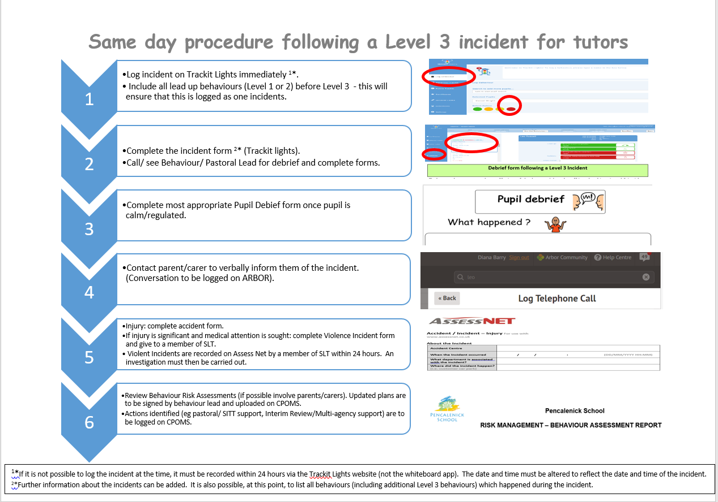
Incident Log for Level 3 Behaviour
To be used in the event of a Level 3 Behaviour occurring to ensure actions have been reviewed and noted down. A member of the behaviour team should be informed and this form needs to be completed within 24 hours of the incident.
To be completed by a member of staff present at the incident
Date of Incident
Location of Incident
Has it been recorded on Trackit | Yes / No |  | Who By
Name/s of staff involved |  |  |  |  |  | Have they had a debrief |  |  | Yes / No
Name/s of learner/s involved |  |  |  |  |  | Have they had a debrief |  |  | Yes / No
Brief Record of Incident
Witnesses/Observer
Injuries occurred by staff |  |  |  |  | Recorded |  |  |  | Yes / No
Injuries occurred by learner |  |  |  |  | Recorded |  |  |  | Yes / No
This section to be completed by a member of the Behaviour Team
or the class Tutor if it is a Class Debrief
Meeting/Debrief/Review
(Same Day)

What needs to be investigated? |  |  |  |  | Who is it allocated to
What needs to be changed? RA/Policy/Well-Being Plan
Has the incident been shared with parents/carers | Yes / No | Time |  | Who made the phone call
Name/s of person completing the form |  |  |  |  |  |  | Date

Debrief form following a Level 3 Incident

To be used to support the wellbeing of the learner(s) and staff involved in a Level 3 incident and to look at strategies to reduce the possibility of the incident happening again. A member of the Senior Leadership Team must be informed and be part of the debrief, within 24 hours of the incident occurring.
Please refer to the learners Individual Risk Assessment and Well-Being Plan.
Class | Staff |  | Learner(s)
Please complete as appropriate
Date and Time of Incident | Staff Injury |  | Learner Injury
 | Y/N |  | Y/N
Learner Wellbeing
Concerns |  | Actions
Staff Wellbeing
Member of the Behaviour Team
Name: |  | Signed:
Date: |  | Time:

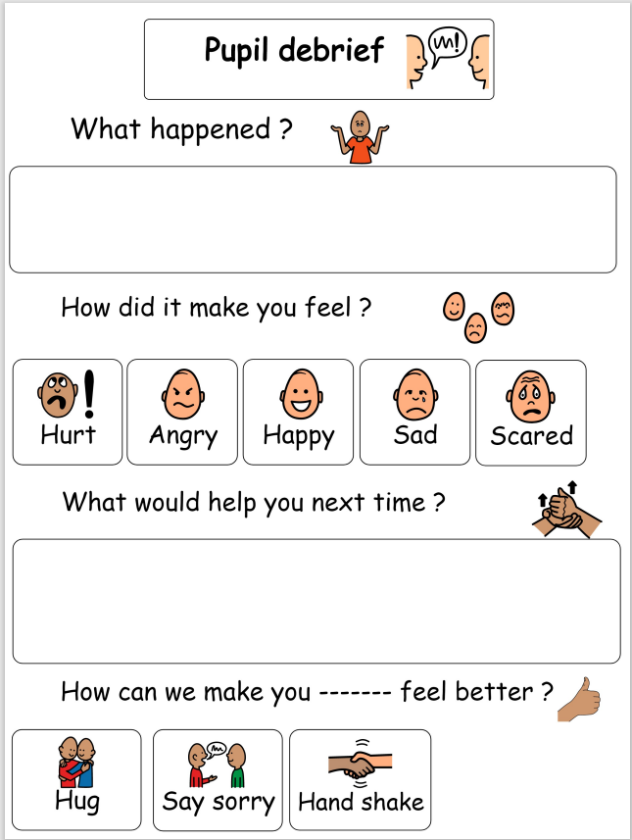

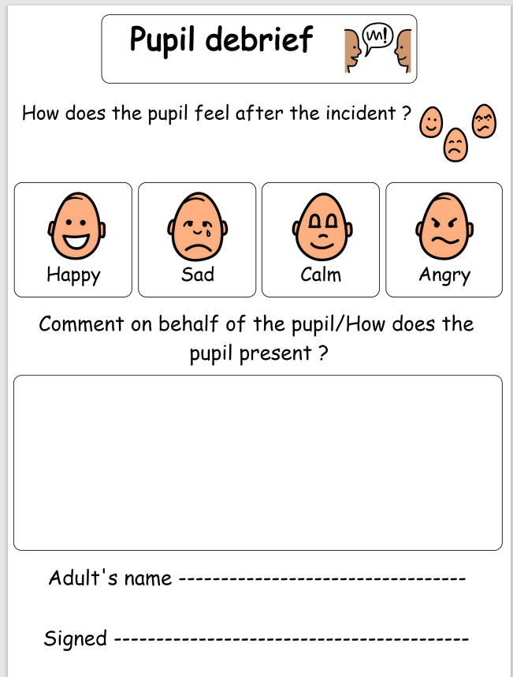

APPENDIX B
Symbols
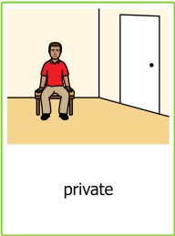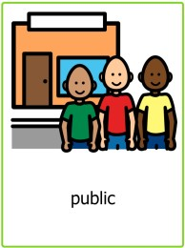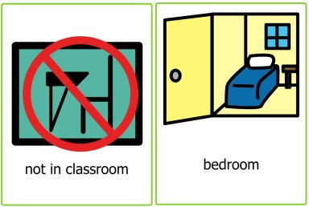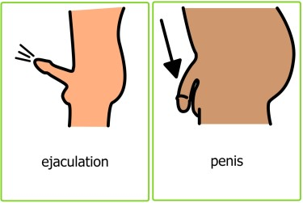

Terminology Used
- Hands up/out
- Private time at home
- Public/ Private
- Save for your bedroom
- Stop/No
Redirection Support Plan
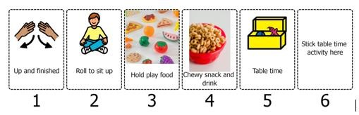
Social Story
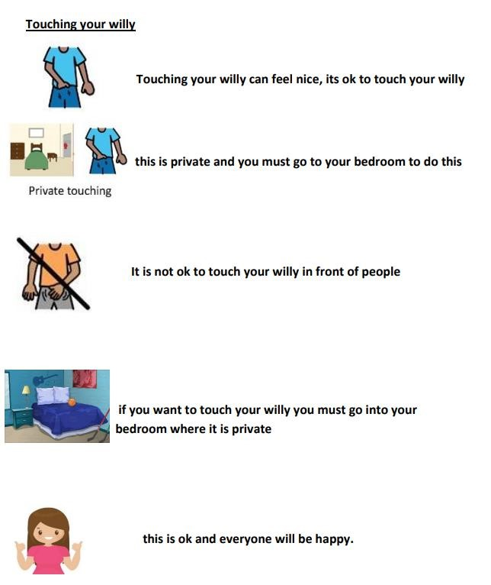
Persistent masturbation/self-stimulation in school could result in a young person being sent home from school. The reason could be that they are unfit for learning due to an unmet physical and/or sensory need, or they have met the criteria for the SPT’s exclusion policy.

