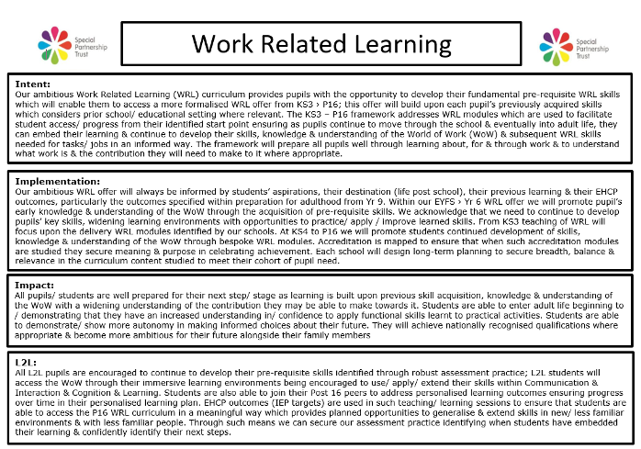

WRL Curriculum - Breadth of Study

INTENT
To provide pupils with the opportunity to develop their fundamental pre-requisite WRL skills which will enable them to access a more formal WRL offer from KS3 › P16; this offer will build upon each pupil’s previously acquired skills which identifies the need to consider prior school/ educational setting where relevant. Where pupils have come from different educational settings, particularly at Key Stage 3, schools may identify the need to address learning outcomes at an earlier stage, therefore addressing the ‘end points’ identified within EYFS › KS2 to ensure pupils are well-equipped for their next stage; this aspect will be reflected in their school implementation of this offer. For our remaining schools’, skills identified within EYFS › KS2 would be addressed via the curriculum areas of English, Maths, PSED & Citizenship. The acquisition of essential skills will therefore help prepare pupils well for their next stage in Key Stage 3 including the Preparing for Adulthood Outcomes identified via the EHCP process where our formal planned teaching of WRL begins. The KS3 › P16 framework addresses bespoke WRL modules which are used to facilitate student access/ progress; the framework builds upon previous learning ensuring as pupils continue to move through the school & eventually into adult life, they continue to develop their WRL skills in an informed way building upon skills acquired. The framework will prepare all pupils well in getting to know about the world of work, understand what work is & the contribution they will need to make to it where appropriate. Each school will use their school-based Gatsby/ Compass benchmark outcomes achieved via their self-evaluation framework to further strengthen this collective offer implementing identified development points accordingly.
EYFS › Year 6 | KS3 | KS4 › P16
Rationale/ ‘end points’:  Within our EYFS › Yr 6 WRL offer we will promote pupil’s early knowledge & understanding of the World of Work (WoW) through the acquisition of pre-requisite skills acknowledging that our children develop at their own rates, & in their own ways. ‘End points’ identified will address the fundamental skills which will enable our young people to complete a task/ given job. Skills identified will encourage them to develop a sense of responsibility in the part they play in completing a job & through effective self-assessment which enables them to identify what comes next/ how to improve.  To provide planned opportunities woven through the school day/ week to help pupils develop the key skills needed to prepare them well for their next stage (formal teaching of WRL); our work identifies ‘end points’ which help pupils develop their confidence to:  - try new activities/ say what they like  - speak about their ideas/ expressing their likes/ dislikes  - select equipment needed a task/ job  - organise themselves in their work  - seeks help accordingly  - completes a given activity/ job which is familiar to them  - tries a new job/ transfers learned skills  - demonstrate greater self-confidence & self-awareness  - persevere with less familiar tasks  - form positive relationships/ interactions developing a respect for others  - develop social & interaction skills working cooperatively with others  - recognise their own success & that of others  - recognises the contribution they can make as part of a bigger group | Rationale/ ‘end points’:  We acknowledge at KS3 we are beginning to prepare students for their Yr 9 review where ‘Preparing for adult hood outcomes’ will be discussed/ agreed. We acknowledge that we need to continue to develop students’ key skills building upon previous skill acquisition/ embedding knowledge, widening learning environments with opportunities to practice/ apply / improve learned skills. Formal teaching of WRL will focus upon the delivery of bespoke SPT WRL modules identified via our LT planning framework (see below) which identifies ‘end points’ aimed at furthering students’ skills to:  - state & explain likes/ dislikes in relation to aspirations/ interests  - select/ describe jobs they would enjoy  - begin/ know how to apply/ adapt skills learned to problem solve  - keep trying when things go wrong  - seek help/ assistance where necessary / complete a familiar job  - work cooperatively/ values the effort of others/ the team  - begins / knows how to plan ways they can gather information in relation to interests/ aspirations  - identify roles/ responsibilities & the positive part they play in completing a task | Rationale/ ‘end points’:  At KS4 > P16 we will promote students continued development of skills, knowledge & understanding of the WoW through identified ‘end points’ to assist & inform their choice making which further develops their personal autonomy & independence in relation to their future post school: Students will be encouraged to build upon previous skill acquisition/ embed knowledge to:  - know & plan what they need to do to work towards their aspirations/ interests  - know what jobs/ type of jobs interest them & the skills they have developed towards these jobs  - understand how to use/ know what skills are needed within different jobs to complete tasks/activities  - know when things have gone wrong but know what they need to do/ how to get help to complete a job/task  - understand their part within a team & the importance of working together  - know where to get information & what to do with the information to support their interests & aspirations  - understand the importance of different roles & responsibilities for themselves & others in completing a job/task effectively
IMPLEMENTATION - Depth of Offer
Our depth of offer will consider the age/ needs type of pupils to ensure we uphold the aims of our inclusive school offer
Within our primary provision all classes will have identified class based routines which promote the independence of pupils when undertaking tasks/ jobs acknowledging the active contribution they can make to such tasks/ jobs that are familiar to them – e.g. – helping gather items for drinks/ snack time, helping to take the school register back to the central office etc
All staff will promote WRL opportunities throughout the school day which includes off site visits using all environments to promote pupil’s developing skills, knowledge & understanding required for people to successfully access the WoW – e.g. – discussing the role of builders when walking past building sites & the skills they have needed to learn which enables them to undertake the job etc, therefore, the delivery of WRL becomes immersive & remains immersive throughout the time pupils spend within our schools
Each school will identify via their Long Term Planning framework the delivery of their school-based scheme of work which will be formally delivered from KS3 acknowledging within this scheme if pupils have received their primary age education in another setting; as such these schools will ensure pupils have the pre-requisite skills to build on developing their WRL skills accordingly through bespoke WRL lessons
The SPT Careers offer will enhance the WRL offer utilizing the careers framework adopted by the Trust; this is further informed via the school self-evaluation & development of the Gatsby/ Compass outcomes
Schools will work with the Enterprise advisors allocated to the schools to identify WRL opportunities, using information obtained via the EHCP process where students aspirations/ interests are identified which ensure we use such information accordingly within their personalised school

offer
EYFS → KS2 | KS3 | KS4 → P16
- class based routines  - curriculum offer – interest led - EYFS/ KS1 & 2  - employer encounters (identified via LT planning/ subject specific areas)  - literacy (fiction/ non-fiction)  - effective child/ adult interactions  - participation in/ access to whole school events | - class based/ school-based routines  - explore/ experience the world of work via  - SPT bespoke WRL modules – WoW – modules 1, 5, & 2  - workplace visits made employer encounters (identified via LT planning/ subject specific areas)  - career focus weeks/ days, enterprise education  - participation in/ access to whole school events  - Access to training providers (CEIAG) including county events  - *EHCP outcomes Yr 9 | - SPT bespoke WRL / WoW modules  - World of Work  - Pathways to work  - Skills for work  - Safety at work  - Preparing for work  - Business & Enterprise for work  - Practical skills for work  - My world of work experience  - workplace visits made employer encounters (identified via LT planning/ subject specific areas)  - Access to training providers (CEIAG) including county events  - Transition planning - CSW  - *EHCP outcomes Yr 10 - 14  - Accreditation modules/ qualifications

