Pupil premium strategy statement 2024 - Pencalenick School
This statement details our school’s use of pupil premium (and recovery premium) funding to help improve the attainment of our disadvantaged pupils.
It outlines our pupil premium strategy, how we intend to spend the funding in this academic year and the outcomes for disadvantaged pupils last academic year.

School overview
Detail | Data
Number of pupils in school | 198
Proportion (%) of pupil premium eligible pupils | 53.5%
Academic year/years that our current pupil premium strategy plan covers (3 year plans are recommended) | 2022 - 2025
Date this statement was published | Updated July 2024
Date on which it will be reviewed | July 2024
Statement authorised by | Jodie Watkins-Young
Pupil premium lead | Jodie Watkins-Young
Governor / Trustee lead | Stewart Defriend

Funding overview
Detail | Amount
Pupil premium funding allocation this academic year | 103,188
Recovery premium funding allocation this academic year | N/A
Pupil premium (and recovery premium*) funding carried forward from previous years (enter £0 if not applicable)  *Recovery premium received in academic year 2021 to 2022 can be carried forward to academic year 2022 to 2023. Recovery premium received in academic year 2022 to 2023 cannot be carried forward to 2023 to 2024. | £0
Total budget for this academic year  If your school is an academy in a trust that pools this funding, state the amount available to your school this academic year | 103,188

Part A: Pupil premium strategy plan

Statement of intent

Preparing our pupils for a full, interesting and productive life at Pencalenick and beyond.

Pencalenick is a school for pupils who have an Education, Health and Care Plan, which identifies a need for specialist provision. Our intent is to ensure that pupils access a wide range of opportunities, as well as clear pathways to the most appropriate accreditation for each individual. All school activity is built upon the need to make learning purposeful and meaningful for our lifelong learners. We systematically aim to reduce barriers to learning identified in their EHCPs, allowing the young people to develop confidence, independence and resilience to be fully participative in their lives.

At Pencalenick School we have high aspirations and ambitions for all of our pupils. Whilst our strategy is focused on the needs of disadvantaged pupils, it will benefit all pupils in our school where funding is spent on whole-school approaches, such as high quality teaching. Our data, currently and historically, shows that disadvantaged pupils make as good as or better progress than their peers, so our aim is to use pupil premium funding to achieve and sustain positive outcomes for all.

This plan outlines how we intend to use evidence-informed approaches to achieve the best possible outcomes for pupils by using allocated funding to:
- Ensure that teaching and learning opportunities meet the needs of all young people.
- Develop enrichment opportunities and community links to support pupils’ achievement, resilience, safety, well-being and aspirations.
- Identify and implement specific opportunities and interventions to ensure pupils’ readiness for learning, engagement in learning, and preparation for adulthood. These interventions need to be highly pupil lead and include support for emotional development, behaviour, sensory needs, as well as academic progress.
- Develop specialist resources and specialist staff knowledge to support pupils who have special educational needs in all aspects of their development.

Our strategy is driven by the needs and strengths of our pupils, based on formal and informal assessments. This will help us to ensure that we offer each young person the skills and experience they require to be prepared for the next phase in their education.

Challenges
This details the key challenges to achievement that we have identified among our disadvantaged pupils.
Challenge number | Detail of challenge
1 | All pupils have complex learning needs and have had varied experiences dependent on their background. Each individual pupil has unique circumstances, but many have significant difficulties with social interaction and communication, which present as behaviour challenges.
2 | Our on-going review of the curriculum offer and the need to develop a new assessment framework has led us to review the English curriculum. We have identified that the curriculum requires further development, particularly in the areas of reading and phonics, and handwriting.
3 | Through observations and conversations with pupils and their families, we find that disadvantaged pupils generally have fewer opportunities to develop cultural capital outside of school. School covers a wide geographical area, which presents challenges in developing cultural capital and sustaining parent partnership.
4 | Social, emotional, mental health and complex needs, including attachment, impact on pupils’ ability to be learning ready. Conversations with pupils and their families, and data collected from the Emotional Well-being scale, show that many pupils have a low self-esteem and poor sense of self-worth in their communities.
5 | Many of our pupils have significant sensory processing difficulties and often struggle to regulate their own sensory inputs. This can lead to emotional and behavioural challenges in and out of school.

Intended outcomes
This explains the outcomes we are aiming for by the end of our current strategy plan, and how we will measure whether they have been achieved.
Intended outcome | Success criteria
1 Support pupils in developing their communication skills in line with their developmental needs. Improved access to inclusive and bespoke communication systems to aid pupils’ understanding and develop their expressive communication skills. | Achievement of EHC plan termly outcomes (Communication and Interaction).  EFL effectively used to demonstrate impact – linked to EHCP outcomes.  Pupils develop their ability to engage in shared activities and communicate their wants and needs to a familiar adult.  Feedback from staff and parents of an improvement in language and communication across a range of settings.  Effective use and deployment of AAC.
2. Improved attainment for pupils in reading and writing, relative to their starting points as identified through baseline assessments. Improved language comprehension will increase independence and enhance attainment progress in all subjects. | Achievement of EHC plan termly outcomes (Cognition and Learning).  EFL effectively used to demonstrate impact – linked to EHCP outcomes.  Pupil engagement in Accelerated Reader across the school.  Pupils make additional progress in relation to their reading in standardised objective testing.  Achievement of improved performance in literacy, as demonstrated by our termly and end of year assessments.  Disadvantaged pupils demonstrate progress in line with their peers.
3. Pupils have greater independence and confidence within the wider community in preparation for adulthood. Opportunities for pupils to access a range of broad and balanced experiences, and targeted interventions, both on and off the school site. Provision through enrichment for pupils to apply functional learning beyond the classroom in real life settings. | Clear provision map of enrichment opportunities in place.  Achievement of EHC plan termly outcomes.  EFL effectively used to demonstrate impact – linked to EHCP outcomes.  Pupils have the confidence to engage in a wider range of social activities and experiences.
4. Pupils feel better prepared for post-16 education or employment opportunities through key work, work experience, transition interventions and improved college links. Access to a high quality PSHE curriculum, which addresses regional and national priorities and develops appropriate employability and independence skills in preparation for adulthood. | Achievement of EHC plan termly outcomes (Preparation for Adulthood).  EFL effectively used to demonstrate impact – linked to EHCP outcomes.  All pupils are able to access a high quality work experience placement and careers mentoring in KS4.  All pupils successfully access courses at a range of levels in Post-16 providers across the county.  All pupils access post-16 education – and an increasing number of these pupils leave Pencalenick with an externally recognised qualification.
5. Build on the specialised knowledge and expertise of a highly experienced staff team to meet a range of needs. Teachers and the wider staff identify individual barriers to learning and put the appropriate support and targeted interventions in place. | Achievement of EHC plan termly outcomes (inc. SEMH and Sensory and/or Physical).  EFL effectively used to demonstrate impact – linked to EHCP outcomes.  Targeted interventions in place to address barriers to learning: behaviour, academic, therapeutic, sensory, mental health and wider well-being needs  Progress reviews demonstrate a clear impact of interventions.  Pupils are more focused in class and more focused on learning. They are more able to articulate their feelings and have a range of skills to support themselves.  Improvement in pupils’ well-being evidenced through the Emotional Well-being scale.  Analysis of Track-It behaviour data shows that there is a reduction in incidents involving disadvantaged pupils.
6. Clear and consistent opportunities for parents to work in partnership with the school. | Clear structure of parent coffee mornings and workshops.  Website, social media and newsletters ensure that community information is regularly shared and celebrated.  New TIS practitioner role incorporating parent liaison aspect.

Activity in this academic year
This details how we intend to spend our pupil premium (and recovery premium) funding this academic year to address the challenges listed above.

Teaching (for example, CPD, recruitment and retention)
Budgeted cost: £ 69484
Activity | Evidence that supports this approach (Evidence from Education Endowment Fund) | Challenge number(s) addressed
Quality of teaching for all: Disadvantaged pupils continue to make progress in line with their peers across all areas of the curriculum. Pupils make progress against their EHCP outcomes via termly PLGs.  Practical Maths resource packs for hubs. Continued use of White Rose.  HLTA pay progression for targeted enrichment interventions. Including TIS, Rebound, STEM and Arts. Supporting engagement in the curriculum, and targeted work to support EHCP outcomes.  £4000 | Effective teaching is that which leads to improved pupil achievement using outcomes that matter to their future success: What-Makes-Great-Teaching-REPORT.pdf (suttontrust.com) | 1,2,3, 4,5
Learning Mentors are deployed effectively to enable a more bespoke approach to pupils’ learning.  1-1 deployment of Learning Mentors to support specific needs of individual pupils in the year’s cohort.  £38,484 | There is good emerging evidence that TAs provide noticeable improvements to pupil attainment. Assigning TAs to pupils with difficulties connected to learning, behaviour or attention helps them to develop confidence and motivation, good working habits and the willingness to finish a task: EEF - Making the Best Use of Teaching Assistants | 1,2,4,5,6
Communication focus, CPD and resources for 5 sites  £3,000 | Communication STRATEGY across 5 sites for communication support, leadership and development of resources. | 1, 2, 3, 5
Continued development of resources in reading zones and literacy resources class packs over 5 sites.  £3000 | Prioritise the development of communication and language, develop pupils’ reading using a balanced approach, develop pupils’ capability and motivation to write, and use high quality assessment to ensure pupil progress: EEF - Preparing for Literacy  Learning to read consists of developing skills in two critical areas: 1) Reading each word in a text accurately and fluently. 2) Comprehending the meaning of the text being read:  Learning to Read: “The Simple View of Reading” | National Center on Improving Literacy | 1, 2, 3, 5
Expansion of Phonics programme and phonics resources beyond Twinkl . CPD for all staff on phonics delivery. Including deployment of phonics specialist interventions in timetable  £11000 | Pupils eligible for free school meals typically receive similar or greater benefit from phonics interventions or approaches. This is likely to be due to the explicit nature of the instruction and the intensive support provided:  EEF - Phonics  High quality teaching improves pupil outcomes, and effective professional development offers a crucial tool to develop teaching quality and enhance children’s outcomes in the classroom: EEF - Effective Professional Development | 1, 2, 3, 5
Purchase of Skills Builder package for continued development of Preparation for Adulthood and skills development.  Enrichment opportunities embedded across the curriculum, including curriculum REAL experience days via workshops from visiting practitioners. Additional Educational outings embedded across the curriculum linked to Skills Builder programme.  £3000 | Learning is contextualised in concrete REAL experiences and language-rich environment: EEF - Life skills and enrichment  Ofsted (2019) places emphasis on improving cultural capital, particularly for disadvantaged children. | 1,3,4,5
High quality training and CPD package for all staff. Ongoing CPD delivered by subject specialists, providing practical support. Professional development opportunities for staff to further develop their skills.  Continued Phonics training- Twinkl and other providers for tailored packages for pupils.  £2500 | High quality teaching improves pupil outcomes, and effective professional development offers a crucial tool to develop teaching quality and enhance children’s outcomes in the classroom. Professional development effectively builds knowledge, motivates staff, develops teaching techniques, and embeds practice: EEF - Effective Professional Development | 1,2,3,4,5
Continued use of Accessible technology available to support teaching and learning. Accelerated Reader package and Handwriting Tech Pens.  £4500 | For pupils with SEND, technology can be a useful tool to support teaching. These resources will also support pupils’ literacy skills and help to deliver the curriculum: EEF - Using Digital Technology to Improve Learning | 1,2

Targeted academic support (for example, tutoring, one-to-one support, structured interventions)
Budgeted cost: £ 16160
Activity | Evidence that supports this approach | Challenge number(s) addressed
Occupational therapist – external provider to provide targeted support to meet individual needs.  £2160 | Supporting social and emotional well-being and behaviour needs including physical needs: EEF - Improving Behaviour in Schools | 1, 4,5
Post-16 readiness intervention. Release time for upper school tutors to deliver to KS4, including bus training, college visits, college interviews and transition meetings.  £3000 | Independent Travel Training is likely to enhance pupils’ social and employment opportunities: Department for Education (publishing.service.gov.uk) | 1,3, 4, 5, 6
Deliver small group and 1:1 reading interventions. Purchase further bespoke reading resources. Monitor whole-school engagement and pupil progress on Accelerated Reader.  £3000 | Learning to Read: “The Simple View of Reading” (National Center on Improving Literacy  Some disadvantaged pupils may not develop phonological awareness at the same rate as other pupils. Targeted phonics interventions may improve decoding skills more quickly for pupils who have experienced barriers to learning: EEF - Phonics  Tuition targeted at specific needs and knowledge gaps can be an effective method to support low attaining pupils or those falling behind, both one-to-one: EEF - One to One Tuition  And in small groups:  Small Group Tuition | Toolkit Strand | Education Endowment Foundation | EEF | 1, 2, 5
Environmental therapy and outdoor offer: Forest School and Outdoor Education opportunities sourced by Pencalenick staff.  Including inclusion activity for 5 sites  £5000 | Outdoor adventure learning provides opportunities for disadvantaged pupils to participate in activities that they otherwise might not be able to access. Through participation in these challenging and physical activities, outdoor adventure learning interventions can support pupils to develop non-cognitive skills such as resilience, self-confidence and motivation:  EEF - Outdoor Adventure Learning  Use TAs to add value to what teachers do and to help pupils develop independent learning skills: EEF - Making the Best Use of Teaching Assistants | 1,3,4,5

Wider strategies (for example, related to attendance, behaviour, wellbeing)
Budgeted cost: £ 20544
Activity | Evidence that supports this approach | Challenge number(s) addressed
Behaviour incentives: Track-It (behaviour management system) implemented across the school. Rewards for accumulation of positive behaviour points.  £1200 | Pupil behaviour will have multiple influences, some of which teachers can directly manage through classroom management approaches. Some pupils will require more specialist support to help manage their self-regulation or social and emotional skills:  EEF - Behaviour Interventions  Know and understand your pupils and their influences. Teach learning behaviours alongside managing misbehaviour. Use classroom management strategies to support good classroom behaviour, and targeted approaches to meet the needs of individuals: EEF - Improving Behaviour in Schools | 1,2, 3,4,5
Sports events – prioritise disadvantaged pupils and encourage participation by providing transport / resources.  £844 | Participating in sports and physical activity has wider benefits in terms of physical development, health and well-being, and social benefits:  EEF - Physical Activity | 1,3,4,5, 6
Cultural capital promoted within the curriculum and funding available to disadvantaged pupils to pursue enrichment opportunities in school e.g. 1:1 music lessons, DJing, Song writing.  £2500 | Ofsted (2019) places emphasis on improving cultural capital, particularly for disadvantaged children.  Rich experiences increase engagement, learning and communication. | 1,2, 3,4,5
Access to a range of Arts opportunities, including music opportunities through Cornwall Music Hub (First Access sessions, Open Orchestra...)  £2000 | There is intrinsic value in teaching pupils creative and performance skills and ensuring disadvantaged pupils access a rich and stimulating arts education: EEF - Arts Participation  Music education and music therapy share a number of similar aims, including improving pupils’ communication, concentration, engagement, verbal development, self-confidence, self-esteem and turn-taking: Music Education and Music Therapy in Schools for Children with Special Educational Needs: Similarities, Crossovers and Distinctions (researchgate.net) | 1,3,4,5
Use of External Providers to support individual timetables  £14,000 | Use of White Gold, Shave Forest School and BF Adventure. Pupils access this provision as part of reduced timetables or long transitions to encourage positive engagement and attendance. Including DJing and songwriting as bespoke interventions. | 1, 3, 4, 5, 6

Total budgeted cost: £ 103188

Part B: Review of the previous academic year

Outcomes for disadvantaged pupils
An analysis has been conducted on the academic performance of disadvantaged pupils in our school throughout the 2023/24 academic year. This analysis utilised the PCAS English and Maths frameworks, as well as the Personal Learning Goals (PLGs) aligned with the outcomes specified in the Education, Health and Care Plans (EHCPs).
Through the analysis of performance data and the monitoring of achievement gaps, we are committed to continuously improving our support systems and strategies to effectively address the needs of our disadvantaged pupils.

English Overall Progress 23/24
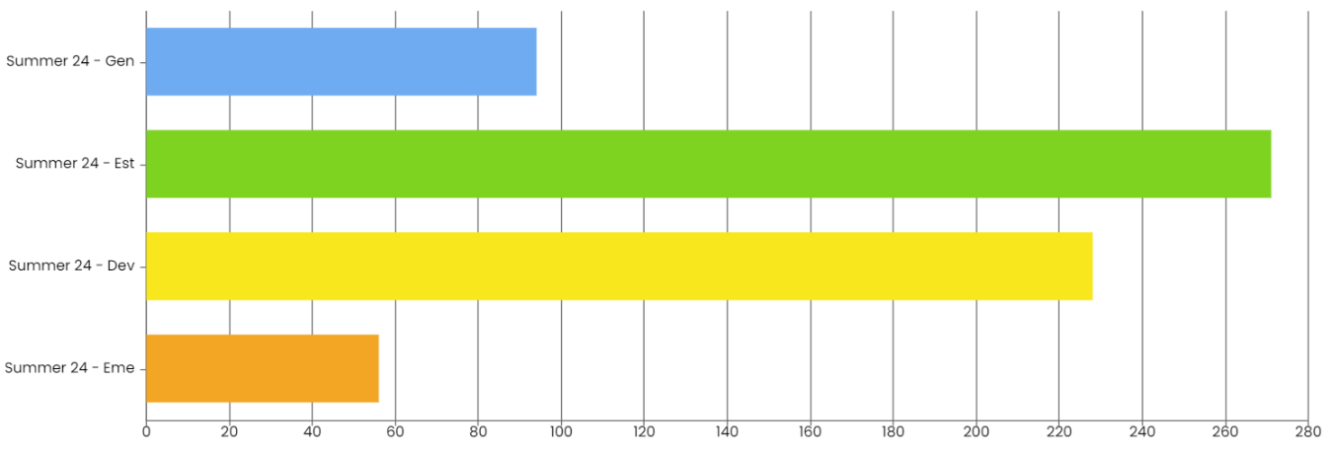
Maths Overall Progress 23/24
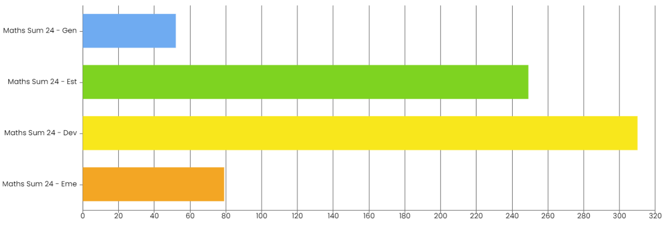
Pupil Premium & Non-Pupil Premium English and Maths Progress
Pupil Premium 2023- 2024
 | Pupils eligible for PP |  |  |  | Pupils not eligible for PP
 | Emerging | Developing | Established | Generalised | Emerging | Developing | Established | Generalised
English | 8% | 31% | 45% | 16% | 8% | 40% | 39% | 13%
Maths | 10% | 46% | 37% | 7% | 13% | 43% | 35% | 9%
 | Emerging | Developing | Established | Generalised | Emerging | Developing | Established | Generalised
EHCP Data | 5% | 19% | 47% | 29% | 7% | 27% | 43% | 22%

English Progress: Pupil Premium vs. Non-Pupil Premium
The comparison between Pupil Premium and Non-Pupil Premium students indicates a consistent pattern of performance, with Pupil Premium students generally achieving higher percentages in the "Established" and "Generalised" categories. This gap suggests that the additional support and resources allocated to Pupil Premium pupils contribute positively to their progress in English.
The continued focus on phonics interventions has been instrumental in supporting reading and writing development for both groups, particularly for Pupil Premium students.
Maths Progress: Pupil Premium vs. Non-Pupil Premium
The development of the Maths progress tracker has played a crucial role in monitoring student progress and identifying areas for improvement. This tool allows educators to track individual progress accurately and tailor interventions to meet specific learning needs.
Termly assessments for KS4 that closely align with Entry Level Maths assessment criteria ensures that all pupils are placed on appropriate qualification pathways. This alignment facilitates a clearer understanding of learning objectives and support personalised learning plans. Through these analytical approaches to tracking progress and interventions, we can see that Pupil-Premium students are progressing either inline or ahead of non-pupil premium. Overall the progress of pupils in Maths is good with pupil-premium students able to achieve at similar comparable levels.
Pupil Premium & Non-Pupil Premium EHCP Progress through Personal Learning Goals (PLGs)
Carefully monitoring the progress of pupils towards the outcomes specified in their Education, Health and Care Plans (EHCPs) is a key measure for the school. This tracking system utilises Personal Learning Goal (PLG) targets, which are recorded and assessed using the Evidence for Learning (EFL) platform.
Upon analysing the performance data collected through this tracking system, it is evident that disadvantaged pupils, as a whole, were broadly in line with the overall performance of the entire school. This finding suggests that, on average, disadvantaged pupils demonstrated similar levels of progress towards their PLG targets as their non-disadvantaged peers.
It indicates that our efforts to provide targeted support and resources to these students have yielded positive results, as evidenced by their alignment with the whole-school performance.
Whole School Pupil Premium 23/24 EHCP (PLG) Progress
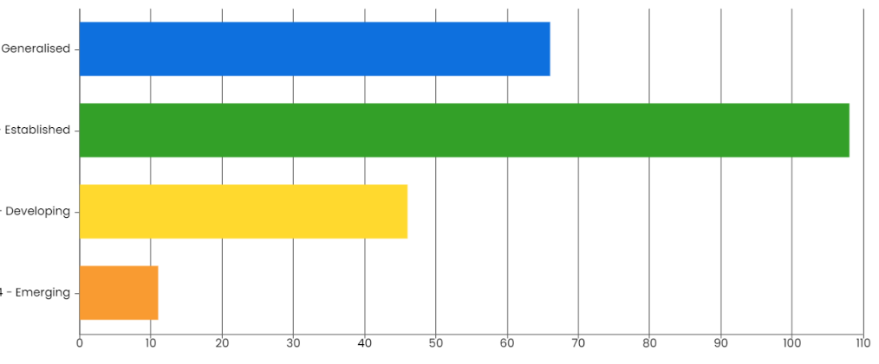
Emerging | Developing | Established | Generalised
5% | 19% | 47% | 29%

Whole School Non-Pupil Premium 23/24 EHCP (PLG) Progress
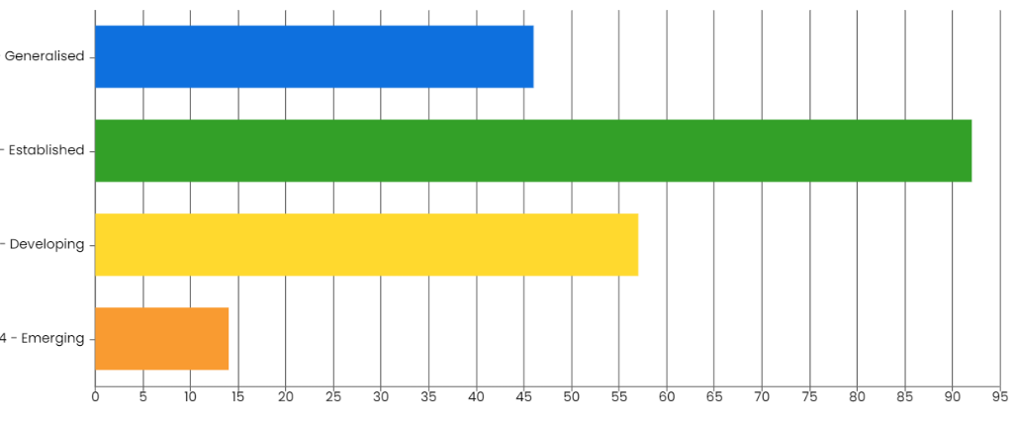
Emerging | Developing | Established | Generalised
22% | 43% | 27% | 7%

Nationally, it is less common for Pupil-Premium students to be achieving to a greater degree than Non-PP students. Broadly this is indicative of progress which closely matches the overall cohort and indicates pupils at Pencalenick are not disadvantaged in their offer, regardless of background. The presence of a high number of Pupil Premium students supports that the school is effectively utilising resources and targeted intervention sessions tailored to meet their specific needs. These interventions include additional support staff, and enhanced engagement strategies that facilitate better outcomes.

Externally provided programmes
Please include the names of any non-DfE programmes that you used your pupil premium (or recovery premium) to fund in the previous academic year.
Programme | Provider
Occupational Therapy | Blue Skies
Music Therapy | Music for Good
Community and Social | White Gold
Swimming Lessons | Truro Leisure Centre
Outdoor Education | BF Adventure

Service pupil premium funding (optional)
For schools that receive this funding, you may wish to provide the following information: How our service pupil premium allocation was spent last academic year
The impact of that spending on service pupil premium eligible pupils

Further information (optional)
Use this space to provide any further information about your pupil premium strategy. For example, about your strategy planning, or other activity that you are implementing to support disadvantaged pupils, that is not dependent on pupil premium or recovery premium funding.

