 | Autumn 1 | Autumn 2 | Spring 1 | Spring 2 | Summer 1 | Summer 2
Cycle A |   An igloo in a Desert? | 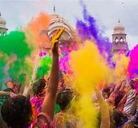  Lights and Colours |   World of work | 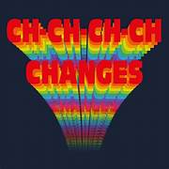  Ch Ch Changes | 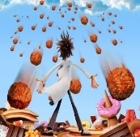  A Chance of Meatballs | 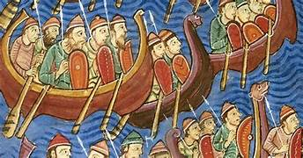  Raiders or Traders
Cycle A | Special people - Why do Christians believe Jesus was God on Earth? | Sikhism: How are Sikh teachings on equality and service put into practice today? | What do we do when life gets hard? | Being atheist in Britain | Looking after our world - Should Christians be greener than everyone else? | How far does it make a difference if you believe in life after death?
Cycle B | 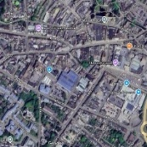  Identity | 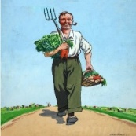  World War 2 |   Different Cultures | 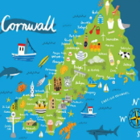  My Cornwall, My Home | 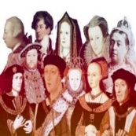  Kings and Queens | 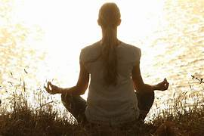  Healthy Body Healthy Mind
Cycle B | Does the world need prophets today? | What is so radical about Jesus? | Should happiness be the purpose of life? Christianity, Buddhism and non-religious views | Why is there suffering? Are there any good solutions? Christians, Buddhists and Humanists | Good, bad; right, wrong: how do I decide? | How can people express the spiritual through the arts?
Cycle C | 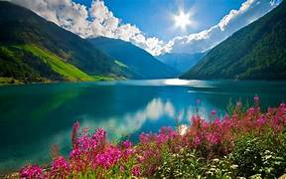  Rivers and Mountains | 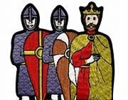  Conquest | 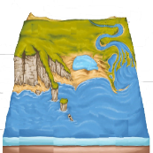  Where the Land meets the Sea | 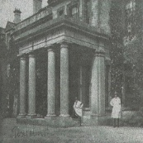  Pencalenick Past | 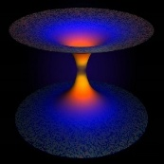  The Final Frontier | 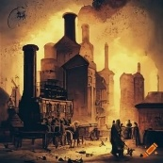  The Age of Steam and Steel
Cycle C | The Buddha: How and why do his experiences and teachings have meaning for people today? | Special people - Why do Christians believe Jesus was God on Earth? | What difference does it make to be an atheist or agnostic in Britain today? | Good, bad; right, wrong: how do I decide? | Does the world need prophets today? | How far does it make a difference if you believe in life after death?
Y10 | Looking after our world - Should Christians be greener than everyone else? | Sikhism: How are Sikh teachings on equality and service put into practice today? | What do we do when life gets hard? | Why is there suffering? | Good, bad, right, wrong; how do I decide? | Expressing the spiritual through the arts
Y11 | Why are people good and bad? | What do Christians believe about God? | What does it mean to be a Hindu? | How far does it make a difference if you believe in life after death? | What difference does it make to be an atheist or agnostic in Britain today? | Being Muslim in Britain
CURRICULUM INTENT
In Religious Education, our intent is to provide a holistic and inclusive education that promotes understanding, respect, and tolerance for diverse religious beliefs and practices at all levels of learning. The curriculum aims to enable all our pupils to explore and engage with religious and philosophical concepts, fostering their spiritual, moral, social, and cultural development. We hope that pupils are able to express their true selves and accept others without judgement, by exploring their own values and beliefs in a nurturing environment.
CURRICULUM IMPLEMENTATION
A multi-sensory and adjusted approach is adopted to cater to the diverse learning needs of our pupils. The curriculum is designed to explore major world religions in a way that make sense to each learner. Teaching accommodates individual abilities, incorporating visual aids, tactile resources, sensory experiences, and simplified language to ensure meaningful engagement and comprehension. Pupils are taught at the cognitive step that is appropriate to their development using the RE P-CAS Assessment Framework. The teaching strategies promote active participation, including role-playing, group discussions, and interactive activities, to foster social interaction and enhance learning outcomes. The syllabus has been created in partnership with Cornwall SACRE (Standing Advisory Council for Religious Education).
CURRICULUM IMPACT
The teaching of Religious Education at Pencalenick has a positive impact on the pupils' personal, social, and emotional development as proven by their progress with Personal Learning Goals. Through the exploration of diverse religious beliefs and practices, pupils develop empathy, understanding, and respect for different cultures and faiths. They also develop critical thinking skills, enabling them to analyse and evaluate ethical and moral issues. In addition to P-CAS, regular learning walks, EfL (Evidence for Learning) audits and book looks take place to ensure that pupils are well supported and making progress. The advantage of assessments being recorded on EfL is that progress and evidence sit together within the assessment system. This ensures accuracy in reporting and easily accessible quality assurance checks, whilst ensuring each child engages with their learning in the most meaningful ways to them.

