 | Autumn 1 | Autumn 2 | Spring 1 | Spring 2 | Summer 1 | Summer 2
Theme | 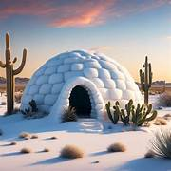  An igloo in a Desert? | Lights and Colours   |   World of work | Ch Ch Changes  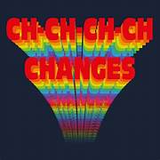 | 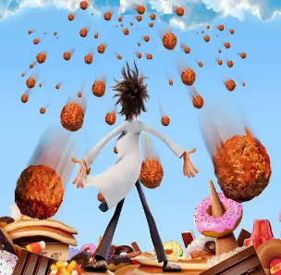  A Chance of Meatballs | Raiders or Traders  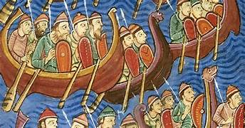
Maths | Number and Place Value  identify, count, order &compare numbers to:  5, 10, 20, 100, 1000, a million and beyond  decimals  negative numbers  Calculations Addition/subtraction  single digit -manipulatives, pictorial, abstract  double digit mentally and written methods  carrying and borrowing  decimals and negative numbers | Properties of shape  matches, sorts, compares, identifies and describes  2D shapes, 3D shapes  Angles  Money  Recognising coins/notes  Making different amounts  Converting between £ and p  Conversions  Time  Days/months/seasons  Calendars  Equivalence -secs/mins/hours/days/weeks etc | Number and Place Value  Counting in steps  Formulae  Calculations  Multiply/divide  Timetables  formulae | Measures  compares/describes units of measure  measuring length and width  perimeter and area  volume  Time  Telling the time-  Hour/half hour  Quarter of an hour  Problem solving using time  Weight and Volume  Measure/compare  Units of measure | Calculations  Problem solving  Real life situation  BIDMAS  Money  Using coins  Shopping with coins/notes  Calculating with money  Fractions  Finding fractions of amounts -sharing/pictures/numbers  Equivalent fractions  F/D/P | Data Handling  Read, draw and interpret graphs and charts  Averages  Position and Direction  Positional language  Simple directions  Compass points  Coordinates
English | Fame Autobiography  Reading to instruct  Writing to inform  different audiences | Novels and Short Stories Pencalenick Book Festival  Descriptive narratives  Short story writing/ retell writing  Describe/sequence/elaborate  Tone | Careers & Aspirations  Reading non-fiction media texts  Writing  Completing an application form  Speaking to different audiences  Formal/informal | Poetry and Rap  Reading: Rhyme and meaning A Poet for each decade  Structure, rhyme, adapt  Reading using punctuation prompts  Volume | Water  Reading  Fact and Opinion. Persuasive techniques  Argue/advise/persuade Argue/advise/persuade | Drama & Plays  Shakespeare or agreed alternative Beowulf  Writing speech/dialogue  perform  Character
Science | Skills for Science & safety in the lab  Changing substances | Solid, liquid, gas -mixtures & solutions | Matter and energy atoms | Feeding relationship/ competition | reproduction – different cell structures | Contact forces/ Gravity/ Energy transfer
Computing | Introduction to Computers & Digital Literacy | Typing and Word Processing | Internet Safety & Online Communication | Basic Spreadsheets & Data Handling | Multimedia & Creative Computing | Coding & Computational Thinking (Basic Introduction)
Computing  Basics | Getting Started with iPads | Everyday Digital Skills | Communication & Expression | Creativity with Apps | Using Tech in Everyday Life | Safe & Fun Digital Use
Humanities | Habitats and Biomes | Africa Identify Human and Physical Features of Africa | Development (rich world poor world) | Post-war Britain through the Decades | Weather & Climate | Vikings  Who were the Vikings?
RE | Special people - Why do Christians believe Jesus was God on Earth? | Sikhism: How are Sikh teachings on equality and service put into practice today? | What do we do when life gets hard? | Being atheist in Britain | Looking after our world - Should Christians be greener than everyone else? | How far does it make a difference if you believe in life after death?
Art and Design | Prehistoric Art | African Beads | Identity | Album Covers | Weatherscapes | Hockney Journeys
Food Tech | Food hygiene & Safety  Getting to grips | Food & drink for life  African Food | Food Origins  Pack a lunch | Variety – Eat well  Noodle time | Choice, preference & occasions  Meatballs | Food is produced & processed  Simple but fun
Music | Introduction to Music | World Music: Samba | Instrument Focus: Ukulele | Musical Soundscapes | World Music: African Drumming | The Orchestra
PE | Intro to Invasion Games  Intro to Cardio  Sens fit  Swimming | Ball Skills – Football  Cardio  Sens fit  Swimming | Wheelchair Basketball  Cardio  Sens fit  Swimming | Ball skills- Unihoc  Cardio  Sens fit  Swimming | Athletics  Sens fit  Cardio  Cricket | Athletics  Sens fit  Rounder  Sens fit  Cardio
PSHE | Likes and dislikes.  Similarities and differences with others. | Healthy relationships and values. | What is a job? | Self-awareness.  Managing emotion and change. | Physical safety: water, sun, road...  Feeling unwell.  Who can help us? | Healthy living.  Choices and consequences
Citizenship and Careers | ASDAN New Horizons Personal | ASDAN New Horizons Social | ASDAN New Horizons Health | ASDAN New Horizons Citizenship | ASDAN New Horizons Citizenship | ASDAN New Horizons Relationships
ASDAN | Realising aspiration: my friends and relationships | Realising aspiration: my friends and relationships | Realising aspirations: my help and support | Realising aspirations: my help and support | Realising aspiration: my healthy lifestyle | Realising aspiration: my healthy lifestyle
Keeping Safe | Underwear Rule |  | Positive Friendships |  | Trust Me

