 | Autumn 1 | Autumn 2 | Spring 1 | Spring 2 | Summer 1 | Summer 2
Theme | 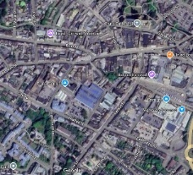  Identity | 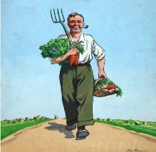  World War 2 | Different Cultures   | 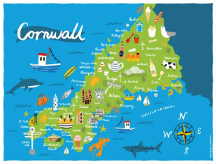  My Cornwall, My Home | 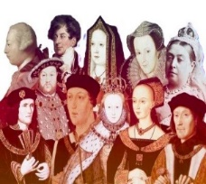  Kings and Queens |   Healthy Body Healthy Mind
Maths | Number and Place Value  identify, count, order &compare numbers to:  5, 10, 20, 100, 1000, a million and beyond  decimals  negative numbers  Calculations Addition/subtraction  single digit -manipulatives, pictorial, abstract  double digit mentally and written methods  carrying and borrowing  decimals and negative numbers | Properties of shape  matches, sorts, compares, identifies and describes  2D shapes, 3D shapes  Angles  Money  Recognising coins/notes  Making different amounts  Converting between £ and p  Conversions  Time  Days/months/seasons  Calendars  Equivalence -secs/mins/hours/days/weeks etc | Number and Place Value  Counting in steps  Formulae  Calculations  Multiply/divide  Timetables  formulae | Measures  compares/describes units of measure  measuring length and width  perimeter and area  volume  Time  Telling the time-  Hour/half hour  Quarter of an hour  Problem solving using time  Weight and Volume  Measure/compare  Units of measure | Calculations  Problem solving  Real life situation  BIDMAS  Money  Using coins  Shopping with coins/notes  Calculating with money  Fractions  Finding fractions of amounts -sharing/pictures/numbers  Equivalent fractions  F/D/P | Data Handling  Read, draw and interpret graphs and charts  Averages  Position and Direction  Positional language  Simple directions  Compass points  Coordinates
English | Novels and Short Stories  Reading  Descriptive narratives  Short story writing/ retell  Describe/sequence/elaborate  Tone | Drama & Plays  Reading  Shakespeare or agreed alternative  speech/dialogue  perform  character | Fame  Reading and researching multimedia texts  Explain/inform/describe  Speaking and Listening  Pace | Poetry and Rap  Reading  Rhyme and meaning  Structure, rhyme, adapt  Reading using punctuation prompts  Volume | Where we are/were  Reading non-fiction media texts  Completing an application form  Speaking to different audiences  Formal/informal | Healthy Choices  Reading  Fact and Opinion. Persuasive techniques  Argue/advise/persuade  Argue/advise/persuade
Science | Elements & compounds  Rock cycle | Magnetism/ Speed/ Light/ Electrical energy | Tissue and organs – the digestive system | Plant distribution - respiration | Human reproduction – specialised cells | Organisms Plant & human Safety in the lab  Reactants and products
Computing | Advanced Word Processing & Digital Communication | Spreadsheets for Real-World Tasks | Spreadsheets for Real-World Tasks | Cybersecurity & Digital Responsibility | Creative Media & Design | Intermediate Coding & Game Design
Humanities | Romans | WW2 - Why did WW2 happen?  The Home Front | China | Cornish History | Tudors  Henry VII, Henry VIII, Pendennis Visit | Field work either on site or Truro Investigation into urban environment and Environmental Quality Survey
RE | Does the world need prophets today? | What is so radical about Jesus? | Should happiness be the purpose of life? Christianity, Buddhism and non-religious views | Why is there suffering? Are there any good solutions? Christians, Buddhists and Humanists | Good, bad; right, wrong: how do I decide? | How can people express the spiritual through the arts?
Art and Design | Portraits | World War II Posters | Ancient Egyptian Art | Cornish Artists | Fauvism | Native American Art
Food Tech | Italian Food  Being Active, serving & sharing, Shopping | Exploring fruit & Vegetables | Food from different Cultures - Chinese Food | Recipes from Cornwall  Cooking & Nutrition | Celebrating Culture & Seasonality | Healthy Eating – Catering for need  Veg out
Music | Rhythm and Ensemble Skills | Instrument Focus: Keyboard Skills | World Music: Indonesian Gamelan | Folk Music: Cornwall My Home | Instrument Focus: Ukulele | Band Skills: Ensemble Project
PE | Cardio  Ball skills  Sens fit | Cardio  Ball skills  Sens fit | Wheelchair Basketball  Cardio  Sens fit | Unihoc/Badminton  Cardio  Sensory Circuits | Athletics  Tennis  Sens fit | Athletics  Sens fit  Cricket  /Rounders
PSHE | Physical safety and self-care – seeking help. | Romantic relationships.  Gender identity and sexual orientation. | Personal strengths.  Similarities and differences – ethnicity, culture, religion. | Job roles and responsibilities.  Different types of employment | Healthy and unhealthy habits. | Self-awareness.  Managing emotion and change.
Citizenship and Careers | ASDAN Key Steps Community | ASDAN Key Steps Community | ASDAN Key Steps Community | ASDAN Key Steps Citizenship | ASDAN Key Steps Citizenship | ASDAN Key Steps Citizenship
ASDAN | Being an active citizen | Being an active citizen | Realising aspirations: Getting about | Realising aspirations: Getting about | Realising aspiration: understanding my behaviour | Realising aspiration: understanding my behaviour
Keeping Safe | Share Aware |  | Body Confident |  | Disrespect Nobody

