 | Autumn 1 | Autumn 2 | Spring 1 | Spring 2 | Summer 1 | Summer 2
Theme |   Rivers and Mountains | 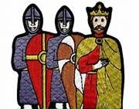  Conquest | 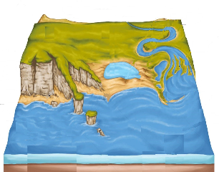  Where the Land meets the Sea | 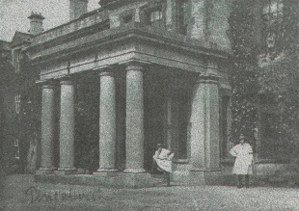  Pencalenick Past | 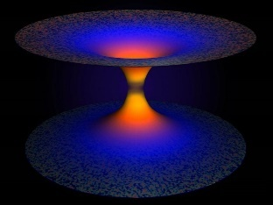  The Final Frontier | 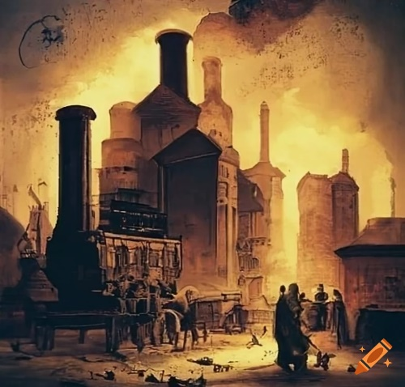  The Age of Steam and Steel
Maths | Number and Place Value  identify, count, order &compare numbers to:  5, 10, 20, 100, 1000, a million and beyond  decimals  negative numbers  Calculations Addition/subtraction  single digit -manipulatives, pictorial, abstract  double digit mentally and written methods  carrying and borrowing  decimals and negative numbers | Properties of shape  matches, sorts, compares, identifies and describes  2D shapes, 3D shapes  Angles  Money  Recognising coins/notes  Making different amounts  Converting between £ and p  Conversions  Time  Days/months/seasons  Calendars  Equivalence -secs/mins/hours/days/weeks etc | Number and Place Value  Counting in steps  Formulae  Calculations  Multiply/divide  Timetables  formulae | Measures  compares/describes units of measure  measuring length and width  perimeter and area  volume  Time  Telling the time-  Hour/half hour  Quarter of an hour  Problem solving using time  Weight and Volume  Measure/compare  Units of measure | Calculations  Problem solving  Real life situation  BIDMAS  Money  Using coins  Shopping with coins/notes  Calculating with money  Fractions  Finding fractions of amounts -sharing/pictures/numbers  Equivalent fractions  F/D/P | Data Handling  Read, draw and interpret graphs and charts  Averages  Position and Direction  Positional language  Simple directions  Compass points  Coordinates
English | Where we are/were/future us  Reading and researching multimedia texts  Explain/inform/describe  Pace | Novels and Short Stories  Descriptive narratives  Short story writing/ retell writing  Describe/sequence/elaborate  Tone | Sport  Reading  Reading and researching multimedia texts  Explain/inform/describe | Poetry and Song  Reading  Rhyme and meaning  Writing  Structure, rhyme, adapt  Reading using punctuation prompts  Volume | Healthy Choices  Persuasive techniques  Writing  Argue/advise/persuade | Drama & Plays  Reading  Shakespeare or agreed alternative  speech/dialogue  perform  character
Science | The periodic table  Using resources | Cell & Human reproduction – controlling reproduction | Human body - Cell transport | Human interaction- Biodiversity | Space Physics | Acceleration (Newton)/ Heat transfer/ Sound and waves
Computing | Productivity & Office Software | Data Analysis & Database Skills | Advanced Cybersecurity & Ethical Hacking Basics | Digital Functional Skills IT Exam Preparation | Digital Creativity & Entrepreneurship | Advanced Coding & Automation
Humanities | Rivers and Mountains | Medieval Britain The Norman Conquest | Coasts | Local History and Geography  of Pencalenick | Natural Hazards Earthquakes and Volcanoes  Structure of the Earth | Victorians/Industrial Revolution
RE | The Buddha: How and why do his experiences and teachings have meaning for people today? | Special people - Why do Christians believe Jesus was God on Earth? | What difference does it make to be an atheist or agnostic in Britain today? | Good, bad; right, wrong: how do I decide? | Does the world need prophets today? | How far does it make a difference if you believe in life after death?
Art and Design | All things autumnal | Bayeux Tapestry | Landscapes and Cityscapes | Still Life | The Objective Lens | Assemblage
Food Tech | Lovely Lunch  Autumnal Recipes | Grab & Go  Indian Express | Bring on Breakfast  A fishy tale/From the land and the sea | Food in Victorian times  Victorian food | Food in Space  Take out cook in | Party Time  Impress
Music | Theme and Variations | Music Through Time | Instrument Focus: Keyboard Skills | The Blues | Film Music | Band Skills: The 4 Chord Trick
PE | Cardio  Ball skills - Football  Sens fit | Cardio  Ball skills – Tag Rugby  Sens fit | Wheelchair Basketball  Cardio  Sens fit | Cardio  Sens fit  Badminton  Boccia & Kurling | Athletics  Tennis  Sens fit  Cardio | Athletics  Sens fit  Cricket/Rounders  Cardio
PSHE | Self-awareness.  Managing emotion and change. | Healthy and unhealthy relationships.  Family conflict. | Strengths and interests.  Stereotypes: Everyone is different and unique. | Employment/  independent living  Jobs and wages | How healthy am I?  Importance of sleep.  Personal hygiene. | Vaping, alcohol, drugs education.  Physical and emotional safety – the importance of seeking help.
Citizenship and Careers | ASDAN Citizenship Rights and Responsibilities | ASDAN Citizenship Community and Volunteering | ASDAN Citizenship Government and Democracy | ASDAN Citizenship Law and Order | ASDAN Citizenship Finance | ASDAN Citizenship Global Citizenship
ASDAN | Realising aspiration: my friends and relationships | Realising aspiration: my friends and relationships | Realising aspirations: my help and support | Realising aspirations: my help and support | Realising aspiration: my healthy lifestyle | Realising aspiration: my healthy lifestyle
Keeping Safe | Naked Online |  | Mental Health I am Whole |  | Boundaries Privacy in Consent

