 | Autumn 1 | Autumn 2 | Spring 1 | Spring 2 | Summer 1 | Summer 2
Cycle A |   An igloo in a Desert? | 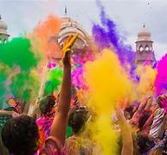  Lights and Colours |   World of work | 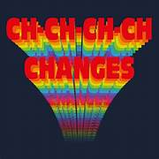  Ch Ch Changes | 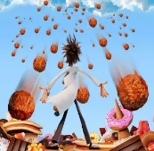  A Chance of Meatballs | 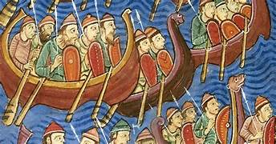  Raiders or Traders
Cycle A | Prehistoric Art | African Beads | Identity | Album Covers | Weatherscapes | Hockney Journeys
Cycle B | 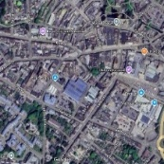  Identity | 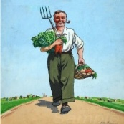  World War 2 |   Different Cultures | 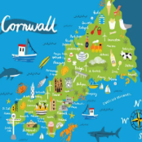  My Cornwall, My Home | 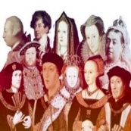  Kings and Queens |   Healthy Body Healthy Mind
Cycle B | Portraits | World War II Posters | Ancient Egyptian Art | Cornish Artists | Fauvism | Native American Art
Cycle C |   Rivers and Mountains | 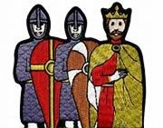  Conquest | 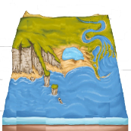  Where the Land meets the Sea | 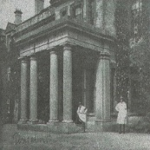  Pencalenick Past | 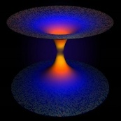  The Final Frontier | 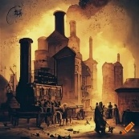  The Age of Steam and Steel
Cycle C | All things autumnal | Bayeux Tapestry | Landscapes and Cityscapes | Still Life | The Objective Lens | Assemblage
Key Stage 4 Option | AQA GCSE Art, Craft and Design | AQA GCSE Art, Craft and Design | AQA GCSE Art, Craft and Design | AQA GCSE Art, Craft and Design | AQA GCSE Art, Craft and Design | AQA GCSE Art, Craft and Design
Key Stage 4 Option | Art Trinity College Arts Award  Explore, Bronze and Silver | Art Trinity College Arts Award  Explore, Bronze and Silver | Art Trinity College Arts Award  Explore, Bronze and Silver | Art Trinity College Arts Award  Explore, Bronze and Silver | Art Trinity College Arts Award  Explore, Bronze and Silver | Art Trinity College Arts Award  Explore, Bronze and Silver
CURRICULUM INTENT
The Art curriculum encourages pupils to develop both artisitc skills and an appreciation of art with the aim for both to be a source of creative enjoyment in their lives beyond school. Space is at a premium but we have created an art studio and appreciate the opportunities the space provides for our pupils including being place where pupils can feel safe to express their creativity and feelings. The art studio is also used as a base for the art based interventions..

Our pupils are encouraged to express themselves visually and to become reflective thinkers, making their own creative responses to the world around them. Involvement in the community and exhibitions allow the pupils to share their creative messages, taking pride in
their work around school.
CURRICULUM IMPLEMENTATION
The Creative Arts curriculum is planned and organised by specialist teachers. Subject content is delivered via topic-based schemes of work, which support pupils’ spiritual, moral, social and cultural development by exploring the arts from different cultures, countries and time periods. In line with NC expectations, pupils produce creative work, exploring their ideas and developing a critical engagement. Teaching and learning is personalised to the group’s strengths and interests, allowing pupils to specialise in their preferred art form. The curriculum is enhanced by enrichment opportunities, including workshops from visiting artists, musicians and dance practitioners, and community projects that enable pupils to showcase their skills to a wider audience. It is our intent to make Creative Arts an enjoyable experience, taking into account interests and needs of individual groups and cohorts. We seek to enlighten inquisitive minds through the exploration of Art, Dance, Drama and Music, and to increase self-confidence through active and purposeful learning. We aim to develop independent learning skills and resilience by encouraging creative thinking to problems and concepts, so that our pupils may go on to achieve a full, interesting and productive life.
The learning opportunities in each curriculum stage provide future preparation for the next steps in learning. The pupils develop their proficiency in art making, confidence in expressing themselves and communicating as they move through each stage of the curriculum.

The pupils acquire new knowledge and skills, always building and revisiting previous learning. The pupils are able to create art through drawing, painting, printmaking and sculpting whilst developing contextual knowledge of these art forms. They will be enabled to use an increasing art vocabularly to describe and explain their work and respond to the work of other artists.

The Key Stage 3 curriculum delivers a solid foundation of creative and critical thinking, personal development and technical ability. The knowledge and skills delivered at KS3 prepare our students for success in the Bronze or Silver Arts Award in KS4.

Assessment in Art focuses on progress in skills and knowledge and includes practical as well as theoroetical knowledge and the application of these skills and knowledge to pieces of artwork. Each stage develops on the previous learning and the schemes of work ensure opportunities exist for pupils to revisit previous learning and understand the development of a skill.

The Arts Award specification is offered as an option in KS4 and pupils complete a number of units. Their personal portfolios are used to collate evidence for each unit. There are four units in the Bronze Award and five in the Silver Award. It is possible, for a pupil to focus on achieving one award over KS4 or to progress from Bronze (Level 1) to Silver (Level 2) award.

The Bronze Arts Award enables pupils to develop a basic understanding of arts practice and some knowledge of arts provision in the community. Pupils commit to taking part in creative activities and demonstrate a basic understanding of effective communication and an ability to convey information. They create personal arts log or portfolios containing evidence of their experiences.

The Silver Arts Award enables pupils to develop their own arts practice and arts leadership skills, underpinned by knowledge of their own art form and its relationship to arts provision in the community. They demonstrate their artistic imagination in their own art form and the ability to implement appropriate responses to challenges. Pupils develop their ability to analyse situations, design appropriate action plans and review outcomes. They demonstrate effective communication in a range of situations, showing an ability to convey information and provide some justification for their approach. Pupils create a personal arts portfolio containing evidence of their experiences.

The Arts Award qualifications support and encourage learners of all levels and abilities to engage and participate in the arts. Through Arts Award, pupils will achieve a national qualification that will build confidence through nurturing their individual interests, while also equipping them with life skills that will support their education and future employment.

To achieve their Arts Award, pupils take on challenges in an art form, participate in arts activities, experience arts events, get inspired by artists and share their arts skills with others. They are supported by an adult, who has trained as an Arts Award adviser and acts as an assessor, facilitator and mentor.

Arts Award is designed as a flexible, personalised learning programme in which allows our pupils to have choice and control over their learning.
CURRICULUM IMPACT
Our main focus is to equip pupils with core soft skills that will enable them to pursue their goals and achieve success in any field of artistic endeavour.

Introducing Art awards and qualifications will allow our pupils who enjoy and excel in these areas to develop the skills they need for further study or enjoyment in their lives beyond school. Creating an Art Studio allows us to elevate the importance of the arts in the curriculum.

The curriculum will demonstrate that taking small steps, practicing to get better at something, being persistent, and being patient are important for growth and improvement both in school and beyond. With self-confidence and independent learning skills, the ability to communicate and collaborate with others, and the resilience to rise to life’s challenges, our pupils will be ready for a world beyond Pencalenick.

