 | Autumn 1 | Autumn 2 | Spring 1 | Spring 2 | Summer 1 | Summer 2
Cycle A | 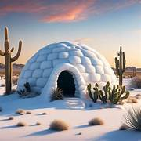  An igloo in a Desert? |   Lights and Colours |   World of work | 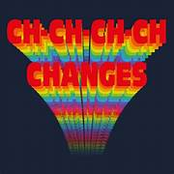  Ch Ch Changes |   A Chance of Meatballs | 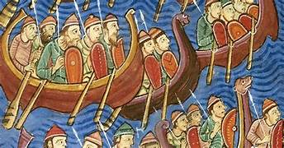  Raiders or Traders
Cycle A | Habitats and Biomes | Africa Identify Human and Physical Features of Africa | Development (rich world poor world) | Post-war Britain through the Decades | Weather & Climate | Vikings  Who were the Vikings?
Cycle B | 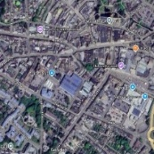  Identity | 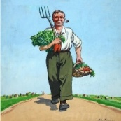  World War 2 |   Different Cultures | 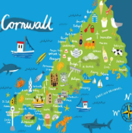  My Cornwall, My Home | 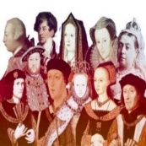  Kings and Queens | 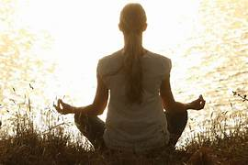  Healthy Body Healthy Mind
Cycle B | Romans | WW2 - Why did WW2 happen?  The Home Front | China | Cornish History | Tudors  Henry VII, Henry VIII, Pendennis Visit | Field work either on site or Truro Investigation into urban environment and Environmental Quality Survey
Cycle C | 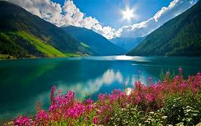  Rivers and Mountains | 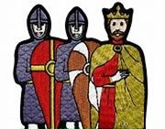  Conquest | 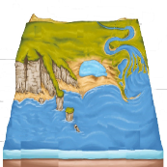  Where the Land meets the Sea | 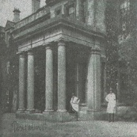  Pencalenick Past |   The Final Frontier |   The Age of Steam and Steel
Cycle C | Rivers and Mountains | Medieval Britain The Norman Conquest | Coasts | Local History and Geography  of Pencalenick | Natural Hazards Earthquakes and Volcanoes  Structure of the Earth | Victorians/Industrial Revolution
Key Stage 4 Option | WJEC Entry Level Humanities award  Entry Level 2-3 | WJEC Entry Level Humanities award  Entry Level 2-3 | WJEC Entry Level Humanities award  Entry Level 2-3 | WJEC Entry Level Humanities award  Entry Level 2-3 | WJEC Entry Level Humanities award  Entry Level 2-3 | WJEC Entry Level Humanities award  Entry Level 2-3
CURRICULUM INTENT
To develop a curiosity about the world and people who differ from ourselves. To develop a sense of identity and place. To explore and challenge our morals and values.

Geography concerns the relationship between humans and our environment. Students will be supported to develop a wider view of how people around the world live and how they relate to their environments.

Geographical studies should help pupils:
- Become aware of their environment and their place in it.
- Explore relationships between people and environments.
- Develop skills for geographical enquiry and interpreting information, such as fieldwork, map work, and logical thinking.
- Understand physical processes related to weather, rivers, seas, oceans, and landforms.
- Develop responsibility for the environment, including conservation and human impact.
- Communicate information using maps, plans, graphs, and diagrams.

The Geography curriculum at Pencalenick School follows the National Curriculum and leverages our unique geographical setting.

Learning about the past and its study methods helps children understand their world. History fosters empathy and open-minded views on cause and effect, stimulating intellectual skills by focusing on why changes occurred.
Pupils develop:
- awareness of the worl
- an understanding of attitudes, actions, ideas, and beliefs
- interest in the past
We encourage skills in:
- interpreting sources
- historical enquiry
- communicating history
- research

The History curriculum at Pencalenick School follows the National Curriculum and utilises our historical school grounds for local studies.
CURRICULUM IMPLEMENTATION
Exploring themes around human and physical geography. Discovering historical characters and events. Learning about cultures and religions around the world.

Good geographical practice will first be associated with experiences within the local area, which builds upon pupils’ real life hands on experiences and enables them to develop both understanding and skills.

As with other aspects of the curriculum, many elements of Geography interrelate strongly with work in other subject area at all key stages. Teachers should aim to draw links between Geography and English, Maths, PSHE and British Values. This will be augmented in KS3 by our school-wide thematic approach.

KS3 students will engage in one History lesson per week, three half terms per academic year. KS4 Students will have the opportunity to further their study of Humanities through an accredited pathway where appropriate.

Good historical practice will first be associated with experiences within the local area, which build upon pupils’ real-life, hands-on experiences of evidence and enables them to develop both understanding and skills.

KS3 students will engage in one History lesson per week, three half terms per academic year. KS4 Students will have the opportunity to further their study of Humanities through an accredited pathway where appropriate.
CURRICULUM IMPACT
Awareness and understanding of human and physical geographical processes. A sense of history and change over time. Respect and acceptance of different faiths and cultures. Awareness and understanding of human and physical geographical processes. A sense of history and change over time. Respect and acceptance of different faiths and cultures.

The history curriculum will encourage children to develop:
- historical knowledge
- historical skills
- understanding of attitudes, actions, ideas, and beliefs that shaped the past

Teachers should capture evidence of sequenced learning through EFL and book work, use PCAS Step Descriptors for accurate and ambitious delivery, and employ 'I Can' statements to ensure broad coverage.
Cross Curricular Links
There is rich opportunity to draw links between History and English, Maths, PSHE and British Values as well as delivering progress against PLG’s. This will be augmented in KS3 by our school-wide thematic approach.

