 | Autumn 1 | Autumn 2 | Spring 1 | Spring 2 | Summer 1 | Summer 2
Cycle A | 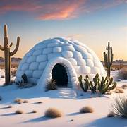  An igloo in a Desert? | 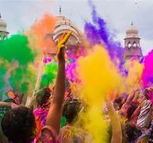  Lights and Colours |   World of work | 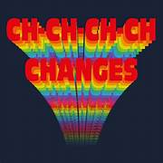  Ch Ch Changes | 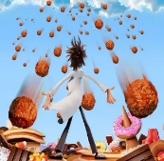  A Chance of Meatballs | 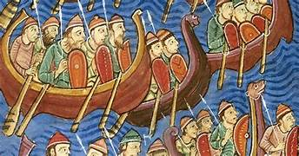  Raiders or Traders
Cycle A | Skills for Science & safety in the lab  Changing substances | Solid, liquid, gas -mixtures & solutions | Matter and energy atoms | Feeding relationship/ competition | reproduction – different cell structures | Contact forces/ Gravity/ Energy transfer
Cycle B | 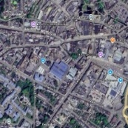  Identity | 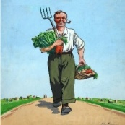  World War 2 |   Different Cultures | 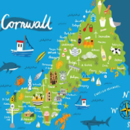  My Cornwall, My Home | 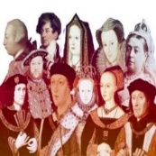  Kings and Queens | 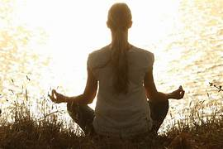  Healthy Body Healthy Mind
Cycle B | Elements & compounds  Rock cycle | Magnetism/ Speed/ Light/ Electrical energy | Tissue and organs – the digestive system | Plant distribution - respiration | Human reproduction – specialised cells | Organisms Plant & human Safety in the lab  Reactants and products
Cycle C | 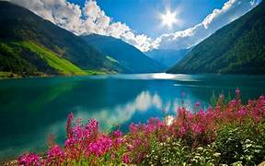  Rivers and Mountains | 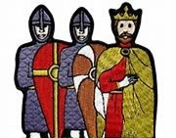  Conquest | 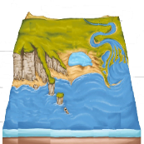  Where the Land meets the Sea | 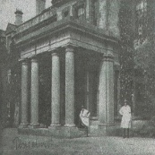  Pencalenick Past | 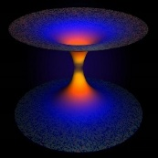  The Final Frontier | 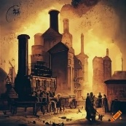  The Age of Steam and Steel
Cycle C | The periodic table  Using resources | Cell & Human reproduction – controlling reproduction | Human body - Cell transport | Human interaction- Biodiversity | Space Physics | Acceleration (Newton)/ Heat transfer/ Sound and waves
Y10 | Rate of reactions- controlling substances | Structure and bonding  Atmosphere/ climate change | Organ systems & system damage | Photosynthesis | Human reproduction – evolution & adaptation | Momentum/ Force fields/ Energy conservation
Y11 | Making substance - salts | Carbon chemistry | Enzymes and hormones | Life diversity – waste management LCA | Human reproduction – genetics & inheritance | Energy conservation/ Radioactivity
CURRICULUM INTENT
At Pencalenick School, pupils get the opportunity to explore different aspects of life and scientific discoveries with experiments that offer excitement, imagination, stimulate curiosity, and improve long-term memory. This will allow pupils to become resilient and independent learners where they discover concepts for themselves can be inquisitive and can be proud of their achievements to lead a full, interesting and productive life.
CURRICULUM IMPLEMENTATION
Science is delivered in a spiral curriculum building a deep understanding of our world by sequencing the curriculum in such a way that simpler concepts are presented before ones that are more complex. Subject content focuses on ‘Working scientifically’ where Entry Level (ELC) overlaps with GCSE Combined Science with progressively greater depth over the course of Key Stage 3 and Key Stage 4. GCSE outcomes may reflect or build upon subject content that is typically taught at Key Stage 3. (This helps progression to GCSE science, if appropriate). Teachers co-teach ASDAN, ELC and GCSE Science to students of different abilities (L2L/B2L/R2L) by including engaging practical’s and retrieval practice to suit pupils’ interests and strengths according to their EHCP whether it be investigating, observing, experimenting or testing out ideas and developing them.

CURRICULUM IMPACT
Pupils are able to explore essential aspects of processes and uses of Science where key ideas prepare them for change, improve resilience and long-term memory; and the ability to focus whilst underpinning EHCP outcomes using various toolkits. Pupils can use their scientific knowledge and understanding with confidence within their day-to-day lives.

