 | Autumn 1 | Autumn 2 | Spring 1 | Spring 2 | Summer 1 | Summer 2
Cycle A |   An igloo in a Desert? | 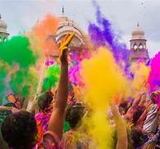  Lights and Colours |   World of work |   Ch Ch Changes | 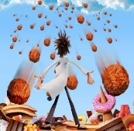  A Chance of Meatballs | 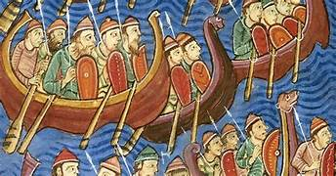  Raiders or Traders
Cycle A | Intro to Invasion Games  Intro to Cardio  Sens fit  Swimming | Ball Skills – Football  Cardio  Sens fit  Swimming | Wheelchair Basketball  Cardio  Sens fit  Swimming | Ball skills- Unihoc  Cardio  Sens fit  Swimming | Athletics  Sens fit  Cardio  Cricket | Athletics  Sens fit  Rounder  Sens fit  Cardio
Cycle B | 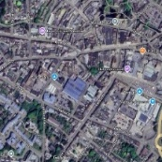  Identity | 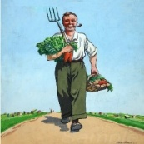  World War 2 |   Different Cultures | 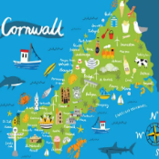  My Cornwall, My Home | 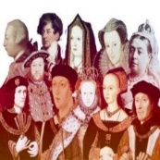  Kings and Queens | 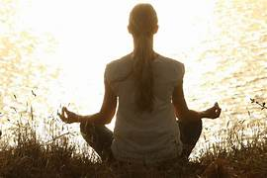  Healthy Body Healthy Mind
Cycle B | Cardio  Ball skills  Sens fit | Cardio  Ball skills  Sens fit | Wheelchair Basketball  Cardio  Sens fit | Unihoc/Badminton  Cardio  Sensory Circuits | Athletics  Tennis  Sens fit | Athletics  Sens fit  Cricket  /Rounders
Cycle C |   Rivers and Mountains | 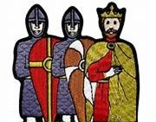  Conquest | 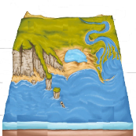  Where the Land meets the Sea | 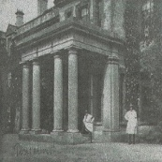  Pencalenick Past |   The Final Frontier |   The Age of Steam and Steel
Cycle C | Cardio  Ball skills - Football  Sens fit | Cardio  Ball skills – Tag Rugby  Sens fit | Wheelchair Basketball  Cardio  Sens fit | Cardio  Sens fit  Badminton  Boccia & Kurling | Athletics  Tennis  Sens fit  Cardio | Athletics  Sens fit  Cricket/Rounders  Cardio
Y10 | Cardio  Ball skills - Football  Sens fit | Cardio  Ball skills – Tag Rugby  Sens fit | Wheelchair Basketball  Cardio  Sens fit | Cardio  Sens Fit  Badminton  Boccia & Kurling | Athletics  Tennis  Sens fit  Cardio | Athletics  Sens fit  Cricket/Rounders  Cardio
Y11 | Cardio  Ball skills - Football  Sens fit | Cardio  Ball skills - Tag Rugby  Sens fit | Wheelchair Basketball  Fitness  Cardio  Sens fit | Cardio  Sensory  Badminton  Boccia & Kurling | Athletics  Tennis  Sens fit  Cardio | Athletics  Sens fit  Cricket/Rounders  Cardio
CURRICULUM INTENT
That all pupils disregarding ability experience a broad and balanced healthy lifestyle and to develop into a good sportspeople to the best of their abilities.
CURRICULUM IMPLEMENTATION
All pupils will be grouped according to ability and or friendships whilst engaging in PE. The PE department recognises the importance of using Physical Education to develop social opportunities through working with partner schools undergoing interschool games.
CURRICULUM IMPACT
Pupils will engage in graded skills sets in order to improve their game play, coordination, engagement and enjoyment which underpin the curriculum.

