 | Autumn 1 | Autumn 2 | Spring 1 | Spring 2 | Summer 1 | Summer 2
Cycle A |   An igloo in a Desert? |   Lights and Colours |   World of work | 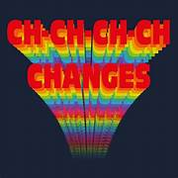  Ch Ch Changes |   A Chance of Meatballs | 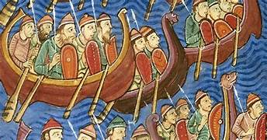  Raiders or Traders
Cycle A | Likes and dislikes.  Similarities and differences with others. | Healthy relationships and values. | What is a job? | Self-awareness.  Managing emotion and change. | Physical safety: water, sun, road...  Feeling unwell.  Who can help us? | Healthy living.  Choices and consequences
Cycle B | 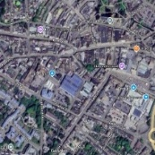  Identity | 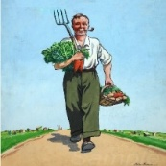  World War 2 |   Different Cultures | 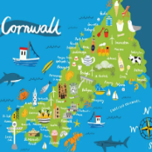  My Cornwall, My Home | 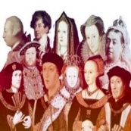  Kings and Queens |   Healthy Body Healthy Mind
Cycle B | Physical safety and self-care – seeking help. | Romantic relationships.  Gender identity and sexual orientation. | Personal strengths.  Similarities and differences – ethnicity, culture, religion. | Job roles and responsibilities.  Different types of employment | Healthy and unhealthy habits. | Self-awareness.  Managing emotion and change.
Cycle C |   Rivers and Mountains | 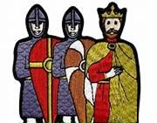  Conquest | 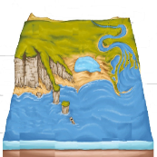  Where the Land meets the Sea | 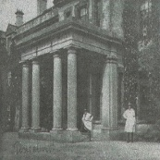  Pencalenick Past | 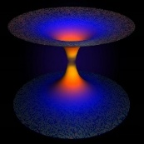  The Final Frontier | 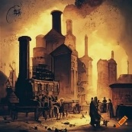  The Age of Steam and Steel
Cycle C | Self-awareness.  Managing emotion and change. | Healthy and unhealthy relationships.  Family conflict. | Strengths and interests.  Stereotypes: Everyone is different and unique. | Employment/  independent living  Jobs and wages | How healthy am I?  Importance of sleep.  Personal hygiene. | Vaping, alcohol, drugs education.  Physical and emotional safety – the importance of seeking help.
Y10 | Healthy working relationships and values.  Co-operation and compromise.  Changing friendships. | Gangs and knife crime.  Organised crime.  Change, loss and grief.  Grooming.  RSE and consent. | Skills/qualities.  Jobs of interest.  Applying for a job.  Prejudice and discrimination.  Human rights.  Protected characteristics. | Independent living skills.  Payslips and deductions.  Budgeting.  Ethical spending.  Gambling.  Mental health. | Personal hygiene.  Body image and media influence.  Challenging stereotypes.  Digital resilience. | Vaping, drugs and alcohol.  First aid/999.  Sharing nudes.  Contraception and sexual health.
Y11 | Healthy working relationships and values.  Negotiation and managing setback.  Friendships ending. | Relationship abuse.  Forced marriage.  Stalking and harassment.  Parenting.  RSE and consent. | Personal strengths.  Influences on employment options.  Challenging stereotypes.  Post 16 options. | Value for money.  Saving and investment.  Enterprise.  Managing risk.  Cash flow and profit. | Maintaining a healthy balance.  Influences on lifestyle choices.  Self-esteem.  Online forums.  Digital resilience. | Substance abuse.  First aid/999  Sexually explicit content online.  Contraception and sexual health.
CURRICULUM INTENT
Our intentions and expectations for PSHE across the school are to equip pupils with the knowledge and understanding of key issues that are essential for them to become responsible and valuable members of society. PSHE supports the school's aims and values by fostering personal development, promoting fundamental British values, and encouraging an appreciation of diversity. It plays an integral role in helping pupils develop respectful character traits, maintain mental and physical health, and stay safe both online and offline. Through PSHE, we aim to create a supportive and inclusive environment that enables pupils to lead a fulfilling life both at Pencalenick and beyond.
CURRICULUM IMPLEMENTATION
The delivery of PSHE at Pencalenick is via a rolling, two-year spiral curriculum, mapped out by long-term, sequential planning across KS3 and KS4. The curriculum is written in line with the SEND PSHE Association and centres round the three core themes: Relationships; Living in the Wider world; and Health and Wellbeing. It is flexible to accommodate individual developmental needs and learning styles, ensuring breadth and balance.
CURRICULUM IMPACT
Our aim is to prepare pupils for adulthood by helping them recognise the relevance of their learning and apply this to their daily lives. In this way, our PSHE offer provides a context which enables pupils to progressively develop their knowledge and understanding of overarching concepts and transferable skills. Impact is measured through PLGs (Personal Learning Goals to support progress against EHCP outcomes), SPT-wide and whole-school moderation, subject-monitoring and on-going assessment using P-CAS (Pencalenick Cognitive Assessment Steps.)

