English
Contents: click on each item to navigate then press back to return to the contents list
English Philosophy
English Intent, Implementation and Impact Statements
P-CAS English Assessment Overview
English Pathways and Qualifications
How is English Taught at Pencalenick School?
Phonics
Reading
Writing
Handwriting
Community Partners
Extracurricular: Whole School Performance
The Full P-CAS English Assessment



Our SEND-focused English teaching program supports pupils with diverse learning needs in developing their English language skills and communication abilities through inclusive and targeted tuition.
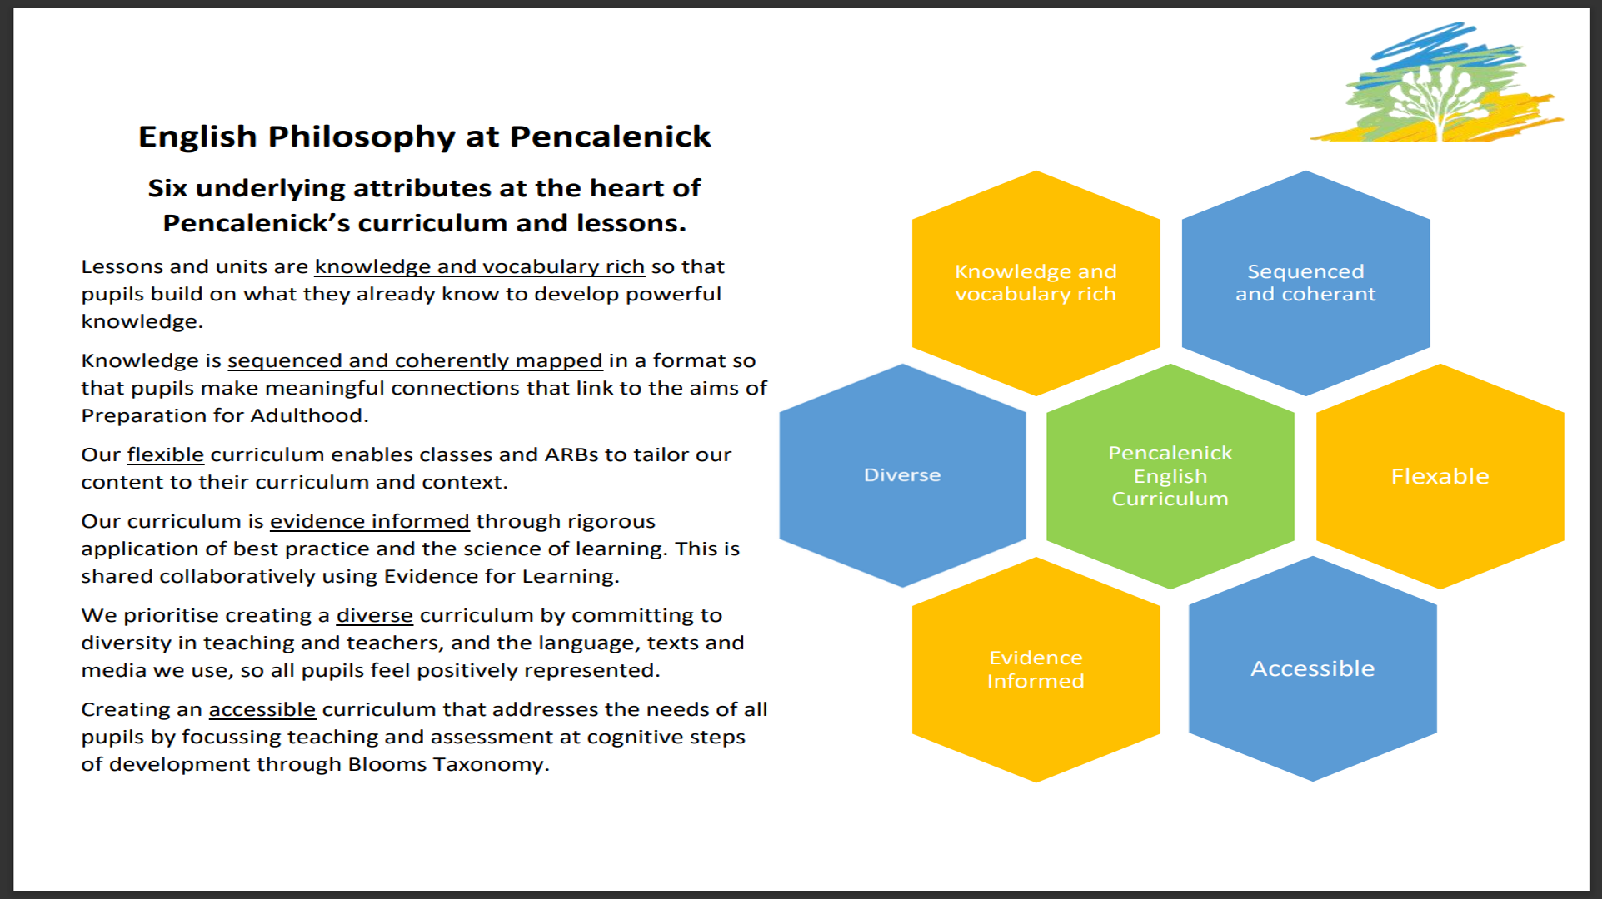

English Intent, Implementation, Impact
Our SEND (Special Educational Needs and Disabilities) focused English teaching program aims to provide inclusive and targeted teaching that supports pupils with diverse learning needs in developing their English language skills, communication abilities, and literacy proficiency.
Implementation
Pupils engage with schemes of work that capture their imagination and help them achieve. The curriculum incorporates key skills that need embedding over time within a clearly structure sequence. Learners will study oracy; writing that is both functional and creative and reading; taught in lessons ranging from phonics to complex textual analysis. All learners will be taught a curriculum that is personalised to their needs using P-CAS (Pencalenick Cognitive Assessment Steps).
By using differentiated approaches, adaptive materials, and assistive technology, we can cater to the diverse needs of pupils and ensure they receive the necessary support to develop their English language proficiency. This inclusive approach empowers pupils to actively participate in English lessons, collaborate with peers, and experience success in their English skills development.
At KS4 pupils will work towards qualifications that will help them post 16, by following one of three clear pathways which have been carefully designed to ensure that all pupils receive appropriate and tailored learning opportunities that align with their individual needs. Across all Key Stages, focussed interventions support those who require further support and progress is tracked to ensure appropriate levels of challenge and high expectations of learners are maintained.
Impact
The SEND-focused English teaching at Pencalenick has a positive impact on pupils' academic achievement and progress. By focusing on key areas, such as vocabulary, grammar, phonics, reading, writing, speaking, and listening, pupils develop a strong foundation in English language skills that will support their learning across all subjects. With targeted interventions, individualised support, and ongoing assessment, pupils can make significant progress in their English proficiency, enabling them to fully access the curriculum and reach their academic potential. In addition to P-CAS progress reporting, regular learning walks, EfL (Evidence for Learning) audits and book looks take place to ensure that pupils are well supported and making progress. The advantage of assessments being recorded on EfL is that progress and evidence sit together within the assessment system. This ensures accuracy in reporting and easily accessible quality assurance checks.

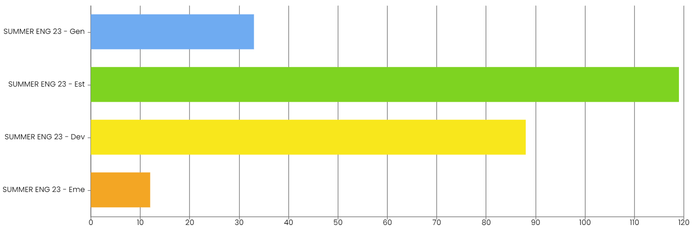
Our last set of data showed that 94% of our pupils are currently ‘Developing’ or above with 63% currently meeting the higher expectation threshold of ‘Established’ or ‘Generalised’ in their learning. This data not only shows that learning in English is successful but allows us to accurately identify where support and interventions are required.
Finally, this program supports pupils' social and emotional well-being. By creating a positive and inclusive learning environment, where pupils feel supported, respected, and valued, we can foster their self-confidence, self-expression, and sense of belonging. Through meaningful and authentic English learning activities, pupils develop effective communication skills, enhance their social interactions, and improve their overall emotional literacy. Through working with partners in the local community, we provide real life learning that will support pupils beyond Pencalenick School.

P-CAS English Assessment Overview
Assessment and Evidence for Learning
Evidence for Learning has transformed how we are able to evidence, assess, review and plan for meeting the unique needs of our SEND learners.
It supports an Inquiry-based approach to education and provision, which allows ALL stakeholders in a child, young person or adult’s learning and development to quickly and easily gather photo and video evidence, linked to the individual’s learning goals as well as key skills frameworks. Observations can be annotated and tagged in an instant. What’s more, teachers can easily amend and add to these goals over time in order to respond to a learners’ ongoing needs and development.
Assessment
Assessment is individualised and tailored to the unique needs of every child within the school. To ensure progress is accurately monitored, EfL (Evidence for Learning) allows for the mark books to sit alongside the recorded evidence. Within PLGs (Personal Learning Goals), this allows progress to be monitored and quality assured on a wide-ranging set of targets with the same measure. We use a four-point measure of progress indicator across the school. These are: Emerging, Developing, Established, and Generalised. The school has high expectations of progress backed by clear evidence that demonstrates that targets are both appropriately set and focussed upon.
With English, Maths and other core subjects, the progress is measured against a seven-step scale which we call P-CAS (Pencalenick Cognitive Assessment Steps). These seven steps are a hierarchical model used for classification of educational learning objectives into levels of complexity and specificity. Again, pupils are measured against these steps using the four main progress indicators. Below is an overview of what would be expected of pupils operating at each step within English and with literacy across the curriculum:
Reading Comprehension
Step 1 Observe
This looks like reacting when you read or sing. Watching highly-motivating interactions.

Step 2 Interact
This looks like being involved. Turning pages, pointing and gesturing.

Step 3 Remember
This looks like following a story. Recognising some words, pictures and signs. Choosing a preference.

Step 4 Understand
This looks like matching a good selection of words and understanding key elements of a text.

Step 5 Apply
This looks like reading for themselves across a range of texts. Answer questions. Read using phonetic clues.

Step 6 Analyse
This looks like explaining choices, purposes of texts and meaning of unfamiliar words.
At this level you will be moving on to the EDEXCEL Entry Level Pathways
Step 7+ Evaluate
This looks like comparing information, ideas and opinions in different texts.
Reads critically to explore how a writer uses language to create meaning and effects.
At this level you will be moving on to the GCSE or EDEXCEL Entry Level Pathways

Writing
Step 1 Observe
This looks like exploring a variety of textures and sensory items.

Step 2 Interact
This looks like improving motor control and mark making.

Step 3 Remember
This looks like copying and forming letters and individual words. Names objects.

Step 4 Understand
This looks like sequencing events and expressing ideas. Writes in lines.
Communicates appropriate word choices.

Step 5 Apply
This looks like writing in sentences for different purposes. Considers grammar and spelling.

Step 6 Analyse
This looks like planning and improving writing for different purposes.
Uses a range of vocabulary, punctuation, sentence types and grammar.
At this level you will be moving on to the EDEXCEL Level Pathways
Step 7+ Evaluate
This looks like evaluating and comparing the purpose of the text they are writing.
Describing the layout and use of language confidently while identifying audience.
At this level you will be moving on to the GCSE or EDEXCEL Entry Level Pathways

Speaking & Listening
Step 1 Observe
This looks like showing you are listening. More consistent responses to others.

Step 2 Interact
This looks like communicating simple phrases (such as hello) using words, signs or symbols.
Looks at person talking.
Step 3 Remember
This looks like following simple instructions. Using a simple series of words to describe or narrate.
Step 4 Understand
This looks like communicating ideas with short phrases or sentences.
Follows instructions containing key words.
Step 5 Apply
This looks like communicating with others more freely. Communicates feelings or viewpoint.
Asks questions.
Step 6 Analyse
This looks like using formal/informal language and asking clear questions appropriately in different contexts.
Considers tone and purpose.
Step 7+ Evaluate
This looks like using language which is effective, accurate and appropriate to context and audience.
Makes relevant and constructive contributions to move discussions forward.

English Pathways and Qualifications
Upon entering Key Stage 4, all pupils are assigned to one of three pathways for English. These pathways have been carefully designed to ensure that all pupils receive appropriate and tailored learning opportunities that align with their individual needs. The pathways are as follows:
1. ASDAN Entry
ASDAN stands for Award Scheme Development and Accreditation Network. It is a British education charity and awarding organisation that provides curriculum programs and qualifications to help young people develop knowledge and skills for learning, work, and life. ASDAN's mission is to engage young people aged 11 to 25 years in greatest need to achieve meaningful learning outcomes, which elevate them to go on to further education, training or work, and empower them to take control of their lives.
More information about ASDAN can be found at: www.asdan.org.uk/about-us/

2. EDEXCEL English Entry Level with Functional Skills
Entry Level Certificates are nationally recognised qualifications that give pupils the opportunity to achieve a certified award. Our assessments are designed to inspire and motivate your pupils, providing appropriate stretch and challenge whilst ensuring that the assessment and texts are accessible to Entry Level pupils.
The specification will encourage Entry Level pupils to develop the skills they need to read and understand a range of texts as well as to write clearly, coherently and accurately using a range of vocabulary and sentence structures.
The qualification can be tailored to pupils' needs through Entry 1 and Entry 2 and Entry 3 through to Functional Skills qualifications.
More information about Entry Level English can be found at: https://qualifications.pearson.com/en/qualifications/edexcel-entry-level-certificate/english-2017.html

3. GCSE English Entry
Cambridge IGCSE English
The course enables learners to:
- develop the ability to communicate clearly, accurately and effectively when speaking and writing
- use a wide range of vocabulary, and the correct grammar, spelling and punctuation
- develop a personal style and an awareness of the audience being addressed.
Learners are also encouraged to read widely, both for their own enjoyment and to further their awareness of the ways in which English can be used. Cambridge IGCSE English also develops more general analysis and communication skills such as inference, and the ability to order facts and present opinions effectively.
More information about iGCSE English can be found at: www.cambridgeinternational.org/programmes-and-qualifications/cambridge-igcse-english-first-language-0500/

How is English Taught at Pencalenick School?
Phonics
Phonics Intent, Implementation, Impact
Intent
Our Phonics Programme offers a coherently planned sequence of lessons that supports the effective teaching of phonics. Throughout Level 1, learners develop the knowledge, skills and understanding to discriminate between and use auditory, environmental and instrumental sounds. In Levels 2-4, learners are introduced to phonemes/sounds and graphemes/letters systematically. Level 5 allows opportunities for pupils to apply their phonics knowledge and skills as the prime approach to reading and spelling. It focuses on phonetically decodable two-syllable and three-syllable words and the alternative ways of pronouncing and representing the long vowel phonemes. Furthermore, pupils will develop their ability to attempt to read and spell increasingly complex words. During Level 6, pupils explore spelling patterns and grammar while also developing a breadth of knowledge, skills and understanding in the recognition and spelling of common exception words. The Phonics Programme intends to not only provide pupils with opportunities to develop the knowledge, skills and understanding essential for reading and writing, but also, to develop each pupils’ confidence, resilience and engagement in phonics lessons and a love for reading and writing.
Implementation
The Phonics Progression Map and EFL Framework set clear expectations for pupils’ progress within the Phonics Programme. The direct teacher-led lessons enable all learners to develop and apply new skills, while also providing opportunities to further apply these skills within fun and engaging activities and through continuous provision. The use of the supporting phonics iPad based app allows all those delivering phonics to be confident in correctly delivering phonics skills and learning which is fully sequenced. The lesson presentations, stories, games, additional texts and toolkits are planned to allow pupils to apply and practise phonics skills. Teacher guides for each stage are provided to allow teachers and adults working with children to feel confident in their own subject knowledge, knowing they are fulfilling the national phonics criteria and enabling each pupil to achieve their potential.
Impact
The impact of using our complete Phonics Programme is for pupils to develop their phonics skills and knowledge through a systematic, synthetic approach, while covering the statutory requirements outlined in the 2014 National Curriculum. It provides sufficient support for most pupils to become fluent readers. Following this programme gives us a consistent approach to phonics, which is clear to teaching staff and learners.
In addition to Phonics Tracker and Reading P-CAS progress reporting, regular learning walks, EfL (Evidence for Learning) audits and book looks will take place to ensure that pupils are well supported and making progress. The advantage of assessments being recorded on EfL is that progress and evidence sit together within the assessment system. This ensures accuracy in reporting and easily accessible quality assurance checks.

Reading
Reading Intent, Implementation, Impact
Intent
The aim of our SEND (Special Educational Needs and Disabilities) focused program for teaching reading is to provide inclusive and targeted instruction that supports pupils with diverse learning needs in developing essential reading skills and strategies.
Implementation
Our reading scheme books keep the focus on phonics, with clear progression and support for pupil’s early decoding skills as they move through each level. This method ensures pupils only read the sounds and tricky words they’ve already learnt. Pupils build confidence as they work through the levels, regularly applying new learning. Sounds, tricky words and common exception words are introduced systematically and gradually. Smooth, clear progression through the levels enables pupils to consolidate learning and build reading fluency.
Level 1 books have been carefully crafted around seven key aspects of Level 1 phonics teaching - environmental sounds, instrumental sounds, body percussion, rhythm and rhyme, alliteration, voice sounds and oral blending and segmenting. Establishing the journey to reading success, by laying the foundations for good phonemic understanding and developing pupil’s spoken language skills.
Through Levels 2 - 6, Our Reading Scheme books keep the focus firmly on phonics progression - supporting pupil’s mastery of the sounds and tricky words learned, and ensuring they meet only the content they’ve already covered in their Phonics teaching. They are accurately pitched to offer challenge and opportunities for reinforcement, and the Before Reading and After Reading pages ensure there’s structure and support for reading from beginning to end.
For established readers, we offer a curriculum which provides access to a full range of different reading opportunities. For example, our fiction based schemes include extended extracts from His Dark Materials by Philip Pullman and The Edge Chronicles by Paul Stewart and Chris Riddell. Our library offers a full range of engaging and challenging texts across poetry, prose and non-fiction.
This program promote inclusivity and accessibility by providing a range of teaching materials and strategies that accommodate different learning styles and abilities. By using multisensory techniques, visual aids, assistive technology, and adapted materials, we can engage pupils with diverse learning needs and facilitate their understanding and retention of reading concepts such as inference. This inclusive approach will empower pupils to actively participate in reading activities and experience success in their reading development.
Furthermore, the implementation of a SEND-focused program for teaching reading contributes to a more inclusive and supportive school culture. It will foster a shared commitment to promoting a love of reading as a fundamental skill and a lifelong passion. By celebrating pupils' achievements, providing opportunities for independent reading, and integrating reading across the curriculum, we can create a community of readers where all pupils are encouraged to explore, question, and grow through the power of literature.
To encourage a love of reading we have adopted Cressida Cowell's charter as the Children's Laureate 2019-2022:
Every child has the right to...
- Read for the joy of it
- Access new books in schools, libraries and bookshops
- Have advice from a trained librarian or bookseller
- Own their own book
- See themselves reflected in a book
- Be read aloud to
- Have some choice in what they read
- Be creative for at least 15 minutes a week
- See an author event at least once
- Have a planet to read on
Impact
The SEND-focused program for teaching reading has a positive impact on pupils' academic achievement and progress. By focusing on foundational reading skills, such as phonics, decoding, fluency, and comprehension, pupils develop a strong literacy foundation that will support their learning across all subjects. With targeted interventions and individualised support, pupils can make significant progress in their reading abilities, bridging any gaps and reaching their full potential.
Overall, our teaching of reading has the potential to transform pupils' reading experiences, enabling them to develop essential reading skills, ignite their curiosity, and unlock a world of knowledge and imagination. By providing targeted and inclusive teaching, we can empower pupils with diverse learning needs to become confident, proficient readers who are equipped for academic success and lifelong learning. The development of functional reading skills will help pupils’ access opportunities and important life skills beyond school as part of their preparation for adulthood.
In addition to Reading P-CAS progress reporting, regular learning walks, EfL (Evidence for Learning) audits and book looks will take place to ensure that pupils are well supported and making progress. The advantage of assessments being recorded on EfL is that progress and evidence sit together within the assessment system. This ensures accuracy in reporting and easily accessible quality assurance checks.

Writing
Writing Intent, Implementation, Impact
Intent
The intent of teaching SEND-focused writing skills is to equip pupils with the necessary tools and strategies to effectively communicate through written expression. Our aim is to provide pupils with a solid foundation in writing that promotes independence and facilitates their overall academic and personal development.
Implementation
We employ a range of evidence-based teaching practices and strategies that are tailored to meet the diverse learning needs of pupils according to their phonics and writing P-CAS levels. This involves incorporating multi-sensory approaches, personalised learning plans, and adjusted teaching to address writing challenges such as organisation, grammar, sentence construction, and coherence. Writing is taught alongside phonics and handwriting to build basic writing skills before progressing onto writing for different purposes.
Within each unit of work, carefully sequenced lessons ensure that prior learning of grammar, punctuation and spelling is revisited and developed. Using the P-CAS writing steps, we ensure that pupils are aware of their strengths and areas for development in writing so that they can take ownership of their progress. Teachers leave next steps when marking to ensure that pupils know exactly what they need to do to make progress. We also ensure that appropriate scaffolds are put in place to support learning.
Writing is evident in every aspect of our curriculum and varying text types are taught throughout the school. The objectives the writing P-CAS are followed to ensure that the skills learnt in spelling, punctuation and grammar are embedded and transferred into writing. Lessons are carefully planned so that skills are taught, embedded, revisited and then developed in a sequential way which promotes learning and retention of knowledge and skills. ‘Talk for Writing’ strategies are used by some to support the teaching of writing. Fiction writing is modelled on appropriately challenging class texts which are studied in guided reading sessions, strengthening the link between reading and writing. Pupils are given a language rich curriculum and are encouraged and shown how to effectively use interesting and adventurous language in their writing.
In addition to P-CAS progress reporting, regular learning walks, EfL (Evidence for Learning) audits and book looks will take place to ensure that pupils are well supported and making progress. The advantage of assessments being recorded on EfL is that progress and evidence sit together within the assessment system. This ensures accuracy in reporting and easily accessible quality assurance checks.

Impact
The impact of teaching SEND-focused writing skills will be measured through ongoing assessment and evaluation of pupils' progress and achievements. By equipping pupils with the necessary skills, confidence, and strategies to overcome writing challenges, we aim to foster improved written communication abilities, increased self-esteem, and enhanced overall academic performance. Through individualised support and targeted interventions, we aspire to empower pupils to become effective and proficient writers, enabling them to fully participate and succeed in both academic and real-life contexts.
At the end of Key Stage 4, all pupils will achieve one or more of the three pathways for English. These pathways have been carefully designed to ensure that all pupils receive appropriate and tailored learning opportunities that align with their individual needs. The pathways are ASDAN, Entry Level English and Functional Skills, and iGCSE English.

Handwriting
Handwriting Intent, Implementation, Impact
Intent
Pencalenick use Twinkl Handwriting alongside Phonics and Reading to ensure a consistent and cohesive approach to developing literacy. This Handwriting provides a planned sequence of lessons to help teachers ensure they have progressively covered the skills required to meet the aims of the National Curriculum for writing transcription.
Stage 1 (Let’s Get Ready to Write) of each Handwriting Help Card, available in every lower case letter pack, aims to help children to develop their fine and gross motor skills and pencil control as a precursor to effective handwriting: to show good control and coordination in large and small movements, to move confidently in a range of ways while safely negotiating space, to handle equipment and tools effectively and to safely use and explore a variety of materials, tools and techniques.
Stages 2 and 3 (Forming Letter Families and Positioning & Pre-Cursive) aim to teach children the statutory objectives from the year 1 and year 2 curriculum: to sit correctly at a table, to hold a pencil comfortably and correctly, to begin to form lower case letters in the correct direction and of the correct size relative to one another, to start and finish letters in the right place, to form capital letters and the digits 0-9 of the correct size, orientation and relationship to one another and to lower case letters, to understand which letters belong to which handwriting ‘families’, to start using some of the diagonal and horizontal strokes needed to join letters and to use spacing between words that reflects the size of the letters.
Stages 4 and 5 (Joining Letters and Fluency, Style & Speed) teach the statutory skills from the year 3 - year 6 curriculum: to use the diagonal and horizontal strokes that are needed to join letters; to increase the legibility, fluency, consistency and quality of their handwriting; to ensure that their lines of writing are spaced sufficiently so that the ascenders and descenders of letters do not touch; to write with increasing speed by choosing which shape of a letter to use when given choices and deciding whether or not to join specific letters and to choose the writing implement that is best suited for a task.
This Handwriting scheme intends to take all pupils on a journey to using fluent, speedy and joined handwriting throughout their independent writing. This, in turn, will help to support their composition and spelling.
Implementation
Following the programme allows teachers to feel confident about curriculum design and delivery throughout; this is detailed in the EFL Handwriting progression framework which supports delivery and helps track progress.
The detailed planning and progressive sequence of the programme assures subject quality, sufficient depth and coverage of skills and gives teachers the curriculum expertise to deliver effective writing transcription lessons. The scheme’s supporting resources enable effective curriculum implementation and can be differentiated to meet all pupils’ learning needs. Where gaps in pupils’ skills are identified, the handwriting materials can also be used within intervention sessions to enhance pupils’ capacity to access the full curriculum. Each lesson has built-in assessment opportunities, which give reliable snapshots of pupil progress. The scheme also offers more formal assessment materials as well as a handwriting coverage and assessment pack to track progress over the longer term.
Impact
The impact of using the full range of handwriting resources, including display materials, will be seen across the school with an increase in the profile of handwriting and a standardised approach to delivering it. Following the scheme, gives us a consistent approach where handwriting expectations are clear and the same technical vocabulary is used with, and spoken by, all teaching staff and learners. The impact of the scheme should be noticeable within written work in all areas of the curriculum and not just confined to handwriting or designated English lessons.
In addition to Handwriting Framework and the Writing P-CAS progress reporting, regular learning walks, EfL (Evidence for Learning) audits and book looks will take place to ensure that pupils are well supported and making progress. The advantage of assessments being recorded on EfL is that progress and evidence sit together within the assessment system. This ensures accuracy in reporting and easily accessible quality assurance checks.

Community Partners
Local community partners are invaluable when it comes to teaching English at Pencalenick, across all our sites, as they bring real-world relevance and authentic language experiences to the classroom. These partners, which include local businesses, cultural organisations, community leaders, and volunteers, offer a wealth of knowledge, expertise, and resources that enrich the learning process for pupils.
Additionally, community partners contribute to creating a more inclusive and diverse learning environment. They can share different perspectives, traditions, and cultural practices, fostering a sense of acceptance, empathy, and respect among pupils. This exposure to diverse cultures and languages not only enhances pupils' understanding of the world but also promotes multiculturalism and global citizenship.
Examples of community partners who have recently collaborated with the English department include:
The Hall for Cornwall www.hallforcornwall.co.uk
Rogue Theatre www.rogueotherworld.co.uk
Volunteer Cornwall www.volunteercornwall.org.uk
Author Hannah Beven www.hannahbevan.co.uk/
Poet Harry Baker www.harrybaker.co/
Spaceport Cornwall www.spaceportcornwall.com/
Falmouth University www.falmouth.ac.uk
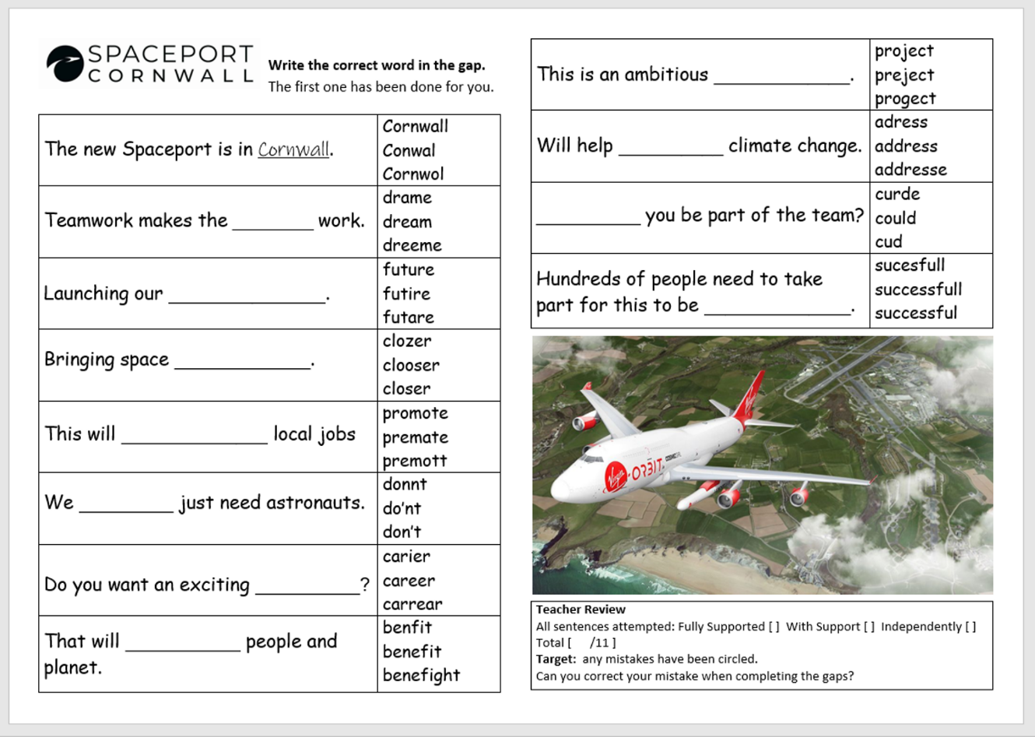
Example resource produced in collaboration with Spaceport Cornwall

Extracurricular: Whole School Performance
Putting on a whole school performance is important at Pencalenick School for several reasons:
Community building: A school-wide performance brings together pupils, teachers, staff, and families, fostering a sense of community and unity. It provides an opportunity for everyone to work together towards a common goal, creating a shared experience that strengthens relationships. It is an opportunity for pupils at the four ARBs to join in a combined set of activities with the main school site.
Creativity and self-expression: A whole school performance allows pupils to showcase their creativity and talents. It provides a platform for pupils to express themselves through various art forms like music, dance, drama, or visual arts.
Skill development: Preparing for a school-wide performance involves teamwork, discipline, and time management. Our pupils learn to collaborate with others, practice and perfect their skills, and work towards a deadline. These experiences contribute to their personal growth and develop important life skills.
Appreciation for the arts: By organising and participating in a school-wide performance, pupils gain exposure to different art forms and learn to appreciate the performing arts. It broadens their horizons, encourages cultural appreciation, and may even ignite a passion for the arts that lasts a lifetime. As part of our most recent performance, twenty-four of our pupils performed at the opening of the International Sea Shanty Festival in Falmouth.
Celebration of achievement: our whole school performance allows our pupils to celebrate their achievements and showcase their hard work to the entire school community. It provides a sense of accomplishment and recognition, boosting their self-esteem and motivation.
This year we wrote and performed a science fiction based interpretation of The Tempest by William Shakespeare. Our whole school Performances have included:
- Poldark (2019)
- Much Ado About Nothing (2020)
- A Midsummer Night’s Dream (2021)
- Bugsy Malone (2022)
- The Pirates of Pencalenick (2023)
- The Space Tempest (2024)
Here is the YouTube link to watch our last whole school performance:
https://youtu.be/70ksQ1_8Z5w?feature=shared
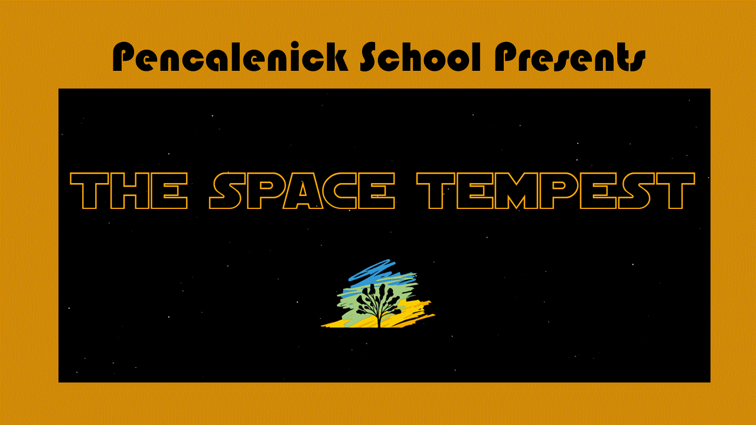
Full P-CAS English Assessment
In the preceding section, you were provided with an overview of the Seven Step P-CAS Assessment Structure. Each step within this framework delineates a series of pedagogical and learning milestones that have been devised by the Special Partnership Trust, of which Pencalenick School is an integral constituent. This assessment structure amalgamates the imperatives of the National Curriculum with insights derived from the SEND-focused Cherry Garden Framework, Step Up to English Framework, Entry Level Framework, and GCSE Framework. It is important to note that this Assessment System is still in its developmental phase, as it endeavours not only to ensure comprehensive coverage of requisite skills but also to meticulously sequence the learning process in a manner that is readily comprehensible to all stakeholders, most notably the pupils themselves. What follows is the current full P-CAS English Assessment Sequence.
English P-CAS Assessment
Reading Comprehension
Step 1 Observe
This looks like reacting when you read or sing. Watching highly-motivating interactions.
---Attention and understanding
---Notices Stimuli
---Taste
---Smell
---Touch
---Visual
---Auditory
---Vestibular
--Reacts to close contact with a familiar adult
--Responds consistently to one stimulus
---Responds to familiar voice or other personal identifier
---Familiar Voice
---Familiar personal object or touch cue
--Responds to own name
---Anticipates within social routines
---During social games
---During social songs
---Everyday routines
---Object to termination of an interaction
---Contingency responding
---Switch toys
---Computer input devices
---Cause and effect items
--Changes behaviour in response to an interesting event nearby
--Looks backwards and forwards between two objects (knows two objects are present)
--Changes behaviour in response to familiar sounds or word
-- I can react to you when you read or sing, I might smile, make sounds or move
-- I can engage in highly-motivating interactions with familiar adults
-- I can react to changes in your voice as you sing or tell stories
-- I can turn towards you reading or singing to me
-- I can watch an adult's face, or watch their movements as they sing or read a story
-- I can consistently follow sounds, like singing or music
-- I can track people or objects as they move or make sounds around me
-- I can turn my head towards the source of at least two sounds
-- watches a computer screen
-- I can respond to objects associated with the story or song, including smells, tastes, sounds and texture
-- I can respond consistently in any way to at least 1 stimulus
-- I can show you that I have remembered rhymes by anticipating what comes next
-- I can look towards objects of reference shown to me to symbolise motivating activities or routines
-- watches a member of staff point to pictures/ listens as a member of staff talks about a book

Step 2 Interact
This looks like being involved. Turning pages, pointing and gesturing.
---Start to understand contextual clues
---Within social routine
---Using objects or props
---Transition songs and symbols
---Contingency awareness
---Switch toys
---Computer input devices
---Cause and effect items
---Understands single words/sounds signs/symbols in context
---Using objects or props
---Within social routine
---In play situations
---Follow simple familiar instructions
---Understand 1 key word sentences
---Within social routine
---In play situations
---In structured situations
---In unfamiliar environments
---Understands ‘who’ and ‘what’ in simple questions
---In play situations
---In structured situations (colourful semantics)
--Understands ‘where’ in simple questions
---Shows understanding of prepositions such as ‘under’ ‘on top’, ‘behind’
---In play situations
---In structured situations
--Responds to instructions involving a two part sequence in a range of familiar contexts
--Focusing attention – still listen or do but can shift own attention
---Understand 2 key word sentences
---Within social routine
---In play situations
---In structured situations
---In unfamiliar environments
---Listen and respond to ideas expressed by others in conversations or discussions
---In structured situations
---In play situations
---With familiar and unfamiliar people
---Understands instructions containing sequencing words such as ‘first’, ‘after’ and ‘last’
---Follow a recipe
---Follow a simple route plan (first go to pink class, then...)
---Can answer simple questions about a story without props or pictures, to show understanding
---Familiar story
---Unfamiliar story
---Demonstrate an understanding of ‘how’ and questions
---Able to communicate ideas in response to a ‘how will you do this?’ question
---Has a good understanding of phase 2 initial phonic sounds
---Saying
---Reading
---Writing
---Indicate or sign the correct picture or object when the adult says or signs the first sound
---Indicate or sign the correct letter when the adult says or signs the sound
---To recognise and communicate every letter of the alphabet
-- I can show enjoyment of rhyming and rhythmic activities
-- I can respond consistently to familiar songs
-- I can show that I am interested in books and rhymes by showing a preference for a familiar story
-- I can initiate a story or song by gesturing towards a book or related object
-- I can participate in songs and stories, engaging with characters, props, sounds and movements
-- I can mimic 'reading like' behaviour
-- I can explore books and printed material with curiosity
-- I can demonstrate emerging awareness of the way stories are structured
-- I can use picture cues when sharing a book or in other contexts, With support
-- I can follow a simple visual of three images
-- I can fill in the missing word or phrase in a known rhyme, story or game, e.g. Humpty Dumpty sat on a wall...
-- I can listen to stories with attention and recall what happened
-- I can show you that I know the names of the key characters and main objects in a text
-- I can show a basic understanding of how books work
-- I can show interest in print in the environment
-- I can match pictures or symbols to objects that motivate me e.g. at snack time
-- I can sometimes match pictures or symbols to objects
-- I can match at least 4 pictures or symbols to objects
-- I can communicate a preference for certain images
-- picks up books/looks for a specific book
-- reads and responds to their visual planner with assistance
-- identifies letters and symbols demonstrating an understanding that they convey meaning
-- points to pictures, some words
-- draws attention to symbols and signs in the environment
-- picks out symbols /pictures of items that have been read out to them with 1:1 assistance
-- repeats key words with 1:1 support
-- sits for several minutes looking at books,

Step 3 Remember
This looks like following a story. Recognising some words, pictures and signs. Choosing a preference.
-- recognises familiar objects with symbols e.g. cornflake box. Matches objects to pictures
-- I can match 10 pictures or symbols to objects
-- I can show understanding of 10 pictures or symbols
-- I can match 20 pictures
-- I can understand 20 pictures
-- I can match 40 pictures
-- I can understand 40 pictures
-- I can demonstrate knowledge that print carries meaning and, in English, is read from left to right and top to bottom
-- I can match 60 pictures
-- I can match more than 60 pictures
-- I can understand more than 60 pictures
-- I can match the letters of my name
-- I can recognise a familiar written word from a choice of two
-- I can show that I know the meaning of familiar words
-- I can name 20 pictures using words or signs
-- I can name 40 pictures using words or signs
-- I can name 60 pictures using words or signs
-- I can name more than 60 pictures using words or signs
-- puts three pictures in order to sequence day e.g. breakfast, taxi, reading in school or in a story Cinderella, sad, ball, marries prince
-- shows anticipation to communicate a repetitive word or shouts it out in a familiar rhyme/story

Step 4 Understand
This looks like matching a good selection of words and understanding key elements of a text.
-- understands key elements of a story e.g. a unicorn are made up
-- answers giving a single word response
--can find a book about 'tigers' among familiar books, knows some environmental signs
-- explores pictures on a screen
-- follows visual planner/ timetable with support
-- matches pictures to pictures with assistance, or picture with vc/cvc word on (e.g. it/dog)
-- reads cvc set 1 & 2 sounds/ reads equivalent words by sight. Find the correct letter to a letter sound being spoken. CVC words like pin, pat, tap, tin.
-- matches letters and numbers pointing them out when seeing them in text. Understands and can suggest suitable conjunction e.g. the boy…'and' the dog. Connectives, first we - next
-- echoes a member of staff sounding out cvc words
-- picks out symbols /pictures of items that have been read out to them
-- sequences pictures to words / caption sequence
-- understands key elements of a story e.g. a unicorn are made up will give closed response e.g. are unicorns real or not real - yes/ no response
-- answers a simple question with short phrase
-- repeats key words from a narrative indicating understanding
-- says what they think might happen next when given two options or asked close questions
-- demonstrates an interest in reading books, magazines independently
-- recognises print and pictures separately
-- recognises a favourite website, finds information with an adult on the internet
-- follows a class timetable, visual planner
-- reads vc such as it, at & cvc words such as pot, leg
-- reads a good selection of words from the first 100 high frequency word list.
-- identifies letters of the alphabet saying/hearing their sounds knows some conjunctions e.g. and, but and time connectives, then, next
-- reads a few common exception words the, to, I , no, go
-- moves finger along from left to right following text
-- Identifies titles and key words in bold
-- matches pictures to cvc words/ matches short words with clear shapes
-- sequences key facts
-- understands stories are made up and not real, can give an example e.g. monster not real

Step 5 Apply
This looks like reading for themselves across a range of texts. Answer questions. Read using phonetic clues.
-- answers questions on reading with two simple sentences
-- retells narrative in own words
-- makes predictions in a familiar story
-- engages with a range of short texts that instruct, describe & narrate e.g. short postcard with 3 sentences reading age 5-6
-- understands pictorial signs e.g. no entry, male/female toilets
-- uses simple searches to find basic information e.g. facts about where they live, uses pictures to support understanding
-- follows a list to find 5 things
-- uses phonetic cues when attempting to read words, reads letter sounds. (knows all sounds - individual letters & corresponding grapheme phoneme)
--Entry 1 reading and spelling appendix/ reads equivalent words by sight
-- reads simple sentences, reads alphabet in lower & upper case
-- uses a range of strategies to get meaning, e.g. sounding words out, using context, pictures
-- pauses at a full stop. Knows capital letters are at the start and for some words e.g. names
-- identifies title, on a book / page. Says what book might be about from title
-- reads for gist. Matches a picture to a simple text that has been read to them e.g. Cinderella + picture of glass slipper
-- recalls key facts from a narrative e.g. who, what, when…
-- distinguishes between fact & fiction
-- makes simple factual statements about basic information they have read or had read to them
-- follows a short descriptive/narrative texts and comments
-- makes simple predictions linked to deductions
-- engages with a range of short texts that instruct, describe & narrate e.g. short story reading age of 6-7
-- understands short texts e.g. instruction: no entrance, closed. Descriptions 'the boy in the red hat'
-- suggests different sources of information. Looks for information e.g. leaflets to find out opening times, address of venue
-- follows instructions e.g. a checklist for familiar routines, tidy desk, or simple recipe
-- uses phonics without overt sounding out and blending to read
-- reads conjunctions/ connectives/ homophones (and, but, so. They're, there…)
-- uses knowledge of sentence structure to help decode words
-- reads taking note of simple punctuation .,?
-- identifies organisational features, bullet points, numbers, title.
-- reads for gist. uses pictures and captions to decide if information is useful
-- finds specific information under key headings
-- explains difference between fact & fiction & opinion
-- understands the main points, gives examples
-- explains sequence of events using given main points
-- says what they think might happen next in order to clarify own ideas
-- engages with straightforward texts that instruct, describe, explain, persuade.
-- Explains purposes of straightforward texts
-- Carries out searches finding simple information and key sentences they can copy
-- Follows written instructions - and sequentially carries them out
-- attempts longer or new words using knowledge of phonic structure, requiring support to understand meaning
-- reads and understands meaning of specialist words in context
-- uses knowledge of sentences to help decode words using context and headings, pictures to work out words
-- reads adhering to punctuation .,?! Showing evidence of expression linked to punctuation when reading
-- identifies organisational features, bullets, numbers and uses them to find key points
-- skim to decide if content is of interest
-- scan for specific information using devices e.g. structural/presentational features to aid understanding
-- sorts statements into fact & opinion
-- extracts main points, to use in their work
-- explains main points chronologically in a longer text
-- asks questions to clarify, suggesting possible deductions, next logical points
-- engages with straightforward texts on a range of topics of varying lengths that instruct, describe, explain, persuade.

Step 6 Analyse
This looks like explaining choices, purposes of texts and meaning of unfamiliar words.
-- explains purpose of texts identifying audience and form text is written in e.g. report.
-- uses online sources to inform their opinion and gain more understanding about a topic. Accesses the web to find information to plan a journey or trip
-- follows detailed written instructions e.g. to make a lasagne, set out a science experiment, build a complex Lego model with minor assistance
-- uses knowledge of phonic structure to attempt new words using simple knowledge of etymology
-- reads and understands a range of specialist words in context related to their own areas of study
-- works out meaning of words from context
-- reads adhering to punctuation in longer texts e.g. A4 sheet
-- understands organisational and structural features and use them to locate relevant information in a range of straightforward texts, e.g. index, menus, subheadings, paragraphs
-- skims texts using a range of strategies to get the gist and to find key ideas/information
-- summarises information from more than one paragraph, noting key details which support the main ideas, noting use of structure and presentation to help find information
-- distinguishes between fact and fiction, and fact and opinion,. Compares information, ideas and opinions in texts
-- extracts the main points and evaluates them using them in their work
-- identifies and groups points retelling text in their own words and offering analysis/ comparison. Uses inference & deduction
-- uses a range of devices to clarify understanding, questioning, comparison of texts , research
-- engages with a range of straight forward and complex texts on a range of topics of varying lengths that, instruct, describe, explain and persuade
-- can explain a range of texts identifying audience, purpose, form and identifying textual features
-- quickly selects online sources to research, selects material relevant to a project or longer piece of writing on a topic. Uses websites to plan a detailed journey and itinerary.
-- uses etymology to read complex words reliably relating words to known vocabulary and understanding with te help of context/ online dictionaries
-- uses reference materials to develop knowledge of specialist words for different purposes e.g. complex sources, glossaries, synonym list
-- finds the meaning of words quickly e.g. phone & wiki and applies them appropriately
-- reads adhering to wide range of punctuation - reflecting intonation and pace in voice for sustained time to engage listener
-- understands organisational and structural features, understands how these add clarity to the text and uses them to locate relevant information in a range of more complex texts, e.g. index, menus, subheadings, paragraphs

Step 7+ Evaluate
This looks like comparing information, ideas and opinions in different texts. Reads critically to explore how a writer uses language to create meaning and effects.
-- skims texts to find if they are relevant, picking out key information to compare. Identifies connections quickly between texts. Identifies where it is important to have further specific information.
-- compares information, ideas and opinions in different texts, including how they are conveyed e.g. commenting on use of language
-- explains how presentational features help convey information, ideas and opinions, such as colours images, fonts.
-- analyses texts to decide whether the information given is relevant to their study. Compares obvious and some subtle connections across texts which are informed by linguistic and literary concepts and methods
-- identifies implicit, inferred meaning and uses deduction/analyses information including presentational features
-- reads critically to explore how a writer uses language to create meaning and effects, recognising bias within a text/where there is no evidence - opinion based. Detects point of view. Identifies influences on reader e.g. exaggeration

Writing
Step 1 Observe
This looks like exploring a variety of textures and sensory items.
-- I can gesture towards a requested item
-- I can attract attention consistently
-- I can repeat an action to achieve a desired effect
-- I can make a consistent choice between two items
-- I can reach for a motivating object
-- I can explore a variety of textures and sensory items
-- I can grasp, hold and release a motivating object
-- I can pass an object to someone on request
-- I can pass an object from one had to another
-- I can track objects across my midline
-- I can raise my hand to my mouth
---Engages in the sensory experience of making marks
---In wet messy play
---In dry messy play
---Holds writing tool using a whole hand grasp and makes random marks with different strokes
---Crayons
---Pens
---Chalks
---Pencils
---Paintbrush

Step 2 Interact
This looks like improving motor control and mark making.
-- I can pick up objects
-- I can link stack three blocks
-- I can put something down in order to pick up something else
-- I can squeeze and position a peg
-- I can thread beads on a pole
-- I can cause effects on a screen
-- I can transfer objects/items in and out of a container
-- I can imitate a single gross motor action in response to a song or game
-- I can shake, roll, drop objects
-- I can squeeze, prod, push, pull objects, eg playdough
-- I can post items
-- I can complete an easy hold inset jigsaw
-- I can isolate single digits, eg alongside an action song
-- I can thread beads onto a string
-- I can take lids of bottles or pens
-- I can switch toys on and off
-- I can operate a push button toy
-- I can make random marks using a given media, eg in glitter tray
-- I can watch as I make random marks using a given media, eg in glitter tray
-- I can demonstrate grip control by making a mark with a tool
-- I can make a variety of different shape and directional marks with support
-- I can choose from two photographs to indicate the activity
-- I can explore mark making using a variety of media.
-- I can attend to symbols within the environment to locate or help, eg toilet symbol
-- I can use my fingertips to operate to operate a touch screen device
-- I can draw lines or shapes on a small or large scale eg on paper, air, in sand
-- I can trace or overwrite patterns or shapes
-- I can imitate horizontal, vertical and circular strokes using my whole arm
-- I can use my whole arm to mark make eg painting on large surfaces, water play, sensory trays
-- I can scribble with either hand
-- I begin to develop a preferred hand
---Traces horizontal, vertical and circular lines
---In messy play
---Using writing tools
--Beginning to use three fingers (tripod grip) to hold writing tools
---Copies horizontal, vertical and circular lines
---In messy play
---Using writing tools
--Can use a keyboard to match letters and input into the computer or tablet
---Can copy line patterns
---Horizontal
---Vertical
---Circular
---Wavy
---Zigzag
---Make marks, with the intention of conveying meaning
---Draws a person including simple features
--Can colour in simple pictures staying within the lines
-- Can copy some letters from their own name accurately
-- Holds pencil near the point between first two fingers and thumb and uses with good control
-- Write or type the correct letter for most of the letters in the alphabet in response to hearing the sound or a single letter sign
- Punctuation and Grammar Focus: Simple sentences
-- I can recognise the capital letter in my own name
-- I can label what (noun)
-- I can label what and who
-- I can suggest a way to complete a sentence to describe a picture, such as ‘the cat was…’, using my preferred communication method
-- I can label what, who and describe
-- I can attempt to put more than one word in combination for a purpose
-- I can re-read what I have written
-- I can chose a correct verb to link with a pronoun (add a what to a who)

Step 3 Remember
This looks like copying and forming letters and individual words. Forming and making meaning of sentences.
-- I can place symbols, pictures, photographs in a sequence
-- I can use symbols in the environment to help my convey a message
-- I can use my agreed AAC method (eg communication book, choice board, Makaton sign) to request a motivating item at a single symbol/photograph level
-- I can use a single digit to tap or drag an icon on a touch screen device.
-- I can use a photograph or name label to indicate something that is mine, eg label my work, add a reward to my chart
-- I can use a single word, sign or symbol to name an object
-- offers a phrase or fragment that can be written on a postcard after discussion with an adult
-- selects two pictures that represent an event they have heard and places them in the right order
-- identifies signs/symbols represent different activities on the timetable with 1:1 support
-- identifies a variety of concrete nouns in familiar environment e.g. table, chair
-- spells some vc words E.G. it, on. Spells cvc set 1 & 2 sounds/ reads equivalent words by sight CVC words like pin, pat, tap, tin, cat, him.
-- sequences a familiar journey e.g. home, walk, work
-- suggests a phrase to use in their work , uses and to link ideas
-- says relevant phrase about a picture e.g. boy has jumper
-- creates a symbol/word/ picture list of shopping items with support
-- dictates text for a purpose e.g. a postcard, copies their name to go on cards
-- makes marks in response to a range of contexts
-- makes a 'list' of what they want to do using own writing
-- relates days of week to being in school/ weekends at home/ makes short statements/phrases in future/ past tense
-- identifies signs/symbols represent different activities on the timetable
-- writes letters of inconsistent size, includes letters within lines of scribble, writes in lines
-- copies letters or words from their environment
-- attempts to write words other than their name
-- identifies a variety of concrete nouns in familiar environment e.g. table, chair
-- writes name independently (semi-legible), writes some letters
-- Spells and writes most vc words E.G. it, on. Spells and writes cvc set 1& 2 sounds/ reads equivalent words by sight
--To begin to write or type common and cvc words like pin, pat, tap, tin, cat, him.
---Knows difference between upper and lower case and can form these for each letter of the alphabet.
---In typing
---In writing
---Attempts to write more than one word in combination for a purpose
---Lists
---Labels
---Captions
---Leave spaces between words
---In typing
---In writing
--Writes and types common exception words
---Re-reads what they have written
---Check
---Type
---Share
--Consistently use capital letters for names
--Writes a simple sentence
- Punctuation and Grammar Focus: Making meaning of sentences
-- I can separate written words with spaces
-- I can begin to indicate when an adult needs to take a breath and pause between sentences when being read to
-- I can indicate where the sentence starts and finishes
-- I can indicate understanding that a full stop is needed at the end of a sentence
-- I can use a capital letter to start my own name with support
-- I can begin to recognise other capital letters (recognise difference between upper and lower case letters)
-- I can label what, who and where
-- I can put a three word sentence sequence together (Who, what object, what doing)
-- I can check my 3 word sentence makes sense
-- I can rearrange a 3 word sentence to make it make sense
-- I can decide whether a sentence makes sense when the words are rearranged and read to me.
-- I can demonstrate understanding that a group of word makes a sentence that gives meaning
-- I can begin to indicate when an adult needs to take a breath and pause between sentences when being read to

Step 4 Understand
This looks like sequencing events and expressing ideas. Writes in lines. Communicates appropriate word choices.
-- sequences a familiar journey e.g. home, walk, work
-- suggests a phrase to use in their work , uses and to link ideas
-- says relevant phrase about a picture e.g. boy has jumper
-- can discuss what might go on a list or card with support when given a simple example in front of them following teaching input
-- discusses what might go on a list , card, postcard with support following teaching input and examples
-- copies/writes some key high frequency words independently. Knows first 100-200HF words
-- dictates and copies a note, email with support
-- can say if something happened already / will happen, when teacher reads simple text from board in lesson on past/future
-- Expresses ideas in past tense/present/future.
-- Includes a noun with an adjective.
-- Describes using positional language
-- represents words using single letters. Writes the correct letter of alphabet when they hear letter
-- Spells days of week phonetically plausibly
-- identifies different uses for writing
-- communicates appropriate word choices, in response e.g. 'what colour is the grass… green'
-- writes in lines, writes a list, recognises own work
-- Spells words with most of Phase 3 sounds/ reads equivalent words by sight E.G. ch (as in chip) ng (as in ring) oo (as in book) ur (as in hurt) air (as in fair)
-- sequences short phrases they have been given to go with pictures. Communicates meaning in writing. Sequences 4 parts walk, bus, walk, and school in pictures. Give text same meaning each time
-- dictates a simple question
-- dictates a sentence to go with a picture
-- knows purpose of lists, notes , greetings cards following teaching lesson
-- writes captions, lists, notes , greetings cards, simple text message
-- writes date / copies address on card and 1-2 short sentences.
-- dictates and copies a note, email independently
-- identifies 'ed' words are in the past .
-- understands and can sort simple list of concrete nouns, verbs , adjectives
-- uses capital letters and full stops
-- produces a legible sentence that makes sense.
-- can say when a letter, email, card might be written who its for and why
-- matches a noun and adjective appropriately e.g. green grass
-- suggests a simple sentence and needs support with key words - re-reading or uses clicker to check sense
-- recognises simple spellings. Spells words from Entry 1 reading and spelling appendix/ reads equivalent words by sight
- Punctuation and Grammar Focus: Making meaning of sentences
-- I can add full stops when prompted to my own writing
-- I can recognise and indicate full stops in a text
-- I can use a capital letter at the start of a sentence
-- I can use the pronoun I in my writing
-- I can begin to use capital letters for names of places and other people with prompting
-- I can recognise the difference between a statement and a question
-- I can begin to recognise and indicate question marks in a text
-- I can put a four word sentence together (who, what object, what doing, where)
-- I can write a simple sentence independently
-- I can begin to combine ideas to make longer sentences with some success
-- I can recognise key questions words such as what, who, where, when, how
-- I can select a different verb to describe ‘how’
-- I can begin to indicate where question marks belong instead of a full stop
-- I can use a full stop but not always consistently
-- I can use capital letters for names of places and other people consistently
-- I can use a capital letter at the start of a sentence, although not always consistently
-- I can hold and write a phrase from memory
-- I can write a simple sentence for a specific purpose
-- I can begin to use ‘and to join simple words and phrases
-- I can use an adjective to describe a noun with some support (colour and size)

Step 5 Apply
This looks like writing in sentences for different purposes.
-- dictates or uses word bank to write short sentence. Uses clicker sentence builder.
-- writes a question/ sentence on a topic when clear example in front of them
-- write three consecutive sentences on the same theme
-- explains purpose of different types of writing
-- writes short straightforward texts, letters, simple narratives e.g. 3-5 sentences attempting to link ideas
-- writes the date, their address on a letter/postcard and 3-5 sentences of text
-- writes a simple note, invitation, text message, email
-- demonstrates an understanding of past tense - verbally changing words from present to past/ understands present tense changing verbs from past to present
-- understands and can classify nouns, adjectives, verbs, adverbs pronouns, can suggest alternatives and develop a list to use in their writing
-- uses capital letters for names and titles, uses basic punctuation full stops, ? !
-- produces a neat sentence that makes sense by hand on or laptop
-- identifies audience they are writing for
-- chooses good vocabulary e.g. powerful verbs, write expanded noun phrases eg the big, red ball.
-- writes a simple sentence under a title
-- checks spellings against a list of key words/ uses a list of key words to write sentences. Spells words from Entry 2 reading and spelling appendix
-- writes sentences, captures what they want to say sentence by sentence
-- writes sentences using different forms with some support, e.g. questions, commands and statements
-- writes sentences with title that are sequenced to form a short narrative
-- identifies the purpose of the text they are writing, describing the basic layout and type of language they should use with some support
-- writes straightforward texts for different purposes
-- writes formal & informal letters
-- reads and responds to electronic emails
-- demonstrates a consistent use of tense & time
-- uses correct grammar, e.g. subject-verb agreement
-- uses a range of punctuation correctly
-- produces legible handwriting or typed work
-- Identifies audience they are writing and the most suitable style
-- writes effectively selecting language that shows good awareness of the reader uses format, structure & language
-- plans and improves writing
-- proofreads for spelling, SPAG. Spells words from Entry 3 reading and spelling appendix
-- organises writing using complex sentences paragraphs
-- writes adding detail to meet criteria
-- includes organisational and cohesive techniques
-- identifies the purpose of the text they are writing, describing the basic layout and type of language they should use
-- writes effective & coherent texts of varying lengths; narratives, instructional, reports, explanatory, persuasive
-- writes formal & informal letters/emails using the correct layout, greeting & ending
-- reads and responds to correspondence addressing points systematically as well as following conventions of layout and greeting
-- demonstrates a consistent use of tense and time
-- chooses the appropriate form for writing purpose
-- language well structured, avoids repetition, uses range of adverbs, prepositional phrases, expanded nouns
- Punctuation and Grammar Focus: Making meaning of sentences
-- I can use a question mark but not always consistently
-- I can use a full stop consistently
-- I can use a capital letter at the start of a sentence consistently
-- I can use a capital letter for days of the week and months of the year
-- I can indicate an exclamation mark in a text
-- I can recognise what type of sentence needs an exclamation mark
-- I can recognise a comma and point these out in a text
-- I can hold and write a sentence from memory
-- I can begin to use ‘and’ in sentences to join clauses
-- I can suggest a different adjective to describe a noun
-- I can recognise the difference between past and present tenses with support
-- I can use a question mark consistently
-- I can use an exclamation mark but not always consistently
-- I can use commas for lists with prompting
-- I can recognise apostrophes in text
-- I can consistently and effectively use ‘and’ in a sentence
-- I can begin to use ‘because’ in a sentence
-- I can use an adverb to describe how something happened
-- I can use an adverb to describe when something happened
-- I can provide enough detail to interest the reader using adjectives
-- I can begin to use appropriate past and present tense but inconsistently

Step 6 Analyse
This looks like planning and improving writing for different purposes. Uses a range of vocabulary, punctuation, sentence types and grammar.
-- improves writing by redrafting, taking out unnecessary information adding in details
-- proofreads for spelling, punctuation, grammar, identifying obvious errors and makes corrections.
-- organises writing using complex sentences, different length sentences including subordinate clause. Uses well sequenced paragraphs in A4 page of writing.
-- writes using appropriate detail to meet criteria, selects correct genre, selecting wide variety of language
-- includes organisational and cohesive techniques e.g. sub-headings, uses format structure and language appropriate to the audience and purpose
-- identifies the purpose of the text they are writing, describing the layout and use of language confidently while identifying audience
-- writes straightforward and complex texts of varying lengths; instructional, reports, explanatory, persuasive, using a range of literary features and broad range of complex vocabulary
-- writes straightforward and complex formal and informal emails using the correct style and language
-- reads and responds to correspondence addressing points and employing persuasive devices to foreground their viewpoints
-- uses tense and time effectively, uses modal verbs to write in the conditional. E.g. I would have gone there if…'
-- comments on the grammatical techniques they have included in their work, consistent use of range of tenses, definite & indefinite articles and modality devices, e.g. to express probability or desirability
-- includes accurate punctuation and comments on punctuation they have used.
-- chooses the appropriate form for writing purpose
- Punctuation and Grammar Focus: Making meaning of sentences
-- I can use exclamation marks consistently
-- I can use commas for lists consistently
-- I can identify commas in texts that are for other purposes than lists
-- I can begin to use apostrophes for contractions with support
-- I can recognise where apostrophes are used for possession
-- I can use connectives other than ‘and’ or ‘because’ in a sentences, for example but, so, then
-- I can order words according to their intensity
-- I can use pronouns accurately
-- I can use past and present tense consistently
-- I can use apostrophes for contraction consistently
-- I can use apostrophes for possession
-- I can use a range of different sentence openers
-- I can use different conjunctions such as when before, after, while.
-- I can use adverbs such as then, next and soon
-- I can use prepositions such and before and after

Step 7+ Evaluate
This looks like evaluating and comparing the purpose of the text they are writing. Describing the layout and use of language confidently while identifying audience.
-- language well structured, avoids repetition, uses range of adverbs, prepositional phrases, expanded nouns, emotive phrases throughout well-structured writing
-- improves making drafts, removing information, adding detail , making writing more concise
-- proofreads for spelling, punctuation, grammar, identifying obvious errors and makes corrections. Reading age 12+
-- organises writing using complex sentences, different length sentences including subordinate clause. Uses well sequenced paragraphs in several A4 pages of writing to form an essay / report…
-- writes using appropriate detail to meet criteria, selects correct genre, selecting wide variety of language and literary devices
-- includes organisational and cohesive techniques e.g. sub-headings, uses format structure and language appropriate to the audience and purpose, follows a specific brief
- Punctuation and Grammar Focus: Making meaning of sentences
-- I can use punctuation to help create dramatic effects in my writing.
-- I can use a semi-colon to link two independent clauses that are connected in meaning.
-- I can use a colon to introduce an item or a list of items.
-- I can use ellipsis to signify that part of a sentence is missing.

Speaking and Listening
-Step 1 Observe
- This looks like showing you are listening. More consistent responses to others.
-Step 2 Interact
- This looks like communicating simple phrases (such as hello) using words, signs or symbols. Looks at person talking.
-Step 3 Remember
- This looks like following simple instructions. Using a simple series of words to describe or narrate.
-Step 4 Understand
- This looks like communicating ideas with short phrases or sentences. Follows instructions containing key words.
-Step 5 Apply
- This looks like communicating with others more freely. Communicates feelings or viewpoint. Asks questions.
-Step 6 Analyse
- This looks like using formal/informal langauage and asking clear questions appropriately in different contexts. Considers tone and purpose.
-Step 7+ Evaluate
- This looks like using language which is effective, accurate and appropriate to context and audience. Makes relevant and constructive contributions to move discussions forward.

