
English Intent, Implementation, Impact
Intent
Our SEND (Special Educational Needs and Disabilities) focused English teaching program aims to provide inclusive and targeted teaching that supports pupils with diverse learning needs in developing their English language skills, communication abilities, and literacy proficiency.
Implementation
Pupils engage with schemes of work that capture their imagination and help them achieve. The curriculum incorporates key skills that need embedding over time within a clearly structure sequence. Learners will study oracy; writing that is both functional and creative and reading; taught in lessons ranging from phonics to complex textual analysis. All learners will be taught a curriculum that is personalised to their needs using P-CAS (Pencalenick Cognitive Assessment Steps).
By using differentiated approaches, adaptive materials, and assistive technology, we can cater to the diverse needs of pupils and ensure they receive the necessary support to develop their English language proficiency. This inclusive approach empowers pupils to actively participate in English lessons, collaborate with peers, and experience success in their English skills development.
At KS4 pupils will work towards qualifications that will help them post 16, by following one of three clear pathways which have been carefully designed to ensure that all pupils receive appropriate and tailored learning opportunities that align with their individual needs. Across all Key Stages, focussed interventions support those who require further support and progress is tracked to ensure appropriate levels of challenge and high expectations of learners are maintained.
Impact
The SEND-focused English teaching at Pencalenick has a positive impact on pupils' academic achievement and progress. By focusing on key areas, such as vocabulary, grammar, phonics, reading, writing, speaking, and listening, pupils develop a strong foundation in English language skills that will support their learning across all subjects. With targeted interventions, individualised support, and ongoing assessment, pupils can make significant progress in their English proficiency, enabling them to fully access the curriculum and reach their academic potential. In addition to P-CAS progress reporting, regular learning walks, EfL (Evidence for Learning) audits and book looks take place to ensure that pupils are well supported and making progress. The advantage of assessments being recorded on EfL is that progress and evidence sit together within the assessment system. This ensures accuracy in reporting and easily accessible quality assurance checks.

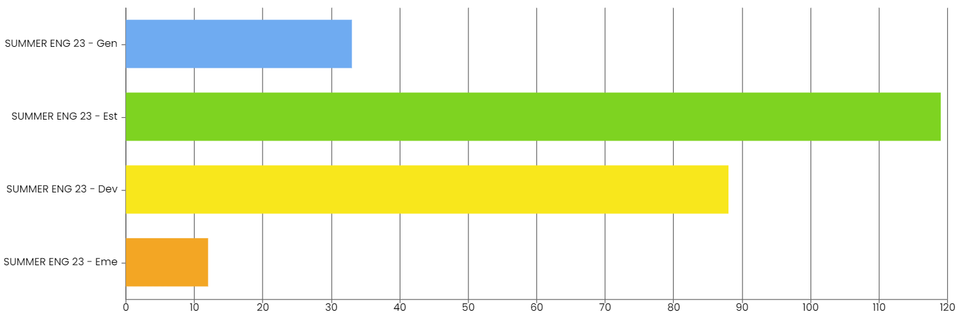
Our last set of data showed that 94% of our pupils are currently ‘Developing’ or above with 63% currently meeting the higher expectation threshold of ‘Established’ or ‘Generalised’ in their learning. This data not only shows that learning in English is successful but allows us to accurately identify where support and interventions are required.
Finally, this program supports pupils' social and emotional well-being. By creating a positive and inclusive learning environment, where pupils feel supported, respected, and valued, we can foster their self-confidence, self-expression, and sense of belonging. Through meaningful and authentic English learning activities, pupils develop effective communication skills, enhance their social interactions, and improve their overall emotional literacy. Through working with partners in the local community, we provide real life learning that will support pupils beyond Pencalenick School.

