 | Autumn 1 | Autumn 2 | Spring 1 | Spring 2 | Summer 1 | Summer 2
Cycle A | 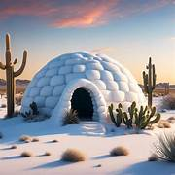  An igloo in a Desert? |   Lights and Colours |   World of work | 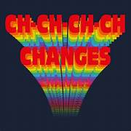  Ch Ch Changes | 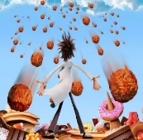  A Chance of Meatballs | 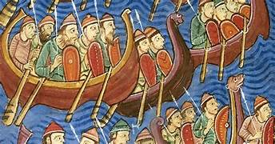  Raiders or Traders
Cycle A | Number and Place Value  identify, count, order &compare numbers to:  5, 10, 20, 100, 1000, a million and beyond  decimals  negative numbers  Calculations Addition/subtraction  single digit -manipulatives, pictorial, abstract  double digit mentally and written methods  carrying and borrowing  decimals and negative numbers | Properties of shape  matches, sorts, compares, identifies and describes  2D shapes, 3D shapes  Angles  Money  Recognising coins/notes  Making different amounts  Converting between £ and p  Conversions  Time  Days/months/seasons  Calendars  Equivalence -secs/mins/hours/days/weeks etc | Number and Place Value  Counting in steps  Formulae  Calculations  Multiply/divide  Timetables  formulae | Measures  compares/describes units of measure  measuring length and width  perimeter and area  volume  Time  Telling the time-  Hour/half hour  Quarter of an hour  Problem solving using time  Weight and Volume  Measure/compare  Units of measure | Calculations  Problem solving  Real life situation  BIDMAS  Money  Using coins  Shopping with coins/notes  Calculating with money  Fractions  Finding fractions of amounts -sharing/pictures/numbers  Equivalent fractions  F/D/P | Data Handling  Read, draw and interpret graphs and charts  Averages  Position and Direction  Positional language  Simple directions  Compass points  Coordinates
Cycle B | 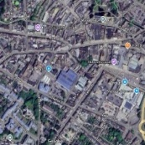  Identity | 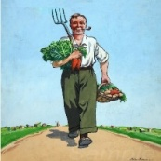  World War 2 |   Different Cultures | 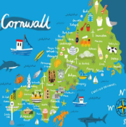  My Cornwall, My Home | 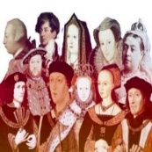  Kings and Queens |   Healthy Body Healthy Mind
Cycle B | Number and Place Value  identify, count, order &compare numbers to:  5, 10, 20, 100, 1000, a million and beyond  decimals  negative numbers  Calculations Addition/subtraction  single digit -manipulatives, pictorial, abstract  double digit mentally and written methods  carrying and borrowing  decimals and negative numbers | Properties of shape  matches, sorts, compares, identifies and describes  2D shapes, 3D shapes  Angles  Money  Recognising coins/notes  Making different amounts  Converting between £ and p  Conversions  Time  Days/months/seasons  Calendars  Equivalence -secs/mins/hours/days/weeks etc | Number and Place Value  Counting in steps  Formulae  Calculations  Multiply/divide  Timetables  formulae | Measures  compares/describes units of measure  measuring length and width  perimeter and area  volume  Time  Telling the time-  Hour/half hour  Quarter of an hour  Problem solving using time  Weight and Volume  Measure/compare  Units of measure | Calculations  Problem solving  Real life situation  BIDMAS  Money  Using coins  Shopping with coins/notes  Calculating with money  Fractions  Finding fractions of amounts -sharing/pictures/numbers  Equivalent fractions  F/D/P | Data Handling  Read, draw and interpret graphs and charts  Averages  Position and Direction  Positional language  Simple directions  Compass points  Coordinates
Cycle C |   Rivers and Mountains | 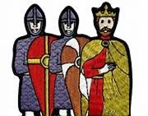  Conquest | 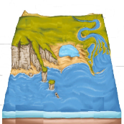  Where the Land meets the Sea | 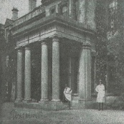  Pencalenick Past | 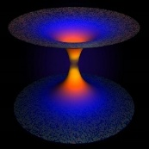  The Final Frontier | 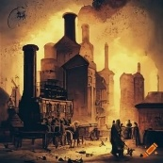  The Age of Steam and Steel
Cycle C | Number and Place Value  identify, count, order &compare numbers to:  5, 10, 20, 100, 1000, a million and beyond  decimals  negative numbers  Calculations Addition/subtraction  single digit -manipulatives, pictorial, abstract  double digit mentally and written methods  carrying and borrowing  decimals and negative numbers | Properties of shape  matches, sorts, compares, identifies and describes  2D shapes, 3D shapes  Angles  Money  Recognising coins/notes  Making different amounts  Converting between £ and p  Conversions  Time  Days/months/seasons  Calendars  Equivalence -secs/mins/hours/days/weeks etc | Number and Place Value  Counting in steps  Formulae  Calculations  Multiply/divide  Timetables  formulae | Measures  compares/describes units of measure  measuring length and width  perimeter and area  volume  Time  Telling the time-  Hour/half hour  Quarter of an hour  Problem solving using time  Weight and Volume  Measure/compare  Units of measure | Calculations  Problem solving  Real life situation  BIDMAS  Money  Using coins  Shopping with coins/notes  Calculating with money  Fractions  Finding fractions of amounts -sharing/pictures/numbers  Equivalent fractions  F/D/P | Data Handling  Read, draw and interpret graphs and charts  Averages  Position and Direction  Positional language  Simple directions  Compass points  Coordinates
Key Stage 4 | AQA GCSE | AQA GCSE | AQA GCSE | AQA GCSE | AQA GCSE | AQA GCSE
Y11 | AQA ELC Mathematics  Entry Levels 1-3 | AQA ELC Mathematics  Entry Levels 1-3 | AQA ELC Mathematics  Entry Levels 1-3 | AQA ELC Mathematics  Entry Levels 1-3 | AQA ELC Mathematics  Entry Levels 1-3 | AQA ELC Mathematics  Entry Levels 1-3
CURRICULUM INTENT
To explore ‘real’ maths in a style that addresses individuals’ learning and develop cross curricular numeracy skills in order to apply their knowledge to real life situations. We encourage pupils to be curious, independent and driven and consequently proud of their achievements ultimately preparing them for the future.
CURRICULUM IMPLEMENTATION
Maths is delivered across the school in a way that best suits individuals’ learning, focusing on their interests and using practical and kinaesthetic activities. Maths is taught for mastery, encouraging a deeper understanding of topics and immediate intervention is given to prevent pupils falling behind. During lessons, there is a strong focus on EHCP targets inspiring pupils to show examples of independence, communication and emotion. Pupils take different pathways giving the opportunity to obtain an Entry Level or GCSE qualifications as and when appropriate.
CURRICULUM IMPACT
We aim to prepare our pupils by giving them numeracy skills for life. Our main focus across the maths curriculum is for pupils to relate and apply the topics to real life situations. Where possible, we promote practical activities and relate exercises to topics of interest. Our aim is to have leavers that are independent and confident young adults able to face the numeracy challenges of real life around them.

