What is bullying?
Bullying is any behaviour by an individual or group that:
- Is meant to hurt.
- Happens more than once.
- There will be a pattern of behaviour, not a one off incident.

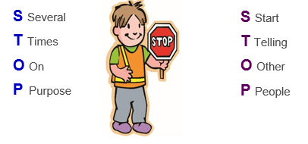

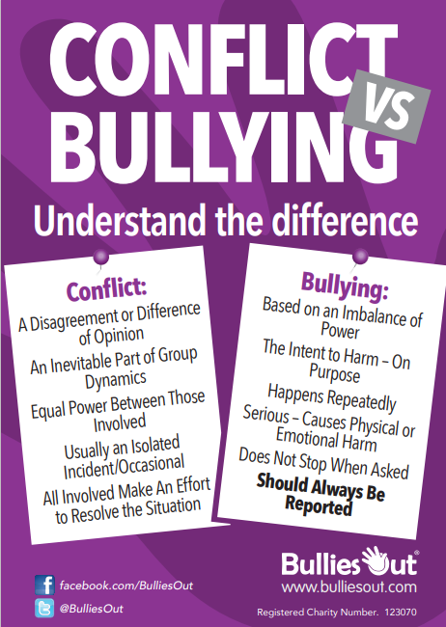



Helping Children Deal with Bullying & Cyberbullying | NSPCC
https://www.nspcc.org.uk/what-is-child-abuse/types-of-abuse/bullying-and-cyberbullying/
0808 800500



Bullying and advice on coping and making it stop | Childline https://www.childline.org.uk/info-advice/bullying-abuse-safety/types-bullying/
0800 1111



Anti-Bullying - Healthy Cornwall
https://www.healthycornwall.org.uk/organisations/healthy-schools/core-themes/emotional-wellbeing/wellbeing-resources/anti-bullying/



Advice for parents and carers (anti-bullyingalliance.org.uk)
https://anti-bullyingalliance.org.uk/tools-information/advice-and-support/advice-parents-and-carers




BULLYING
ADVICE
FOR PUPILS,
PARENTS AND
CARERS


What to do if you think your child is being bullied or bullying anyone else?
- Give reassurance to your child (this is not their fault)
- Talk calmly about what is happening (even though you may feel upset yourself)
- Listen and take what is said seriously
- Let them know you want to help and praise them for telling you.
- Makes notes of what has happened (who, what, when, where)
- Do not encourage your child to retaliate.
- Keep your child involved - it is important that they know what is happening and have a say.
- Encourage them to report incidents to a teacher or pastoral
- Talk to the school immediately
- Reassure your child that the school will deal with the matter sensitively

Spotting the signs of bullying
You may be unsure if your child is being bullied. It may be helpful to look out for some of the following changes in behaviour, which could be an indicator:
- Stress—being moody, silent or crying.
- Making excuse to miss school.
- Upset after using the internet or telephone.
- More bruises or scrapes than usual.
- Withdrawn, anxious, lacking in confidence.
- Torn clothes or things that are missing or broken.
- Poor sleeping.
- Bed-wetting.
Bullying is not when two people have a disagreement or fall out over something. Bullying can be...
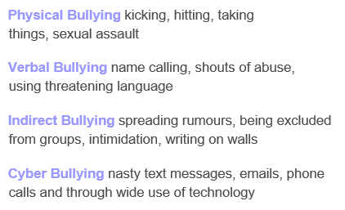
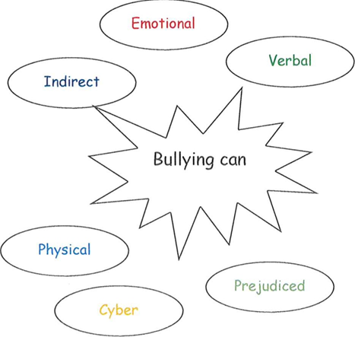
#
Please read this guide in conjunction with the school's behaviour and safeguarding policy, which is available on our website.
We are firmly committed to working in partnership with parents and believe that the best outcomes emerge when staff and parents/carers work together.
Whom to contact about bullying

Please contact your child's class tutor or member of the school's Senior Leadership Team with any concerns.

Anti-Bullying Senior Lead/
Designated Safeguarding Lead:
Gary Oak

Safeguarding Lead/ Behaviour Lead:
Diana Barry
If you like to have a confidential conversation with an independent body you can also ring provisions on the contacts list on the back of the leaflet.
Bullying can be…

